Census Income Analysis

Amy Edwards, Alice Fu, Persid Koci, Carl Snow, Jenny Tong, & Danyang Xiong

# Abstract

With this adult census income dataset extracted by Ronny Kohavi and Barry Becker from the 1994 Census bureau database (UCI Machine Learning, 2016), we have a couple of goals. One goal is to use the data to determine if we can predict if a person will make over $50k per year. This will be analyzed with a logistic regression analysis, for which the final model in one case was able to predict 37.98% of the variability. Logistic regression analysis methodology included exploratory analysis, residual analysis, multicollinearity analysis, examining significant variables, and model selection. The test set performance of the final model was a sensitivity of 88%, an accuracy of 78.67%, a precision of 54.72%, a specificity of 75.53%, and an f-metric of 67.48%. The most influential independent variable was capital_gain. Since the model’s performance and explanatory power can be increased, the recommendation is to explore different modeling techniques in the future, including naive Bayes and a decision tree model.

The second goal is to predict how many hours per week a person will have to work in order to make over $50k per year. This will be done using a full linear regression analysis, including exploratory plots, examining correlation, and model selection in order to determine the most significant factors. The final model for hours per week was only able to predict 10.77% of the variability. There must be many outlying conditions other than the variables used here to determine how many hours per week a person will work. Likely, we need more details about their job, their financial situation, and their work ethic. The most influential variables determining hours worked per week are education_Assoc-voc and occupation_Transport-Moving. If a person as an Associate Vocational degree and also works in Transport Moving, they will work 32 additional hours per week more than a person who does not have those characteristics, holding all other variables constant.

# Introduction

## Amy

When considering how many hours per week a person will have to work to make over $50k/year, some hypotheses come to mind: 1. The individuals native country will be a determining factor, and those from countries with a lower GDP will have to work more hours in order to meet the same income goal as their counterparts (Classora, 2016), 2. The subjects sex will also be a determining factor, as it relates to education and occupation due to the gender wage gap (Hartmann, 2005), and 3. The income bracket over $50,000 will be dominated by those with higher education. Exploring this subject is important to researching wealth inequality between genders, races, and comparing how immigrants fare after moving to the United States. It is likely that due to the slow wage growth beginning in the 1970s, young people are having to work longer hours in order to make the same money as an older generation (Levy 1998). Validating these theories gives credibility to social and political movements that are fighting for higher wages and public access to systems such as job training, transportation, and education all in the name of equality.

## Jenny

The goal of this analysis was to see which independent variable has the greatest effect on whether an individual made more than $50,000 a year, based on a dataset of Census income data from 1994. The null hypothesis is that none of the independent variables had a significant effect on the dependent variable, whether an individual made more than $50,000 a year. Hypothesis 1 is that at least one of the independent variables has a significant effect on income outcomes. It is important to determine which factors individuals can focus on, if they can affect those factors at all, in order to earn a high income.

Hypothesis 2 is that the country of origin will have a significant effect on income outcomes. This is informed by a paper suggesting that immigrants earn higher wages since they are "a self-selected group, and as a result, [they] may be more able and highly motivated" (Borjas 1987). Hypothesis 3 is that number of years of education will have a significant effect on income outcomes. This makes sense as education affects employment types and related incomes, presumably.

A cross-country study found "sizeable differences in...years of schooling between the US and low inequality EU countries" (Devroye and Freeman 2001). This means that since inequality is more prevalent in the US, years of education has an effect on outcomes, whereas it is not as strong a factor in countries with less inequality. Another cross-country study found that "returns to schooling increase over the wage distribution...the earnings increment associated to schooling is higher for those individuals whose unobservable characteristics place them at the top of the conditional wage distribution" (Martins and Pereira 2003). This suggests that increased education helps those who are already naturally advantaged, perhaps by gender or age, suggesting an interaction variable.

## Danyang

The goal is to find what affects the number of working hour per week. I choose this as my research subject since I’m interested in knowing the distribution of working hours among different people. To be more specific, to know whether education level, working class, occupation, age, marital status, race, and relationship have effect on working hour. My hypothesis is higher education level, higher working class may have great influence on the working hour since I believe that those smart people tend to spend more hours working in the modern society. They are eager to learn new things, and they usually have creative thought to manage company’s operation effectively. My second hypothesis is married man works harder than married women since men tend to have greater responsibility on their family. Economic Sociology (1983) argues “But since this means that married man work about 25% more hours per week for pay than married women do” .

## Persid

The goal of this project is to determine a regression model that predicts whether the income of a person exceeds $50,000 per year based on census data. The income levels in the dataset were classified in two categories, less than or equal than $50,000 and more than $50,000. Therefore, a logistic regression analysis will be performed. The results of this project may serve to understand better the contributing factors on the income level, and investments can be made from government agencies or private entities to target directly the problem of poverty and inequality of the population (Hartmann 2005) .

## Carl

The goal of this analysis was to see which independent variables have the most significance on whether an individual made more than $50,000 a year, based on a dataset of Census income data from 1994. For the goodness of fit, the null hypothesis is that none of the independent variables will have a significant effect on the dependent variable. The alternate hypothesis is that at least one of the independent variables will have a significant effect on income.

I believe that number of years of education will have a significant effect on income. This makes sense as education affects occupation and status. Also, I believe as age increases, probability of an individual making more than $50,000 a year goes up. I Also think that a married man works harder than married women since men tend to have greater responsibility on their family. Economic Sociology (1983) argues “But since this means that married man work about 25% more hours per week for pay than married women do”.

I will test my believes while analyzing the income data. Compared to my group members, I am only considering observations which have native country as United States since comparing other countries is not part of my hypothesis.

## Alice

The goal is to see if I can predict the chances of someone making >50k with certain attributes.

H0: none of the predictors can predict the y-variable (d_income)

H1: the more education a person has the greater their chances are of making >50k

H2: single people have a greater chance of making >50k than their married counterparts

According to a recent meta-analysis, the effect of educational expenditure on growth is positive. A 0.2-0.3% increase in growth for an increase in education expenditure by 1% of GDP (Carmignani). This is important because if I can predict how the amount of education a person has affects his/her income, then the broader more important question to ask is if the government should spend more money on its educational to grow their GDP and increase its people’s living conditions.

A study by W. Bradford Wilcox, director of the National Marriage Project at the University of Virginia, and Robert Lerman, an economics professor at American University, insinuates that single women make more than their married counterparts (Wilcox 36). Even though this is not statistically significant, they found that single women between 28 and 30 years old make $1,349 more per year in individual income. This is a widespread question that people have. Are single people more successful than married people, in monetary terms?

# Methodology

## Amy

Kohavi and Becker extracted records from the 1994 census with the following conditions:((age > 16) && (average gross income > 100) && (fnlwght > 1) && (hours per week > 0)). This dataset was retrieved from the UCI Machine Learning Repository via Kaggle [dot] com (UCI MAchine Learning, 2016). I continued to refine this selection to gain a cleaner data set. Using R studio, I began by noting columns with many missing values and I wrote a query to remove those from my data. Then I filtered to only look at cases where income is >50K because that is the selection relevant to my question. Finally, I took a random sample of 27% of the total data in order to get a selection of 2,027 cases.

Next, the data was loaded in to SAS for exploratory analysis. The first steps here are to visualize the data using boxplots, histograms, and scatterplots and to describe the data with statistics and frequency matrices. Based on these, I concluded that the model for hours per week would be a linear. The text variables sex, race, occupation, education, marital-status, relationship, workclass, and native-country were all converted into dummy variables in order to consider them in the model. Based on the histograms of capital-gain and capital-loss, those variables were logarithmically transformed to have a normal distribution (Appendix A.2).

I fit a basic model to get a starting point and examine Pearson Correlation Values. There were no issues there. I took a look at the residual plots – most were dummy variables and therefore not relevant. The other residual plots showed no outstanding issues. The normality plot showed a roughly linear trend. Due to the large number of dummy variables, in order to determine interaction variables I used glmselect with various model selection techniques. Based on the models given, I included all of the interaction variables suggested into further analysis.

I analyzed multicollinearity by using the vif function of proc reg. Where vif > 10, there are multicollinearity issues. I recursively removed variables where vif > 10 and re-ran the model with vif in descending order. I then fit the base model to examine outliers and influential variables, using outliers = Pearson Residual > 3 and influential points = |DfBeta > 2/sqrt(2027)|. After recursively removing cases that were outliers and influential, the adjusted R squared value did not change at all. Therefore, I decided to use the original set of data for the rest of the analysis.

I then split the data into training and testing sets of 75% and 25%, respectively. I will use this tool in order to test how accurate the final model will be. I performed model selection with the training set. For the models I tried adjusted R squared, CP, Stepwise, Forwards, and Backwards. Once I had the variables selected for each model, I analyzed those for significance. The hypothesis test states that a p-value must be than alpha = 0.05 for it to be statistically significant. Upon distilling the 5 models, I determined that the model gleaned from Forward selection had too many variables, making it unreasonable to use. The model for Adjusted R squared and CP ended up as the same. The final models to compare were Adjusted R squared, Backwards, and Stepwise. When comparing the models, the goal is to minimize RMSE, MAE, and CV while maximizing R squared and adjRsq. I will compare the model residuals, looking for constant variance, independence, normality, and linearity. With the final model, we can write the model equation and make predictions.

## Jenny

The Census Income dataset was obtained from <http://mlr.cs.umass.edu/ml/datasets/Census+Income>, and was extracted by Barry Becker from the 1994 Census database. The original dataset had 48, 842 observations, but a random sample of 2000 observations was taken (Appendix B.Figure 1) (SAS Institute, 2010). Originally, there were 6 numerical variables and 8 text variables. 2 independent variables were dropped from the analysis, fnlwgt and relationship. Fnlwgt was the Census's estimate of approximately how many people fit the characteristics for that observation, and would not have been useful to the analysis. Relationship was a field that displayed an individual's relationship status within a family, i.e. Wife, Own-child, Husband, Not-in-family, Other-relative, and Unmarried. This status also seemed unnecessary to include as not having relevance to income outcomes, as well as having overlap with the original marital-status variable.

Since the dataset originally came with many categorical text variables, many dummy variables had to be created. The dependent variable for income was coded as dincome where 1 indicated an income greater than $50,000, and 0 indicating an income less than $50,000. As for independent variables, dsex was 1 for male and the baseline was 0 for female. 3 dummy variables were created to represent levels of workclass, with the baseline of 0 being reserved for an unemployment category of "Without-pay" and "Never-worked." dworkclass2 grouped both self-employed categories, "Self-emp-not-inc" and "Self-emp-inc", into one category. dworkclass3 covered government employment: "Federal-gov", "Local-gov", and "State-gov". The last dummy variable, dworkclass4, was set to "Private" to represent employment in private industry.

There were 6 dummy variables created for various levels of education, with the baseline of 0 being less than a high school education, which covers "11th", "9th", "7th-8th", "12th", "1st-4th", "10th", "5-6th", and "preschool." In ascending order, the education dummy variables represented "HS-grad", "Some-college", "Prof-school", an Associates' category, "Masters", and "Doctorate." The Associates' category represented "Assoc-acdm" and "Assoc-voc." Marital status was split into 4 dummy variables, with the baseline of 0 representing currently married individuals, so the "Married-civ-spouse" and "Married-AF-spouse" designations. In ascending order, the marital status dummy variables represent: "Divorced", "Never-married", a separated category, and "Widowed." The separated category contains both "Married-spouse-absent" and "Separated" itself.

Occupation was a bit tricky to categorize, and best judgment was used in grouping occupations together. The baseline is "Tech-support". In ascending order, the occupation dummy variables represent a mechanical category ("Craft-repair" or "machine-op-inspect"), a service-related category ("Other-service", "Sales", and "Adm-clerical"), "Exec-managerial", "Prof-specialty", a menial work category ("Handlers-cleaners" and "Priv-house-serv"), out-door related work ("Farming-fishing" and "Transport-moving"), and security-related work ("Armed-Forces" and "Protective-serv"). Race was split into 3 dummy variables, with the baseline being "White." "Asian-Pac-Islander" was the second level. "Amer-Indian-Eskimo" and "Other" were grouped together in an other-race bucket for the third level. "Black" was the fourth level.

Native-country presented a categorical challenge as well, and roughly continental regions were decided on as the categorical levels for the dummy variables. Another possibility would have been by the country's level of development."United States" was the baseline so that the native population could be measured against all immigrant populations. The baseline also included "Outlying-US(Guam-USVI-etc)" to stand for U.S. territories. Subsequent dummy variables represented Asia, Europe, Central and South America, and the rest of North America. The second level of Asia included Cambodia, India, Japan, China, the Philippines, Vietnam, Laos, Taiwan, Thailand, Hong and Iran. The Europe level included England, Germany, Greece, Italy, Poland, Portugal, Ireland, France, Hungary, Scotland, Yugoslavia, and Holand-Netherlands. The Central and South American region included "South", Cuba, Honduras, Jamaica, Dominican-Republic, Ecuador, Haiti, Columbia, Guatemala, Nicaragua, El-Salvador, Trinidad&Tobago, and Peru. The other North American region included Canada and Mexico.

There was also an age and sex interaction variable included in the analysis informed by the aforementioned Martins and Pereira study.

After recoding the variables, histogram and scatterplot analysis were conducted, which along with the binary nature of the dependent income variable, suggested a logistic regression analysis. Scatterplots were created to examine the independent variables' relationships with the income variable. A full logistic regression model was fitted and the independent variables were examined for significance. Residual plots were analyzed and observations that were both influential and outliers were removed from the dataset. The model was analyzed for collinearity.

Next, the dataset was split into testing and training datasets. The training dataset was fitted with stepwise and backwards selection methods, and a fitted model was selected after the resulting models were compared. Residual and multicollinearity analysis was conducted on the fitted model and a final model was decided upon. The final model was used to make two predictions on the pre-split dataset that only varied in years of education to see if there was a difference between the two predicted observations' incomes. The training dataset was used to analyze the test dataset's performance. The results are explained in detail below.

## Danyang

I found the data from<https://www.kaggle.com/uciml/adult-census-income>. There are over 30,000 observations, so I organized the data by randomly choosing the first 3,125 observations as my dataset. I deleted all missing values in the original dataset, and I kept the United-States as “native.country” variable, and I dropped other countries because I only did the research for the U.S. people since most people chosen in the dataset come from the U.S.. Then I dropped “native.country” since the rest of data are from the research objects of the United States. I also dropped “fnlwgt” and “education.num” variable. The ratio of train set to the test set is 75:25. The dependent variable is “hours_per_week” (the number of working hour per week). The independent variables are: “age”, “capital_gain”, “capital_loss”, “workclass1” – “workclass5”, “education1” – “education15”, “marital_status1” – “marital_status5”, “occupation1” – “occupation13”, “relationship1”- “relationship5”, “race1” – “race4”, “sex1”, “sex_income”, and “sex_age”. I created “sex_income” and “sex_age” as the interaction variables. My methodologies are regression model, testing performance, 5-folder cross validation method, and calculating prediction intervals.

## Persid

Rows with missing data were deleted prior to selecting a simple random sample of 2000 people on which the logistic regression analysis will be performed.

Variables “fnlwgt” (sample weight) and “education_num” were dropped in the analysis. The sample weight is deleted for not being relevant to the model. Education is represented by the qualitative variable “education”. Qualitative variables were grouped in fewer categories where possible, and coded as dummy variables (Table 1 in Appendix D) . Two interaction terms are investigated in the model, age*marital_status, and hrs_per_week*sex1.

A full model will be fitted with all the variables. The model will be checked for multicollinearity, outliers, and influential points. Appropriate steps will be taken regarding the dataset and the number of the variables analyzed in the final model, after these checks will be performed.

The final model will be selected based on the comparisons among the results of different selection procedure. The selection procedures will be run on the training data that is obtained after splitting the original dataset. The data splitting is done, based on a ratio 60/40, where 60% of the data is in the training set, and 40% is in the test set. The validation and the predictions are made using test set. Two predictions are made in the model and the results will be shown.

## Carl

The Census Income dataset was obtained from [UCI Repository](http://mlr.cs.umass.edu/ml/datasets/Census+Income), and was extracted by Barry Becker from the 1994 Census database. The original dataset had 48,842 observations. I attempted to use the data set in its raw form but the values at the end of each line were not being read. I coded a Python program to replace every new line character with a comma and new line character. Once I got that working, I knew that I only wanted to use observations where the native country is the United States since it would be more relevant to me and comparing other countries would not come into play. I also right away coded age and hours per week into managable sections: age(Under18[0-17], youngAdult[18-29], adult30s[30-39], adult40s[40-49], adult50s[50-59], adult60+[60-99]) hours(lowPartTime[0-19], highPartTime[20-29], fullTime[30-40], overTime[41-99]). I attained these values by research into typical ranges. So now I took a random sample of 2000 observations (Appendix F. Figure 1) (SAS Institute, 2010). Originally, there were 6 numerical variables and 8 text variables. 2 independent variables were dropped from the analysis, fnlwgt and native country. Fnlwgt was the Census's estimate of approximately how many people fit the characteristics for that observation, and would not have been useful to the analysis.

Since the dataset originally came with many categorical text variables, many dummy variables had to be created. The dependent variable for income was coded as dIncome where 1 indicated an income greater than $50,000, and 0 indicating an income less than or equal to $50,000. As for independent variables, workclass(dWork) has Private(0), Self-emp-not-inc(1), Federal-gov(2), Local-gov(3), State-gov(4), Self-emp-inc(5), Without-pay(6), and Never-worked(7). For marital_status(dMstatus) Married-civ-spo(0), Never-married(1), Divorced(2), Separated(3), Widowed(4), Married-AF-spou(5), and Married-spouse(6). For occupation(dJob) Exec-managerial(0), Sales(1), Adm-clerical(2), Craft-repair(3), Prof-specialty(4), Machine-op-inspect(5), Transport-moving(6), Tech-support(7), Other-service(8), Handlers-cleaners(9), Farming-fishing(10), Protective-serv(11), Priv-house-serv(12), and Armed-forces(13). For relationship(dRelation) Husband(0), Wife(1), Own-child(2), Unmarried(3), Not-in-family(4), and Other-relative(5). For race(dRace) White(0), Asian-P(1), Amer-In(2), Black(3), and Other(4). For sex(dSex), 1 is for male and 0 is for female.

Dummy variable value for each independent variable is based on running a test on frequency, and ordered in little endian.

After recoding the variables, histogram and scatterplot analysis were conducted, which along with the binary nature of the dependent income variable, suggested a logistic regression analysis. Scatterplots were created to examine the independent variables relationships with the income variable. A full logistic regression model was fitted and the independent variables were examined for significance. The model was analyzed for collinearity and there was none. 64 outliers were removed.

Then the dataset was split into testing and training datasets. The training dataset was fitted with stepwise and backwards selection methods, and a fitted model was selected after the resulting models were compared. Analysis was conducted on the fitted model and a final model was decided upon. The final model was used to make predictions on specific data using education_num, dMstatus, dJob, dRelation, and dRace.The testing dataset was used to analyze the performance of the dataset.

## Alice

The dataset came from Kaggle (<https://www.kaggle.com/uciml/adult-census-income/data>). First, I read the adult.cvs file into SAS. During this process, I made sure that none of the data was truncated and that everything was read in properly. Then, any observations with missing data values were deleted from the dataset. 2000 observations were sampled randomly from the dataset and giving a seed number. Now that I had a working dataset, I began making dummy variables. For the variable “workclass", I made two dummy variables. d_work_private included the nested categories: “Private,” "Self-emp-not-inc,” and "Self-emp-inc.” I grouped these three categories together because they made the most business sense to be together. d_work_gov included the categories: "Federal-gov," "Local-gov," and "State-gov.” These were grouped together because they were are related to working in the government. The nested categories "Without-pay" and "Never-worked” were set as the base case. Even though it would not really matter what I picked as my base case, I picked the least important categories to be in my “workclass” base case so that analyzing the model later on would be intuitive. "Without-pay" and "Never-worked” had the least amount of observations. For the “education” variable, I made four dummy variables. d_edu_primary includes the nested categories: “Preschool,” "1st-4th,” "5th-6th,” and "7th-8th.” d_edu_primary is grouped by everything before high school. d_edu_secondary includes the nested categories: "9th," "10th," "11th," "12th," and "HS-grad.” d_edu_secondary is grouped by high school because there is a transition from middle school to high school and to college. So, the high school level of education makes another category. d_edu_college includes the nested categories: "Some-college," "Bachelors," "Assoc-acdm," and "Assoc-voc.” d_edu_college is a category for people who have a Bachelor degree and or some sort of college experience. d_edu_higher includes the following nest categories: "Prof-school" and “Masters.” d_edu_higher includes people who have a little more schooling than people who just have a Bachelor degree. The base case is "Doctorate.” People who have doctorates have reached the pinnacle of their education. This is the highest level of education. Essentially, I grouped the education dummy variables by the transitions a student makes throughout their academic career. For the variable "marital_ status,” I felt that it would be most interesting to compare married people not not married people. So, I only made one dummy variable for married people called “d_marital” that includes "Married-AF-spouse," "Married-civ-spouse,” and "Married-spouse-absent.” For “occupation,” I made two dummy variables. d_occup_service included "Farming-fishing,” "Transport-moving,” "Craft-repair,” "Other-service,” "Priv-house-serv," "Protective-serv,” "Armed-Forces,” "Handlers-cleaners,” and "Sales.” These are all service jobs. d_occup_exec included "Exec-managerial” and "Prof-specialty.” These are more advanced jobs with managerial positions and higher skill sets. The base case are the technology jobs: "Tech-support,” "Machine-op-inspct,” and "Adm-clerical.” For “relationship,” I made one dummy variable separating the people with a family and the people who do not. d_relat_family includes “Husband,” “Wife,” "Other-relative,” and "Own-child.” The base case includes “Unmarried” and "Not-in-family.” For race, I simply made four dummy variables, one for each race (“White,” “Asian-Pac-Islander,” “Amer-Indian-Eskimo,” and “Black”) except for the base case (“Other”). For the “sex” variable, I made one dummy variable for “Male” with “Female” being the base case. I also had to recode the y-variable “income" because it was binary. I made the dummy variable d_income to include the category “>50k” because I want to predict how much of a chance a person has of making over 50k based on the certain qualities he or she possesses described in the x-variables. Finally I tried two interaction terms. One of the was thrown out by the model because it was not significant. I thought that that age and education_num might have some correlation o I grouped those two categories to predict who makes over 50k. However, this interaction term was thrown out of the model. So, I tried another interaction term: "interaction2.” This interaction term is between age and hours_per_week (how many hours a person works per week). Interaction2 was eventually found to be significant in the model selection process. I dropped fnlwgt because it is a weighted variable of how many people fall into that observation. After all of the needed variables were recoded. I began the data exploration phase, making frequency tables, descriptive statistics, and box plots to understand the data better. Then, I fit the full model with logistic regression because my y-variable “d_income” is binary. I fit the model with the standardized estimates, r-square, correlation matrix, and residual plots to check for multicollinearity and to exclude any outliers or significantly influential points. After the multicollinearity and outliers/influential points were handled, I fit the full model one more time. Then, I split the dataset into training and testing with a sample rate of 75% to 25%, respectively. The new y-variable for the training was created “train_y” for the values that were selected for the training set. Three model selection methods were run with r-square to find the best model: stepwise, backward, and forward. The with the best model, the full model was fitted with residuals once more to check for outliers and influential points. After this was handled, the full model was fitted once more. Finally, the classification matrix was produced to measure the sensitivity/recall, accuracy, precision, specificity, and F-metric of the model. If the values for these categories were unsatisfactory, then various factors were changed: how dummy variables are created, how outliers/influential points are handled, new sample rate, new seed number, etc. Then, through the selection model process, a new best model for that trial is created. All of the “best” models produced are then compared to see which one of them has the highest values in these categories produced by the classification matrix. Finally, two prediction are made based on the best model.

# Analysis, Results, and Findings

## Amy

In the first steps of exploratory analysis, a scatterplot of all the continuous variables was produced (See Appendix A.2 Figure 1), which did not show any trends in their relationship. From this point on, it became clear that there would not be a very accurate way of predicting how many hours per week one will have to work to make over $50,000 a year. Box plots were produced to examine hours_per_week vs the categorical variables (appendix A.2 Figures 2-9). In summary, they show that men work slightly more hours than women. Those who are self employed have a higher average of hours per week than those in the government or private sectors, though the 25th percentile of all work classes are approximately the same. Marital-Status appears to have no effect on hours worked per week and they have very similar values for the IQR, mean and median. However, being married with a civilian spouse offered the greatest variability with the highest maximum and lowest minimum. The occupation predictor also has similar mean and median hours worked per week, appearing to be between 40 and 50 hours. Notably, members of the armed forces only work 40 hours per week. Many people from certain native-countries are shown to only work a specific number of hours per week, but this may be due to lack of people from those countries in the data rather than a trend. Overall, relationship seems to have an effect on hours worked per week if the relationship variable equals wife. When it comes to education, if a person has not completed high school, there is much less variability in the hours they could work per week. Here I’d hypothesis that perhaps those people are working lower-skilled jobs because they have less education and their jobs are less flexible. A final histogram of hours-per-week confirmed that the best model would be linear, because the distribution is roughly normal (Appendix A.2 Figure 14).

I created dummy variables for the categorical variables. A complete table of the transformations can be found in Appendix A.2 Table 1 and Table 2. I kept many of the variables ungrouped because I wanted to see how relevant that specific occupation or educational attainment was. For the native-country categorical variable, I labeled the dummy variables 1-40, in order of increasing GDP (Classora, 2016) for ease of use.

In order to test interaction variables, I used the glmselect class option. This allowed me to split the dummy variables in the model education rather than multiply each dummy variable by each other dummy variable manually. I ran the glmselect model four times, using stepwise(cp), stepwise(adjrsq), forwards and backwards selections. The only interactions that made it into the model outputs were

education_Doctorate*occupation_Prof-specialty, education_Assoc-voc*occupation_Transport-moving, education_Bachelors*occupation_Prof-specialty, marital-status_married*relationship_Wife, and

marital-status_married*relationship_Child.

I then included these interaction variables into the rest of my model analysis, and treated them as a regular variable. The relationship between education and occupation appears to be highly significant to predict working week hours. As does the relationship between marital-status and relationship, which makes sense because they are speaking to similar criteria.

Next, correlation was examined among the independent variables using the Pearson Correlation Coefficient. There were no issues, and in fact, the variables seemed highly uncorrelated. I next looked at multicollearity and recursively removed variables that were the worst problem and re-ran the model. For this I used the VIF value, and if VIF > 10, there is multicollinearity, but because the model changes each time, I removed the largest VIF each time I ran the model. See appendix A.2 for the final multicollearity model (Figure 27) as well as the residuals (Figures 15-26) associated with that model. Most of the residuals are dummy variables, which do not show accurate assumptions of constant variance, independence, or normality. Those residual plots of the continuous variables (fnlwgt, capital-loss, capital-gain, and age) do not show an even distribution of points around the zero line, and they all show some outliers. This is not enough to deter the analysis, however, because the QQ plot of hours-per-week shows it to be almost linear, except in the extremes. Finally, in order to better represent the data, I examined the outliers and influencers. I ran the model a few times, deleting some of the most egregious outliers and influences each time, and in the end the adjusted R2 value stayed the same as it was before the deletions (9.97%). Because the outliers and influencers may actually be very valuable to the model, as opposed to mistakes, and the model did not get better, I decided to continue the analysis with the original complete data.

At this point none of the model variables are collinear and model selection for hours-per-week can begin. I split the data into a training and testing set of 75%, 25% respectively in order to test the model I find on unseen data. There are 5 selection methods we will use to determine the best model. Selection Method 1 uses Adj-R2 to find a model with the highest R2 value. Method 2 uses the backwards elimination method which begins with the full model and recursively removes the least significant variable until they are all significant. Selection Method 3 is stepwise, which alternates between dropping a variable and re-considering the addition of all previously dropped variables at each step. This method usually gives the smallest number of variables compared to other methods. The 4th method is CP selection method for models of least squares. The smaller the value of C(p) the more precise the model. The last method is forwards selection, which starts with no variables and adds all that are deemed significant. The forward selection result gave a model with twice the amount of variables as any other so we will not mention it again.

With models 1, 2, 3 and 4 from adjusted R squared, backwards elimination, stepwise, and C(p) selection methods, respectively I then examined for variable significance. The hypothesis test states that a p-value must be than alpha = 0.05 for it to be statistically significant.The model for Adjusted R squared and CP ended up as the same. The final models to compare were Adjusted R squared, Backwards, and Stepwise. When comparing the models, we want to minimize RMSE, MAE, and CV while maximizing R squared and adjRsq. We will compare the model residuals, looking for constant variance, independence, normality, and linearity. (see Table 3 and Table 4 in appendix A.2 for training and testing comparisons for Models 1, 2, and 3). Model 1 did better than the other two models in all of the categories, so we will use that to fit our final model on all of the data. The result is:

Hours_per_week = 48.09 + 5.52*(edu_doctorate*occup_ProfSpecialty) + 32.078 *(edu_AssocVoc*occup_TransportMoving) + 7.568*(edu_ProfSchool*occup_ProfSpecialty) -0.154*age -2.253*d_raceAPI + 6.18*d_rlnshpNIF + 6.3*d_rlnshpHubs + 6.82*d_rlnshpSngl -3.785*occup_AdmClerical -2.91*occup_CraftRepair + 5.9*occup_FarmingFish -4.93*occup_MachineOpIns -3.48*occup_ProfSpecialty -5.4696*occup_TechSupport

The strongest predictor in this model is the interaction between education_Assoc-Voc and occupation_Transport-Moving. If both these categories are true for a person, they will work an extra 32 hours, holding all of the other variables constant. The model’s Adj-R2 is only 10.77%. This means that this model only explains 10.77% of the variability in hours worked per week, and, in other words, is not a very good predictor. The F-value is 18.47 and the associated p-value is <.0001. This means that the model is better than the intercept-only model! There may be many outside factors that are better at explaining how many hours per week one will work. These factors might include greater details on occupation and work ethic, as well as a better understanding of one’s financial situation.

For a person to have a doctorate degree and an occupation of specialty professor, holding all other variables constant, their hours worked per week will increase by 5.52. If a person has the education of professional school and the occupation of a specialty professor, all else constant, they will work 7.568 more hours per week. These are interesting because a doctorate degree is higher than a professional one. In the same job position of specialty professor, those with a higher degree work less.

Age plays a small part, where the older you are, the less you work. For each year, all else constant, a person will work 0.154 less hours per week. If a person’s race is Asian-Pac-Islander, all else constant, they will work 2.253 less hours per week. They’ll also work less if your occupation of Admin-Clerical, Craft Repair, Machine-Op-Instruct, Prof-Specialty, or Tech-support. Holding each other variable constantly, they would work 3.785, 2.91, 4.93, 3.28, or 5.4696 less hours per week, respectively. However, if their occupation is Farming-Fishing and all else is constant, they will work 5.9 more hours per week. This makes sense because outdoor labor is typically a job with long hours for a specific season, and then a break in the winter. A technique not discussed in class, that would be interesting to implement on this subset is Time Series Forecasting. Blue collar occupations such as farming and fishing have seasons so in order to accurately predict how much they will work, knowing the trend of the year would be valuable (Roubinchtein, 2017).

The last significant variables are relationship Not-in-Family and relationship Husband. Those not-in-family will work 6.18 more hours a week, all else constant and husbands will work 6.8 more hours a week under the same conditions. This could be due to men often being the breadwinner of a family, though it’s interesting that sex was not a contributing variable to the model. In 1993, the year before this data was collected, men worked 8 more hours a week than women (Rones, 1997).

Nevertheless, with the final model acquired (appendix A.2 Figure 28), we can use it to make predictions. For example, the two situations I devised for practice are:

1. Husband working for himself incorporated,, 35 y/o his race is black and he is from England. His capital loss on the company is $2000. Has a bachelor's degree. how many hours per week will he work?

2. 28 y/o woman working in the federal government with a masters degree. Never married in tech-support. She is from the US. How many hours per week will she work?

For problem 1 - the man is predicted to work 49 hours per week with a 95% confidence interval that the actual hours worked are in the range of 48.2191 hrs - 49.7814 hrs. The 95% prediction interval for a future response is 29.3971 - 68.6032 hours. For problem 2 - the women is predicted to work 38.3077 hours per week with a 95% confidence interval that the actual hours worked are in the range of 35.5968 hrs - 41.0187 hrs. The 95% prediction interval for a future response is 18.5336 - 58.0818 hours (results shown in appendix A.2). Based on these predictions, the women is actually working less hours than the man for both of them to make over $50k a year (appendix A.2 Figure 29). This invites further study to see if her master’s degree is the reason she is working less hours per week or if there is a gender disparity. Unfortunately in this data set, it is unknown which of the two people are making more money.

## Jenny

Exploratory analysis was conducted on the dataset with a histogram as shown in Appendix B.Figure 2. Due to the binary nature of the dependent variable income, which had been recoded as dincome, the histogram did not show much. The mean was .244, which is not very high, and it seemed from the distribution of the 0's and 1's on the histogram that there were far more people with incomes below $50,000 than incomes above $50,000. This makes sense as $50,000 is a high income in 1994 and a smaller portion of the population can be expected to make a high income. The histogram suggests a logistic regression.

A scatterplot matrix was attempted but failed to generate meaningful output with 33 independent variables. The scatterplots of dincome against age and number of years of education (Appendix B.Figures 3 and Appendix B. Figure 4) were examined, but again they failed to reveal much since most of the points were clustered either at the top or the bottom. The case is looking stronger for logistic regression analysis.

Boxplot analysis was conducted on several independent variables against dincome: age, capital_gain, dmarital3, doccup4, doccup5, edu_num, and hours_per_week. Appendix B.Figure 5 for age shows that, somewhat surprisingly, the IQRs of individuals with incomes above and below $50,000 are similar, although it is larger for those with incomes below $50,000. The average ages also seemed similar at around 40. The main difference was in the ranges, as the below $50,000 income had a very wide range that extended to all ages. It makes sense that the age for those making above $50,000 is higher as people need time to start their careers and earn more money.

Appendix B.Figure 6 shows a large range of capital gains for those with incomes above $50,000 and a small range for those with incomes below $50,000, indicating that capital gains probably do not have much effect on income. It makes sense that those with a smaller income would not have much in capital gains. The average capital gains seemed similar for both income groups, at a few thousand dollars. This indicates that most of the people in the dataset earned their money primarily through their income.

Appendix B.Figure 7 shows a large range for those who have never married for both income levels, though the IQR for the lower income level spans the entire range. The average for the lower income level is higher than the average for the income level above $50,000. Dmarital3 is a dummy variable so it is a bit more difficult to interpret, but it seems as if remaining single does not have a strong impact on income; if anything, more single people remain at the lower income level. This is a bit surprising since single status would enable one theoretically to focus more on one's career.

Appendix B.Figure 8 shows the opposite effect from figure 7; there is a large range for both income levels for those working in executive-managerial occupations, but the IQR spans the entire range for the higher income level and the average for the higher income level is also higher than the average for those with incomes below $50,000. This indicates that there are more people with higher incomes working in executive-managerial positions, which makes sense as those positions tend to be higher paid. Appendix B.Figure 9 is similar to figure 8, which makes sense as it is a boxplot of individuals with professional specialty occupations, which also tend to be higher paid.

Appendix B.Figure 10 shows high averages for both men and women, though the average for men is higher. The range for both sexes is quite large but the IQR for women spans the entire range, indicating there are more women in the observations who have an income of $50,000 or less. Since there is a gender-based pay gap, it is not surprising that women have a lower chance of having a higher income.

Appendix B.Figure 11 shows a slightly higher average for those with higher incomes when it comes to years of education, though both are around 10 years of education. The higher income level also had a larger IQR whose upper bound is at about the 12-year mark, so people with higher incomes tend to have more years of education. This makes sense as education is often an investment in obtaining a higher income. Both years of education ranges top out at around 15, so there are lower paying jobs that require the maximum years of education.

Appendix B.Figure 12 shows a slightly higher but similar average, at around 40 hours, for those with higher and those with lower income levels. However, note that the IQR for those with incomes greater than $50,000 extends up to 50 hours a week, while the IQR for those with lower income levels tops out at the average. The range of the lower income level does extend up to almost a 100, so there are individuals who are working long hours for low pay. It makes sense that on average those with higher incomes tend to work more hours.

Next, a Pearson correlation matrix was generated to check for multicollinearity but it is ineffective for a categorical dependent variable like dincome (Appendix B.Figure 13). Logistic regression was run for a full model with all variables. The full model has really high AIC and SC values, of 1433.308 and 1623.738, respectively, which is unfortunate (Appendix B.Figure 14). The r-squared value is also a bit low at 0.3735. However, the goodness of fit test looks good with a likelihood ratio of 935.2461 and a p-value of less than 0.001, so the null hypothesis is rejected. However, there seem to be many outliers and influential points according to the Pearson residuals exceeding +-3, and dfBetas greater than |Dfbeta| > 2/( ), n = 2000, so |Dfbeta| > 0.0447 (Appendix B.Figure 15).

The initial analysis of independent variables' significance based on p-values greater than 0.05 suggests insignificant independent variables of: dsex, dworkclass2, dedu2, dedu3, dedu4, dedu5, dedu6, dedu7, doccup2, ooccup3, doccup6, doccup7, doccup8, drace2, drace3, drace4, dnativec2, dnativec3, dnativec4, dnativec5, and the interaction variable, age * dsex (Appendix B.Figure 16). The occupation related dummy variables correspond to the occupation categories the boxplot analysis excluded, which is a good sign for the executive-managerial and professional-occupation based variables. Race and native-country are insignificant except for one variable, which seems unfavorable for hypothesis 2, that being an immigrant would have a significant impact on achieving a higher income level. Dsex is insignificant, which probably influences the interaction variable's insignificance, and is encouraging for gender-based salary differences.

Multicollinearity was low overall, except for the interaction variable age * dsex, which had a -0.88 correlation with age, and a -.9524 correlation with dsex. (Appendix B.Figure 17). Dworkclass2 and dworkclass3 had a correlation of .8892, and dworkclass4 and dworkclass2 had a correlation of .9347. Dworkclass4 and dworkclass3 have a correlation of .9256. Multicollinearity for these work class dummy variables can be safely ignored because they are levels for a categorical variable with 3 or more levels.

Returning to the analysis of influential points and outliers, there were 12 observations found to be both influential points and outliers with Pearson residuals greater than +-3 and dfBeta values greater than 0.0447 , and these were removed first (Appendix B.Figure 18). The model improved to have an r-square of 0.3904 and an improved likelihood ratio of 983.9645 (Appendix B.Figure 19). AIC and SC have also decreased to 1356.354 and 1552.175, respectively.

Next, outliers were removed in order to improve the model further, but since they only marginally improved the model, they were kept in the dataset (Appendix B.Figure 20). The rejected model had an r-square of .4061 which is only about a .01 improvement (Appendix B.Figure 21). The likelihood ratio only increased slightly as well to 1029.7460, and there were marginal improvements to AIC and SC, respectively, at 1284.306 and 1479.915. The largest deciding factor in rejecting this model was the too-small improvement in r-square.

The dataset without observations that are both influential points and outliers was split into a training and a testing set, and stepwise and backwards selection were used on the training set. Both models resulted in the same 16 remaining variables with r-square of .3798, AIC of 1031.280, SC of 1121.503, and likelihood ratio of 712.2861 (Appendix B.Figures 22 and 23).

The correlation of coefficients matrix analysis reveals the same multicollinearity that can be ignored because it affects dummy variables on a category with 3 or more levels, namely dworkclass2, dworkclass3, and dworkclass4 (Appendix B.Figure 24). The correlation value between dworkclass2 and dworkclass3 was .8823, and the correlation value between dworkclass2 and dworkclass4 was .9315. In addition, there was a correlation value of .9182 between dworkclass3 and dworkclass4. The other variables did not display multicollinearity.

However, the fitted model still seems to have outliers and influential points according to the Pearson residuals exceeding +-3, and dfBetas greater than |Dfbeta| > 2/( ), n = 1491, so |Dfbeta| > 0.0517 (Appendix B.Figure 25). There were 11 observations that were both outliers and influential points found (Appendix B.Figure 26) and 9 observations found that were outliers (Appendix B.Figure 27). Unfortunately, removing observations that were both outliers and influential points did not significantly improve the model, so no outliers or influential points were removed. The rejected model had an r-square of .3970, which is again only a ~0.01 difference from the previous r-square (Appendix B.Figure 28). The AIC, SC, and likelihood ratio were 971.493, 1061.590, and 748.6328, respectively.

So, the final model is p = Pr(dincome = 1) = -7.5738 + .027 * age + .2809 * edu_num + .000366 * capital_gain + .000660 * capital_loss + .0208 * hours_per_week + 1.2277 * dworkclass2 + 1.6779 * dworkclass3 + 1.7319 * dworkclass4 – 2.3294 * dmarital2 – 2.5443 * dmarital3 -2.6342 * dmarital4 * -4.4672 * dmarital5 + 0.615 * doccup2 + 1.2094 * doccup5 + 1.1862 * dnativec3 (Appendix B.Figure 29). The most significant variable is capital gain, as per the standardized estimates. All of the marital categories have negative parameter estimates. The independent variables will be discussed as odds ratios below (Appendix B.Figure 30):

Age: Increasing age by one year increases the average odds of having a salary greater than $50,000 by 2.7%, and with a 95% confidence that the average increase is between 1.2% and 4.3%.

Edu_num: Increasing the number of years of education by one year increases the average odds of having a salary greater than $50,000 by 32.4%, and with a 95% confidence that the average increase is between 22.1% and 43.6%

Capital_gain: Increasing capital gain by one dollar does not increase the chance of having a salary greater than $50,000. There is an equal chance that the salary will be less than $50,000.

Capital_loss: Increasing capital loss by one dollar increases the average odds of having a salary greater than $50,000 by 1%, and with a 95% confidence that the average increase is between 0% and 1%.

Hours_per_week: Increasing the number of hours per week by one hour increases the average odds of having a salary greater than $50,000 by 2.1%, and with a 95% confidence that the average increase is between .8% and 3.4%

dworkclass2: Being self-employed, as opposed to not working, increases the average odds of having a salary greater than $50,000 by 241.3%, and with a 95% confidence that the average increase is between 3.4% and 1026.9%.

dworkclass3: Working for the government, as opposed to not working, increases the average odds of having a salary greater than $50,000 by 435.4%, and with a 95% confidence that the average increase is between 58.2% and 1711.7%.

dworkclass4: Working in private industry, as opposed to not working, increases the average odds of having a salary greater than $50,000 by 465.2%, and with a 95% confidence that the average increase is between 78.6% and 1688.2%.

dmarital2: Being divorced, as opposed to being married, decreases the average odds of having a salary greater than $50,000 by 9.7%, and with a 95% confidence that the average decrease is between 22.1% and 43.6%

dmarital2: Being divorced, as opposed to being married, decreases the average odds of having a salary greater than $50,000 by 9.7%, and with a 95% confidence that the average decrease is between 5.5% and 17.1%

dmarital3: Not having been married, as opposed to being married, decreases the average odds of having a salary greater than $50,000 by 7.9%, and with a 95% confidence that the average decrease is between 4.6% and 13.3%.

dmarital4: Being separated, as opposed to being married, decreases the average odds of having a salary greater than $50,000 by 7.2%, and with a 95% confidence that the average decrease is between 2.3% and 22.9%.

dmarital5: Being widowed, as opposed to being married, decreases the average odds of having a salary greater than $50,000 by 1.1%, and with a 95% confidence that the average decrease is between less than 0.1% and 21.6%.

doccup2: Being employed in a repair-related industry, as opposed to being employed as a tech support worker, increases the average odds of having a salary greater than $50,000 by 85%, and with a 95% confidence that the average increase is between 16.4% and 193.8%.

doccup4: Being employed in an executive-managerial role, as opposed to being employed as a tech support worker, increases the average odds of having a salary greater than $50,000 by 235.1%, and with a 95% confidence that the average increase is between 114.7% and 423.2%.

doccup5: Being employed in a professional specialty, as opposed to being employed as a tech support worker, increases the average odds of having a salary greater than $50,000 by 167.9%, and with a 95% confidence that the average increase is between 62.6% and 341.5%.

dnativec3: Being from Europe, as opposed to being a native born U.S. citizen, increases the average odds of having a salary greater than $50,000 by 227.5%, and with a 95% confidence that the average increase is between 10.9% and 866.9%.

As per the fitted model analysis, the final model has no significant multicollinearity issues. However, it does have unaddressed outliers and influential points. The likelihood ratio of the final model is 712.2861 at a significance of <0.001, so the null hypothesis that none of the independent variables account for the dependent variable of whether income is greater than $50,000 is rejected. Hypothesis 1, that at least one of the independent variables has a significant effect on the dependent variable, is accepted as a better model. Hypothesis 2, that country of origin has a significant effect on the dependent variable, is only partly accepted since it is only true for Europe. Hypothesis 3, that number of years of education has a significant effect on the dependent variable, is accepted, since number of years of education remained in the final model.

Hypothesis 3 was further explored with two predictions added to the pre-split dataset. Two males, both 43 years old, both have a capital gain of $10,000 and a capital loss of $0, both work 40 hours per week, both are self-employed, both are from Europe, and both work in the repair industry. The only difference is that the first prediction has 16 years of education, while the second one has 10 years of education. Both are expected to have a high probability of making over $50,000, although the male with 16 years of education should have a slightly higher probability.

The predicted probability for a 43 year old male with 16 years of education is computed as p = .98999 with a 95% prediction interval of (0.97183, 0.99648) (Appendix B.Figure 31). The odds of having an income greater than $50,000 for the 43-year old male will increase between 164.27% and 170.87% when he has a capital gain of $10000 and a capital loss of $0, works 40 hours a week, is self-employed, is from Europe, and works in the repair industry. 95% of the time, the predicted probability will fall between 0.97183 and 0.97183.

The predicted probability for a 43-year old male with 10 years of education is computed as p = .94589 with a 95% prediction interval of (0.87326, 0.97795) (Figure 31). The odds of having an income greater than $50,000 for the 43-year old male will increase between 139.47% and 165.89% when he has a capital gain of $10000 and a capital loss of $0, works 40 hours a week, is self-employed, is from Europe, and works in the repair industry. 95% of the time, the predicted probability will fall between 0.87326 and 0.97795. These results align with expected predicted probability results.

Finally, the predicted probability for Y in the training set was computed. The classification table was analyzed to identify a threshold value (Appendix B.Figure 32) of 0.2, as that is where sensitivity and specificity are both high, at 87.1 and 74.5, respectively, for a combined value of 161.6. The threshold value was used to generate the classification matrix table (Appendix B.Figure 33) with a true negative frequency of 281, a true positive frequency of 110, a false negative frequency of 15, and a false positive frequency of 91. The performance statistics computed are: a sensitivity/recall value of .88, an accuracy value of .78672, a precision value of .54726, a specificity of .75538, and an f-metric of .67485.

The final model seems to have a high sensitivity value, so a high proportion of correctly classified positives. However, its precision value is low, indicating that it has a low proportion of true positives. The accuracy, or proportion of correctly classified positives and negatives, is good enough, and the same goes for the specificity value, or the proportion of correctly classified negatives.

## Danyang

From the dependent variable, most data are focus on 20-60, and there are many outliers over studentized residual 3 or less than -3. There isn’t a nonlinear relationship, and, from Q-Q plot, we don’t need to transform the dependent variable. “education3”, “education5”, “education6”, “education8”-“education15”, “marital_status1”, “relationship1”,”relationship3”-“relationship4”, “sex1”, and “sex_age” have collinearity issue:

Capital_loss has p-value 0.7727>0.05;

Workclass1 has p-value 0.616>0.05;

Workclass2 has p-value 0.9056>0.05;

Workclass3 has p-value 0.0728>0.05;

Workclass5 has p-value 0.2918>0.05;

Education3 has TOL 0.08605<0.1, and VIF 11.62156>10;

Education5 has TOL 0.05202<0.1, and VIF 19.22499>10;

Education6 has TOL 0.04931<0.1 and VIF 20.27875>10;

Education8 has TOL 0.00449<0.1, and VIF 222.57717>10;

Education9 has TOL 0.01502<0.1, and VIF 66.569>10;

Education10 has TOL 0.02629<0.1, and VIF 38.03019>10;

Education11 has TOL 0.02102<0.1, and VIF 47.59718>10;

Education12 has TOL 0.00574<0.1, and VIF 174.18336>10;

Education13 has TOL 0.00437<0.1, and VIF 228.94588>10;

Education14 has TOL 0.00793<0.1, and VIF 126.04257>10;

Education15 has TOL 0.02411<0.1, and VIF 41.47615>10;

Marital_status1 has p-value 0.6107>0.05, TOL 0.01667<0.1, and VIF 59.98052>10;

Marital_status4 has p-value 0.3798>0.05;

Occupation1 has p-value 0.7429>0.05;

Occupation5 has p-value 0.9565>0.05;

Occupation6 has p-value 0.6545>0.05;

Occuaption7 has p-value 0.1244>0.05;

Occupation8 has p-value 0.5468>0.05;

Occupation9 has p-value 0.0543>0.05;

Occupation10 has p-value 0.2272>0.05;

Occupaton12 has p-value 0.9674>0.05;

Relationship1 has p-value 0.458>0.05, TOL 0.02231<0.1, and VIF 44.82751>10;

Relationship2 has p-value 0.5593>0.05;

Relationship3 has p-value 0.2492>0.05, TOL 0.08708<0.1, and VIF 11.4834>10;

Relationship4 has p-value 0.8013>0.05, TOL 0.06163<0.1, and VIF 16.22672>10;

Race2 has p-value 0.606>0.05;

Race3 has p-value 0.6947>0.05;

Race4 has p-value 0.8602>0.05;

Sex1 has TOL 0.07046<0.1, and VIF 14.19254>10;

Sex_income has p-value 0.5614>0.05;

Sex_age has TOL 0.06899<0.1, and VIF 14.49569>10.

The model approach is using the regression model to find and drop variables whose p-value is less or equal to 0.05, whose tolerance value is bigger than 0.01, and whose VIF is less than 10. When I get Income_Train_new data, some variables became invalid, and I had to drop them:

Workclass4 has p-value 0.1005>0.05;

Education2 has p-value 0.3065>0.05;

Education4 has p-value 0.3725>0.05;

Education7 has p-value 0.2738>0.05.

Then drop all 238 outliers and some influential points to get the final model. The final model is:

hours_per_week = 43.47034-0.049 age + 0.00004216 capital_gain - 1.6397 marital_status3 -3.61086 marital_status5 + 3.91889 occupation3 + 3.0039 occupation4 + 2.36954 occupation11 + 1.69361 occupation13 - 6.24055 relationship5 + 2.67823 income1.

F-value was increased from 10.09 to 41.82. Root MSE was decreased from 10.52 to 6.89. The adjusted-R square is 0.1624. This took great time to finish since I needed to drop each outlier each time to see whether the adjusted-R square had improved.

I tested the performance of the test set using the regression model. There are 2344 observations for train set, and 781 observations for test set. Although it had a new final model basing on validation method, it has lower adjusted-R square (0.119) compared to the previous one (0.1624). CV R2 is 0.036 after calculating the difference between yhat2 (0.155) and R2 Train (0.119). The model is good although there is a low adjusted-R square. The mean of yhat is 44.39; standard deviation is 3.94; minimum is 31.55; maximum is 55.23; RMSE is 10.2792, which is less than the one (6.89) of the final model. MAE is 7.24677, and MAPE is 0.21709. Moreover, sex has the biggest effect on the dependent variable, and people who has sales job showed the least importance to the working hour per week.

Then I did 5-folder Cross validation using two selection methods: stepwise and backward selection. To compare ASE (Train) and ASE (Test), backward method has close ASE (Train) and ASE (Test), and the same is to stepwise method. Although models seem better than what I did since they have higher adjusted-R square (0.1832 for stepwise selection and 0.1856 for backward selection), they have lower F-values (35.77 for stepwise selection and 17.72 for backward selection), bigger RMSE (10.19 for stepwise selection and 10.37 for backward selection), and greater size of variables (15 variables for stepwise method and 32 variables for backward method). Hence, they are not better than my final model.

Finally, I used two random examples to predict the number of working hours per week. The first example is a person, who is never married, who is 50, and whose occupation is farming-fishing tends to work 42.38 hours per week. The second example is a person, who is 30, whose occupation is sales, and who is a wife tends to work 38.13 hours per week. Prediction intervals for two people are (28.62, 56.15) and (24.53,51.73), respectively.

Learning SAS by Example – A Programmers Guide (2007) argues there is a new way to select random sample.

proc surveyselect data=learn.blood

out=subset

method=srs

sampsize=100;

Run;

SRS is called simple random variable. Sampsize allows me to choose the size of the sample.

There are 5 more models from the reference I chose. It limited the p-value in the code:

First three SAS code used forward, backward, and stepwise method. The fourth SAS code calculates the RMSE for each possible subset model, sorts the models from smallest to largest RMSE and then prints the best 10 models. Specifying adjrsq in the option selection=adjrsq is not crucial since the goal is to minimize RMSE. Other choices for the selection option are rsquare or CP. The model diagnostics are output into the data sets est4 and est5.

Some terms in the code:

Outset: output name of the dataset

Slstay: minimum p-value that a variable must have

Slentry: maximum p-value that a variable must have

Noint: fits a model without the intercept term

After running five regressions, I fond the last one is the best since it had the highest Adjrsq, lowest RMSE, relatively low F-value (although it is higher than my final model), and had 35 variables. The final model of the reference I chose is:

hours_per_week= 24.72 - 0.16 age +0.00003 capital_gain + 1.70 workclass3 - 1.80 workclass4 +26.63 education2 + 20.48 education3 + 27.55 education4 + 23.67 education5 + 18.24 education6 + 22.17 education7 22.70 education8 + 28.18 education9 + 22.54 education10 + 23.05 education11 + 22.08 education12 + 23.61 education13 + 24.54 education14 + 27.65 education15 - 2.43 marital_status3 - 4.31 marital_status5 + 2.45 occupation2 + 5.13 occupation3 + 8.72 occupation4 - 2.44 occupation7 + 1.83 occupation9 + 1.97 occupation10 + 4.08 occupation11 + 5.61 occupation13 + 1.40 relationship1 - 3.22 relationship2 - 5.30 relationship3 - 5.38 relationship5 - 6.74 sex1 + 2.01 income1 +0.10 sex_age

Moreover, for the selection of random observation, There is a new way to select random sample from Learning SAS by Example – A Programmer’s Guide (2007):

proc surveyselect data=learn.blood

out=subset

method=srs

sampsize=100;

run;

SRS is called simple random variable. Sampsize allows me to choose the size of the sample.

## Persid

#### Observations

The majority of the people surveyed are white and from USA (Figure 1 in Appendix D). The model will not make good predictions regarding the race and the native country. Married people, and especially married males tend to earn more income. Also, males earn more than females. Educated people and Professionals have greater chances to earn above $50K.

#### Model Estimation and Interpretation

A full model (with all independent variables) is fitted to predict income. No multicollinearity is detected among variables (|corr>Value| < 0.9) (Table 2 in Appendix D). Several outliers (Pearson Residual > 3) and influential points (|DfBeta > 2/sqrt(2000) = 0.0447) are in the model (Table 3 in Appendix D. However, these data points are not removed or modified as no anomalies are noticed. More data would explain better the context (e.g., the person in observation 286 may be the owner of a cleaning business, even though he is included in the working-class category, or he may have other investments outside his everyday job).

#### Final Model

Stepwise selection procedure (Table 4 in Appendix D) and backward selection procedure (Table 5 in Appendix D) are run and the results are compared. Backward selection procedure has better parameters, and more predictors which are useful to create a full picture of the contributing factors on the income.

The fitted regression equation:

Log(p/(1-p))= -2.9433 + 0.9673*sex1 + 0.9373*workclass3 – 0.7879*edLevel1 – 4.4091*maritalStatus1 – 0.7531*occupation1 – 1.3206*occupation2 + 0.7088*occupation3 + 0.7557*occupation5 + 1.0489*relationship1 + 0.0428*hrs_per_week + 0.000384*capital_gain + 0.000587*capital_loss – 2.5824*continent2 + 0.0597*age*maritalStatus1

For this model all the independent variable have p-values less than 0.05 (implying that we would reject H0: 𝛽1=𝛽2= ... =𝛽14=0 for ɑ = 0.05). The chi-square (test statistic for the overall adequacy of the logistic model) is 556.7638 with observed significance level p < .0001. Based on the p-value of the test, we can reject H0 and conclude that at least one of the 𝛽 coefficients is nonzero. The the model is adequate for predicting the income.

From the equation it can be concluded that , Males (sex1), Employees in Federal Government (workclass3), Professionals (occupation3), Executives (occupation5), Wifes (relationship1), longer hours per week (hrs_per_wek), capital gain, capital loss have positive association with p and odds to earn an average income more than $50K get increased.

High-school graduates (edLevel1), Not-married people (maritalStatus1), working class people (occupation1), people working in services (occupation2), people from Latin America have negative association with p and odds to earn an average income more than $50K get decreased.

The coefficient beta for a certain variable X represents the change in log(odds) for any 1-unit increase in X. Exp(beta) is the estimated odds ratio for a unit increase of X, and is equal to the odds at X+1 divided by the odds at X: odds_ratio=odds(x+1)/odds(x).

Thus, exp(beta) represents the change (increase or decrease) in odds for any 1-unit increase in X. If exp(beta)>1 (OR beta >0) the odds increase, if exp(beta)<1 (OR beta < 0), the odds decrease. E.g., the average odds earning an income above $50K are 163% higher in males than females. E.g., the average odds earning an income above $50K are 53% lower for a person working in a working-class job than a person working in an administrative-clerical job.

The predicted probability for a white male, 40 years old, a professional working in private sector, not-married, born in Europe, that works 40 hrs per week is p = 0.171 with a 95% prediction interval between 0.107 and 0.26.

The predicted probability for a white female, 55 years old, a professional working in federal government, married, born in USA, that works 40 hours per week is p = 0.812 with a prediction interval between 0.588 and 0.929.

Performance metrics are computed based on the best cutoff value found to be 0.35 (Table 6 in Appendix D), and are as follows:

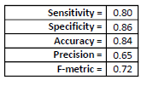

The performance measures indicate that the model is good, but the model needs improvement.

## Carl

I started out trying to get a feel for the way the data is shaped and looks. I ran frequency to variables (age, workclass, education, marital_status, occupation, relationship, race, sex, hours, income) with names to visualise what the demographic of the population is at (Appendix F. Figure 2). I then ran a histogram and a matrix scatterplot. These were not useful since the dependent variable is binary. Scatterplots revealed patterns, but this was expected since I re-coded the categorical variables. The boxplots, like the frequencies, revealed insight into the data (Appendix F. Figure 3) by comparing dIncome to age, dIncome toeducation_num, and dIncome to hours_per_week. I then tested the correlation, which showed no high correlation between any of the variables (Appendix F. Figure 4). I then performed a regression analysis even though my goal is to use binary logistic regression. My initial regression had all the variables, and I integrated two interaction terms (age*education_num dSex*dJob). SAS rejected them, so I ran another regression without them and tested multicollinearity. There was no issues with multicollinearity, and I think it helped that in my data cleaning stage I decided to only use education_num instead of also education, which I would have had to transform to dummy variables. I removed dWork because it had the highest p-value for testing purposes. Now I got to the Logistic regression model, where I also checked for outliers and influential points. I ended up removing 65 outliers based on the DFBeats. I was surprised how much data cleaning was required in this data set. I know that it should take up most of my time, and it did.

For model selection I chose to compare Stepwise and Backward, since they should get different results. However, both eliminated the same independent variables (dSex, dWork, and hours_per_week) (Appendix F. Figure 5). I then split the data into training and testing (60, 40). I fit the model based on Stepwise selection and where above $50,000 a year someone makes is the response. Running predictions showed significance to higher education and age as I predicted. The model passed goodness of fit and test performance, but was low R2 and difficult to fit into useful predictions. The accuracy was good, but the precision was low, and the most significant predictor I observed was education (Appendix F. Figure 6).

## Alice

In the data exploratory stage, I found that 75% of the observations made equal or less than 50k (Figure 1). The descriptive statistics showed that the median number of hours a person works (hours_per_week) in the dataset is 40 hours (Figure 2). The minimum and maximum for hours_per_week is 1 hour and 99 hours, respectively. This suggests that there will be outliers since the range is this large. The median age is 37 years old. The median number of years of education is 10 years. The box plot for d_income and age, shows that the median (44 years old) and mean (44 years old) for age are higher for people who make more than 50k that people who make less than 50k (Figure 3). The median and mode for people who make equal or less than 50k is 38 years old and 39 years old. This suggest that age will have a positive correlation with how much a person makes. The box plot for d_income and hours_per_week also seems to suggest a positive correlation between how many hours a week a person works and the amount of money they make (Figure 4). The mean for people who make over 50k is slightly higher than people who make less. The capital_gains and d_income box plot shows that the capital gains a person making over 50k has is severely skewed to the right (Figure 5). The mean for people making over 50k is higher which suggests that people who make over 50k have more capital gains. However, the box plot for capital_loss and d_income also shows that the mean for the amount of capital loss the people making over 50k experience is slightly more than the capital loss people making <=50 have which suggests that the people who make >50 also have more capital loss (Figure 6). The counts show that there are much more male observations than females (Figure 12). The counts for race shows that there are much more white people in the dataset than people of other races (Figure 11). The counts for race also show that white people have the highest ratio (0.36) of all the white people who make >50k and white people who make <=50k (Figure 10). Asian-Pac-Islander have the next highest ratio (0.27). The counts also show that most of the data has around nine years of education (Figure 7). Also, most of the data shows the people are working in private sectors than in any other sector (Figure 8).

I tried two interaction terms. One of the was thrown out by the model because it was not significant. I thought that age and education_num might have some correlation because as a person gets older, they go up a grade. So I grouped those two categories to predict who makes over 50k. However, this interaction term was thrown out of the model. So, I tried another interaction term: "interaction2.” This interaction term is between age and hours_per_week (how many hours a person works per week). Interaction2 was eventually found to be significant in the model selection process. Since my y-variable d_income is binary, I do not have to check for normality.

First I fit the full model and saw that the AIC and SC were 1382.100 and 1510.921, respectively (Figure 13). The AIC and SC should be minimized as much as possible. One way of doing this is to get rid of the insignificant predictors in the model which I do later on in the model selection process. The r-square is 0.3624 which should be maximized as much as possible. This means that 36.24% of the variation in the dataset is explained by the full model. The likelihood ratio test or goodness-of-fit test tells me to reject the null hypothesis that none of the predictors have a significant effect on d_income. This model is better than the null model with no covariates. The likelihood ratio (899.9606) is high, and the p-value associated with the likelihood ratio is almost 0 (<.0001). The likelihood ratio should be maximized as much as possible and the p-value associated with it should be as close to zero as much as possible.

After I checked the first model’s performance indicators, I checked the correlation matrix for multicollinearity (Figure 14). Any two variables’ correlation values above 0.9 should be flagged as having multicollinearity and should be studied further to see if action should be taken. Hours_per_week and age have a correlation value of 0.9168. However, action should not be taken because I made a interaction variable called interaction2 that is hours_per_week*age. This multicollinearity will not have adverse effects on the model; the p-value will not be affected. D_edu_secondary and d_edu_college have a correlation value of 0.9383, but no action should be taken because these are dummy variables that represent a categorical variable with three or more categories. This is the same deal with d_race_white and d_race_asian (0.9508). In the end, no action was taken over multicollinearity because of these reasons.

After the multicollinearity was reviewed, I checked for outliers and influential points. I checked the Pearson Residual graph and Deviance Residual graph for values that greater than three or less than three (Figure 15). There was one significant outlier (#1914) (Figure 31). The hours_per_week was 25 whereas the 25th percentile of hours_per_week is 40. The Pearson Residual graph indicated that there were outliers, but the Deviance Residual graph did not. Most of the outliers fell towards the end of the dataset. I did calculate the Dfbeta value to check for influential points (2/sqrt(2000) = 0.0447), but did not delete any influential points because all of the data for hours_per_week, age, education_num, capital_gains, capital_loss, and interaction2 are relevant to predicting what type of person makes over 50k (Figure 16-18). Also, the DfBeta graphs for the dummy variables can be ignored. I deleted the outliers.

Then, I fit my model again (Figure 19). AIC (1228.393) and SC (1356.947) decreased. R-square increased to 0.3942. The p-value associated with the likelihood ratio is still <.0001; the likelihood ratio (990.8429) increased. After I split the dataset into training and testing (75%, 25%), I executed the model selection process. I used all of the model selections that I could use for logistic regression: stepwise, backward, and forward. All three models were the same. They had the same variables, standard errors, r-square (0.3988), AIC (925.482), SC (967.896), likelihood ratio (754.5484), p-value associated with the likelihood ratio (<.0001) (Figure 20-22). Then, the full model (M1) was fitted again and outliers were handled (Figure 23-25). The final model’s r-square (0.415) is better than the original model’s. The AIC (865.474) and SC (906.829) has also lowered quite a bit. The likelihood ratio (789.2297) has decreased compared to the original model’s likelihood ratio, but the p-value associated with the likelihood ratio (<.0001) is still almost 0.

Then, I produced the classification matrix to calculate the sensitivity/recall, accuracy, precision, specificity, and f-metric values to compare M1 (the model discussed above) and M2 (Figure 29-30). M2 is another model that I produced by changing a few things. Several independent variables that were a direct copy of each other. For example, education and num_of_edu are a direct copy of each other. So, I deleted education from the model from the beginning. I also used different groupings for dummy variables, seed number, and different handling on outliers and influential points (deleting influential points) to try to improve M1. For, M2 I used several references. For M1, the sensitivity/recall (88%) accuracy (78%), precision (49%), specificity (75%), and f-metric (63%) values in general were better/larger than M2’s the sensitivity/recall (89%) accuracy (73%), precision (42%), specificity (69%), and f-metric (57%) values with the exception of sensitivity/recall. Therefore, M1 is the best model. The sensitivity/recall (88%) means that when the person actually makes >50k, M1 predicts that a person will make >50k correctly 88% of the time. The specificity (75%) means that when the person actually makes <=50k, M1 predicts that a person will make <=50k correctly 75% of the time. The accuracy (78%) means that overall in classifying whether a person will make >50k or not, M1 will predict the right income for the person 78%. The precision (49%) means that when M1 classifies that the person will make >50k, it will be correct 49%. The closer these five values are to 100%, the better the model is. The precision is a little low.

Calculations:

M1

Sensitivity/Recall = 91/(91+12) = 88%

Accuracy = (91+295)/(91+295+96+12)= 78%

Precision = 91/(91+96) = 49%

Specificity = 295/(295+96)= 75%

F-metric = 2(0.49*0.88)/(0.49+0.88)= 63%

M2

Sensitivity/Recall = 71/(71+9) = 89%

Accuracy = (71+222)/(71+222+98+9) = 73%

Precision = 71/(71+98) = 42%

Specificity = 222/(222+98) = 69%

F-metric = 2(0.42*0.89)/(0.42+0.89) = 57%

I calculated two predictions. For the first one, I predicted the probability of a person making >50k if they have these certain attributes: number of education (10), amount of capital gains ($3000), amount of capital loss ($1000), married, white, lives in the U.S, 36 years old, and works 40 hours per week (Figure 27). The probability of a person making >50k with these attributes is 0.71523. 95% of the time, the predicted probability will fall within 0.59789 and 0.80926. For the second one, I predicted the probability of a person making >50k if they have these certain attributes: number of education (9), amount of capital gains ($2000), amount of capital loss ($0), not married, other race, does not live in the U.S, 26 years old, and works 38 hours per week (Figure 28). The probability of a person making >50k with these attributes is 0.00326. 95% of the time, the predicted probability will fall within 0.00120 and 0.00881.

Model Equation (Figure 26):

Log(d_income = 1/d_income = 0) = -11.6287 + 0.4507education_num + 0.000442capital_gains + 0.000671capital_loss + 2.9383d_marital + 0.5097d_race_white + 1.1912d_country + 0.000977interaction2

When d_marital = 1, d_race_white = 1, d_country = 1

The odds of a person making >50k increases by 56.9% ( (exp(0.4507) -1) * 100 ) when number of years of education he or she has increases by one.

The odds of a person making >50k increases by 0.04% ( (exp(0.000442) -1) * 100 ) when the amount of capital gain he/she has increases by one.

The odds of a person making >50k increases by 0.07% ( (exp(0.000671) -1) * 100 ) when the amount of capital loss he/she has increases by one.

The odds of a person making >50k increases by 1788.4% ( (exp(2.9383) -1) * 100 ) if he/she is married and not single (base case).

The odds of a person making >50k increases by 66.5% ( (exp(0.5097) -1) * 100 ) if he/she is white and not other (base case).

The odds of a person making >50k increases by 229.1% ( (exp(1.1912) -1) * 100 ) if he/she is from the U.S and not from any of the other countries (base case).

The odds of a person making >50k increases by 0.07% ( (exp(0.000977) -1) * 100 ) when his/her age increases by one and the amount of hours he/she works per week is held constant, and vise versa.

The most influential predictor of Model 1 is capital_gains because it has the highest standardized estimate (2.4421). d_marital is the next strongest predictor with a standardized estimate of 0.8100.

The null hypothesis can be rejected because the p-value associated with the likelihood ratio (<.0001) is very close to 0.

H1 is correct. The more education a person has, the greater their chances are of making >50k

H2 is incorrect. Single people do not have a greater chance of making >50k than their married counterparts.

# Future Work

## Amy

In conclusion, the final model needs a great deal of performance improvement. The model suggests that education and occupation are the most significant contributors to determining how many hours a person works per week. Performance may be improved by grouping the education and occupation variables differently. For example, jobs in the technical field could all be counted the same, or even broken down by job-sector class like “white collar” and “blue collar”. I also think further research into income trends throughout time would help us create a better model.

An entire other area of research can could influence the hours worked per week is geographical area. This model did not include any native country variables as a predictor, so where a person comes from must not be as important as other life factors. One of these factors could be where they live, ie. suburb vs city. In 1997, the median family income was higher in the suburbs in the city (Levy, 1998) leaving questions of how hard or how much per week one has to work to earn a living wage in these different geographical regions.

## Jenny

In conclusion, the final logistic model seems to have a decent performance on the test set, but it still has outliers and influential points, high AIC and SC values, and a low r-square value. Its performance could be improved upon in the future. There seem to be more significant independent variables missing from the analysis since the model has low explanatory power, even though all of the variables it contains are significant. Two of the significant variables, capital gain and capital loss, also seem to have a very small effect on the dependent variable despite the former's high standardized estimate. More domain research should be conducted to explore other viable independent variables.

Modeling techniques not covered in this class could be more suitable for the dataset, as indicated by the results of a paper which compared logistic regression to the performance of a naïve Bayes, and a decision tree model. The paper claims that the decision tree model had the highest accuracy, with a test error of 14.778% (Lemon 2015). Considering that the logistic regression model was the best fit in this class for a binary dependent variable and several logistic models were analyzed and considered, the results of this paper are a good starting point for future exploration of more advanced models.

## Danyang

My final model is not great since the adjusted-R square is very low (0.1624 of my model and 0.1819 of the hybrid model). The future work is to study other resources to know which aspects have greater influence on the working hours. Hours per hour may relate to personality, confidence level, power of execution, market fluctuation and even company’s policy. Hence, Hours per hour may be simultaneously influenced by national and personal aspects. Although they are assumed by my personal experience, I need to do more research on this topic.

## Persid

Future work could be made in terms of getting more details in the dataset, like the location of each person, or if the person owns a business vs. being employed.

## Alice

The final model’s r-square (0.415) is a little low and could be improved. The AIC (865.474) and SC (906.829) is still a bit high. The p-value associated with the likelihood ratio (<.0001) looks good though. This model could be improved if the data was not so skewed. Gathering more data on females, other races other than white people, more people who have different educational levels other than around 9 years of education, and people from other countries besides the U.S. Also, gathering more data about people who do not work in the private sector would benefit the model as well. So, to improve the model, more data should be gathered.

## Carl

There is a lot of future work needed. Since the data has a high frequency in white males in America, demographics could be explored more. Even though I did a lot of data cleaning, more will probably increase diagnostics. Also breaking down the categorical variables to sections that make more sense would benefit the model. So basically more data from a wider range of income situations would help in the future.

# References

UCI Machine Learning. 2016. *Adult Census Income*. Available at:

<https://www.kaggle.com/uciml/adult-census-income>. Accessed 1 May 2018.

## Amy

Classora. 2016. *Ranking of the World's Richest Countries by GDP (1994).* Available at:

<http://en.classora.com/reports/t24369/ranking-of-the-worldsrichest-countries-by-gdp?edition=1994>. Accessed 23 May 2018.

Hartmann, Heidi. 2005. *The gender wage gap is real.* Available at:

<https://www.epi.org/publication/webfeatures_snapshots_20050914/>. Accessed 30 May 2018.

Levy, Frank, and Nicholas Lemann. 1998*. New Dollars and Dreams, The: American Incomes in the*

*Late 1990s.* New York, NY: Russell Sage Foundation.

Roubinchtein, Alex; Nimmo, Bruce. 2017. *2017 Employment Projections Technical Report.*

Washington. Available at:

<https://fortress.wa.gov/esd/employmentdata/docs/industry-reports/2017-employment-projections-technical-report.pdf>. Accessed 3 June 2018.

Rones, Phillip L, et al. “Trends in Hours of Work Since the Mid-1970s.” *Monthly Labor Review*,

1997, pp. 1–3., <https://stats.bls.gov/opub/mlr>. Accessed 1 June 2018.

## Jenny

Borjas, George. 1987. "Self-selection and the earnings of immigrants". *NBER Working Paper Series.* 2248.

Devroy, Dan and Freeman, Richard. 2009. "Does Inequality in Skills Explain Inequality in Earnings Across Advanced Countries?" *NBER Working Paper Series*. 8140.

Martins, Pedro, and Pereira, Pedro. 2003. "Does education reduce wage inequality? Quantile regression evidence from 16 countries." *Labour Economics*. 11: 355-371.

SAS Institute. 2010. Simple Random Sampling. *SAS/STAT(R) 9.22 User's Guide.* https://support.sas.com/documentation/cdl/en/statug/63347/HTML/default/viewer.htm#statug_surveyselect_sect003.htm. Accessed June 1, 2018.

Lemon, Chet, Zezalo, Chris, and Mulakalu, Kesav. 2015. "Predicting if income exceeds $50,000 per year based on 1994 US Census Data with Simple Classification Techniques." *University of San Diego Computer Science and Engineering*. https://cseweb.ucsd.edu/~jmcauley/cse190/reports/sp15/048.pdf. Accessed June 1, 2018.

## Danyang

# Arthur L. Stinchcombe. 1983. *Economic Sociology*: 173.

Ron Cody. 2007. *Learning SAS® by Example: A Programmer's Guide*:200 Cary, NC:SAS Institute Inc.

Dennis J. Beal, Science Applications International Corporation, Oak Ridge, TN. *SAS Code to Select the Best Multiple Linear Regression Model for Multivariate Data Using Information Criteria*

## Persid

Hartmann, Heidi. 2005. *The gender wage gap is real.* Available at:

<https://www.epi.org/publication/webfeatures_snapshots_20050914/>.

## Alice

Carmignani, Fabrizio. 29 May 2018. “Does Government Spending on Education Promote

Economic Growth?” *The Conversation*, The Conversation,

theconversation.com/does-government-spending-on-education-promote-economic-growth-60229. Accessed May 30, 2018.

Gillett, Rachel. 8 July 2016. “7 Ways Being Single Makes You More Successful.” *Business*

*Insider*, Business Insider,

[www.businessinsider.com/how-being-single-makes-you-more-successful-2016-7#single-](http://www.businessinsider.com/how-being-single-makes-you-more-successful-2016-7#single-men-tend-to-work-fewer-hours-than-married-men-6)

[men-tend-to-work-fewer-hours-than-married-men-6](http://www.businessinsider.com/how-being-single-makes-you-more-successful-2016-7#single-men-tend-to-work-fewer-hours-than-married-men-6). Accessed May 30, 2018.

## Carl

Ron Cody. 2007. *Learning SAS® by Example: A Programmer's Guide*:200 Cary, NC:SAS Institute Inc.

# Arthur L. Stinchcombe. 1983. *Economic Sociology*: 173.

Carmignani, Fabrizio. 29 May 2018. “Does Government Spending on Education Promote

Economic Growth?” *The Conversation*, The Conversation,

theconversation.com/does-government-spending-on-education-promote-economic-growth-60229. Accessed May 30, 2018.

# Appendix A - Amy

## Appendix A.1 - non SAS Code

Preprocessing R Studio Code:

First I loaded the data into R Studio using File > Import Dataset. The name of data is “adult”. Then I began to refine with the following code:

> adult50K = adult[adult$workclass != "?",]

> adult50K = adult50K[adult50K$native.country != "?",]

> adult50K = adult50K[adult50K$income == ">50K",]

(2000/7508 * 100 = 26.6 %, so I'll use 27 percent to get a random sample over 2000 as per the extra credit)

> smp_size <- floor(0.27 * nrow(adult50K))

> set.seed(7853926)

> train_ind <- sample(seq_len(nrow(adult50K)), size = smp_size)

> train <- adult50K[train_ind,]

Then I saved the cleaned up data set named “train” in order to begin analyzing in SAS.

## Appendix A.2 - Relevant Output

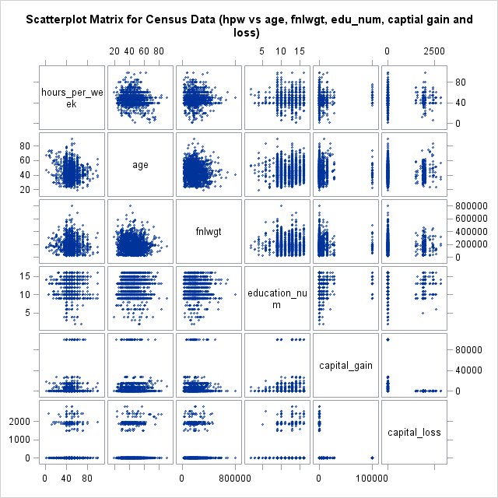

*Figure 1. Scatter plot matrix*

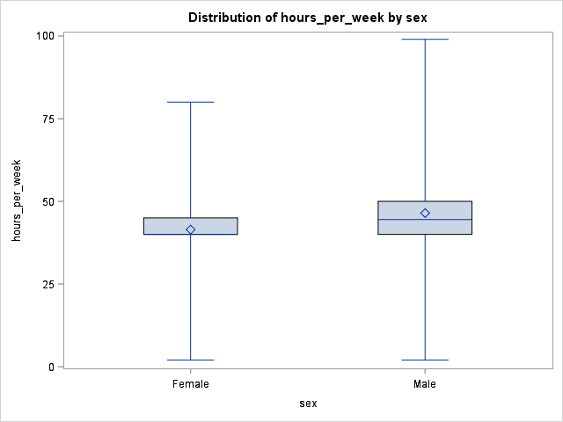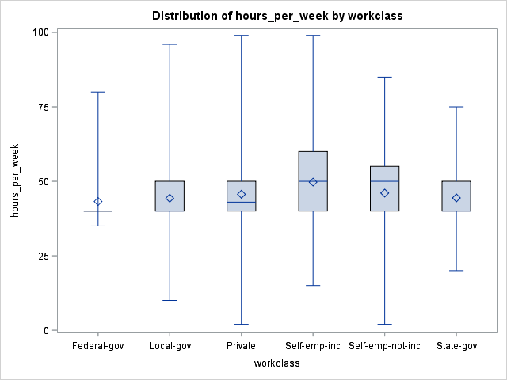

*Figure 2. Boxplot, hours-per-week vs sex Figure 3. Boxplot, hours-per-week vs workclass*

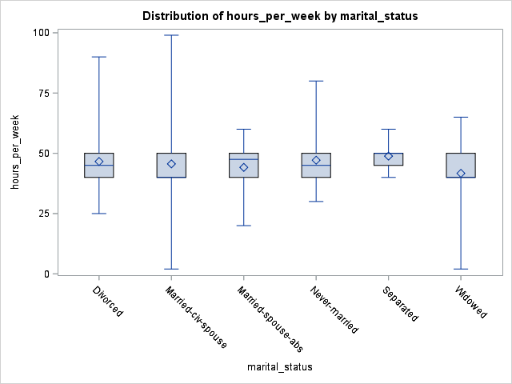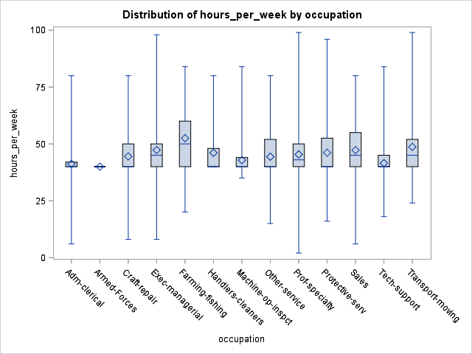

*Figure 4. Boxplot, hours-per-week vs marital-status Figure 5. Boxplot, hours-per-week vs occupation*

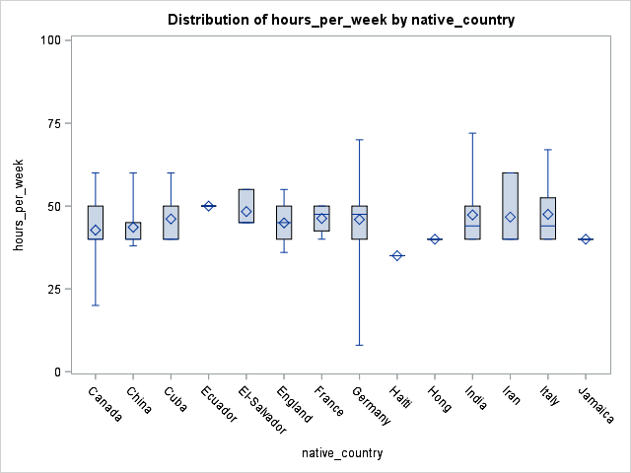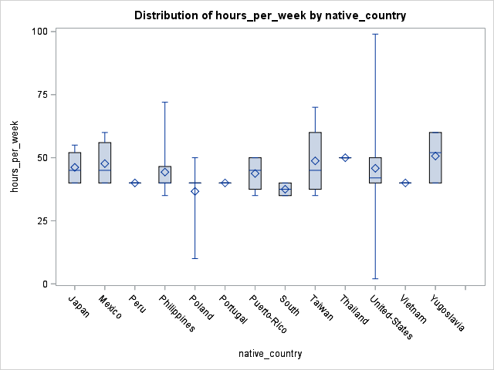

*Figure 6. Boxplot, hours-per-week vs native-country Figure 7. Boxplot, hours-per-week vs native-country pt 2*

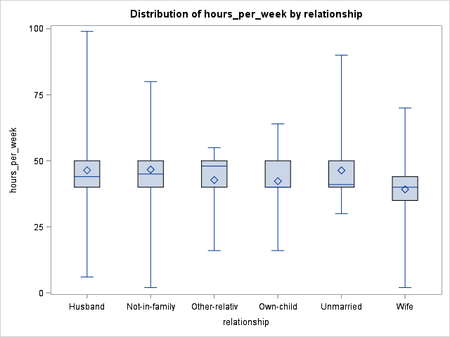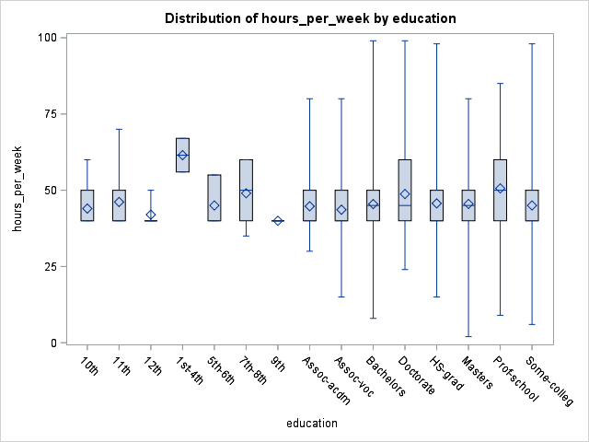

*Figure 8. Boxplot, hours-per-week vs relationship Figure 9. Boxplot, hours-per-week vs education*

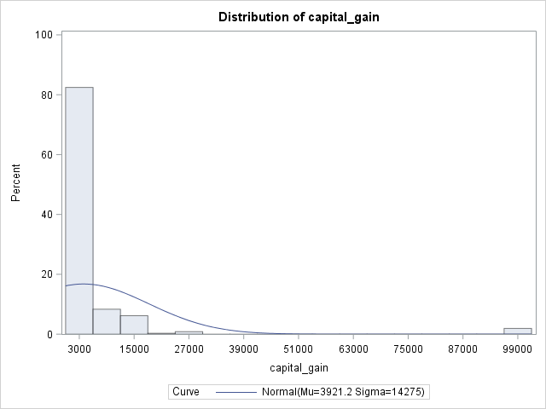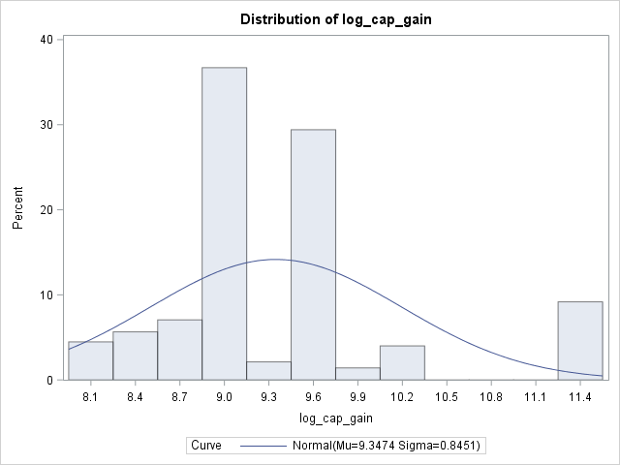

*Figure 10. Histogram of skewed capital gains Figure 11. Histogram of log transformed capital gains*

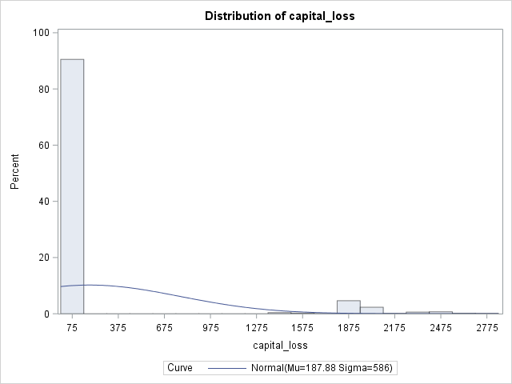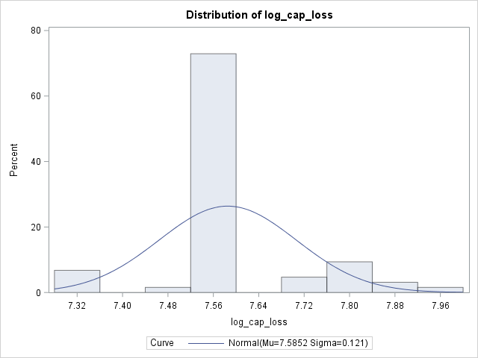

*Figure 12. Histogram of skewed capital loss Figure 13. Histogram of log transformed capital loss*

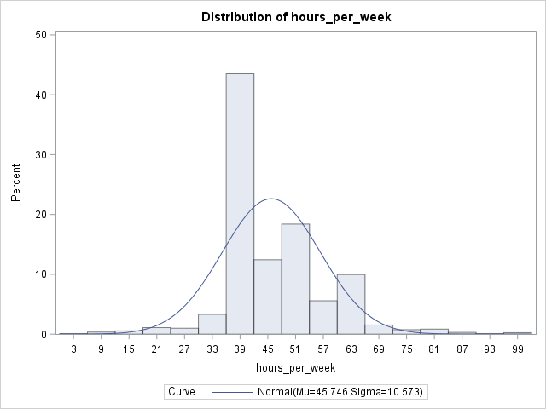

*Figure 14. Histogram of dependent variable, hours per week worked*

##### Residual Plots:

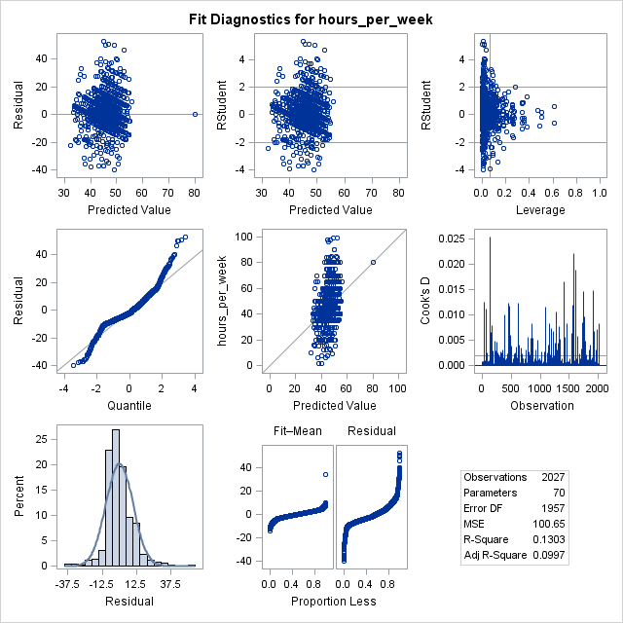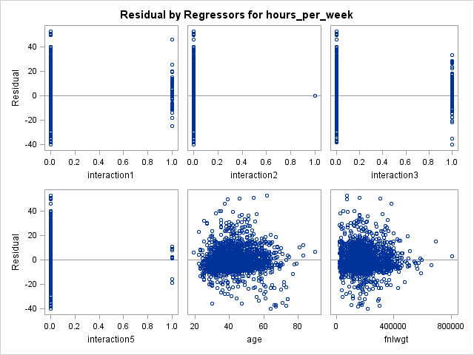

*Figure 15. Figure 16.*

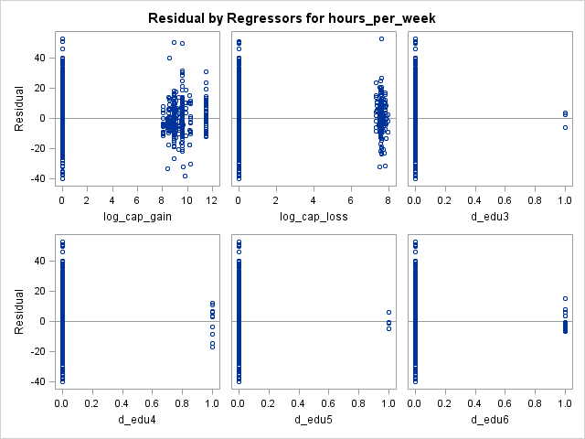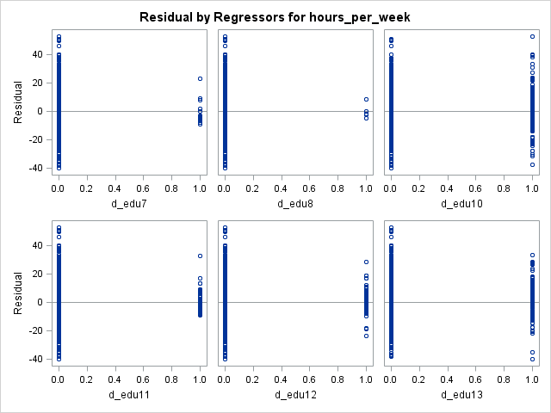

*Figure 17. Figure 18.*

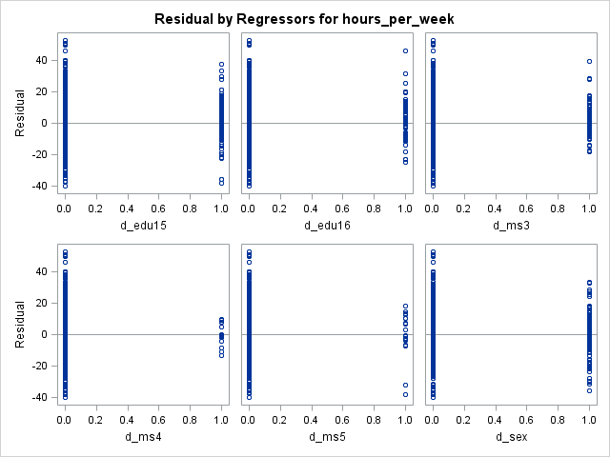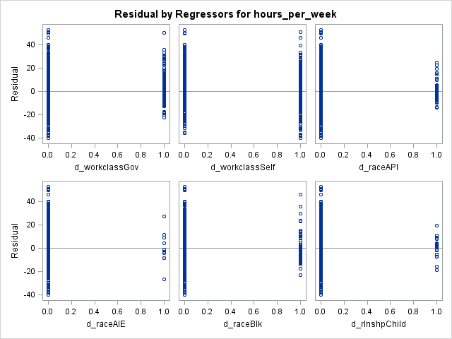

*Figure 19. Figure 20.*

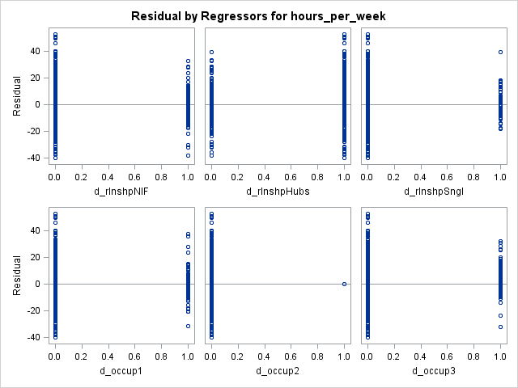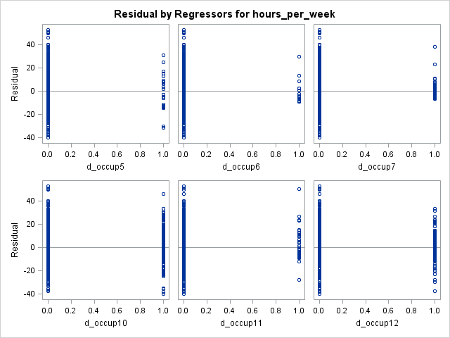

*Figure 21. Figure 21.*

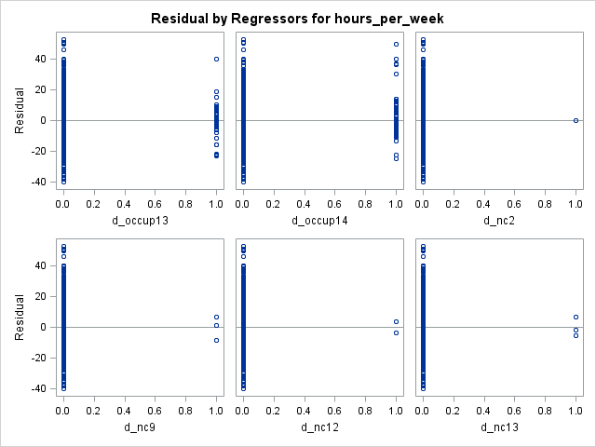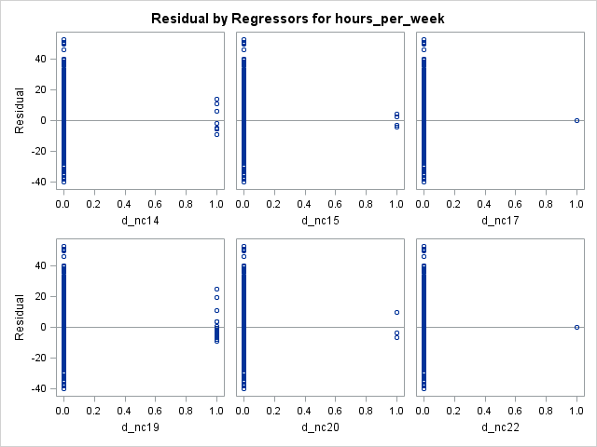

*Figure 22. Figure 23.*

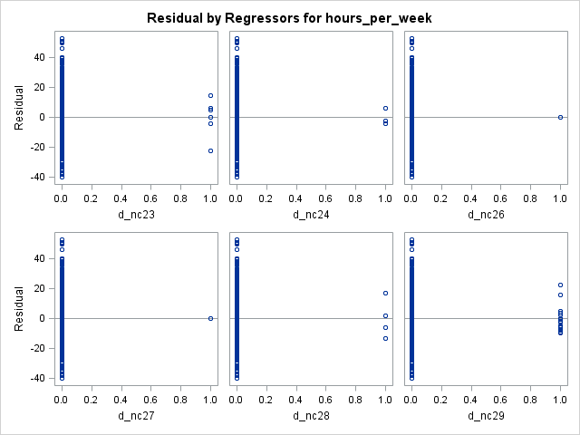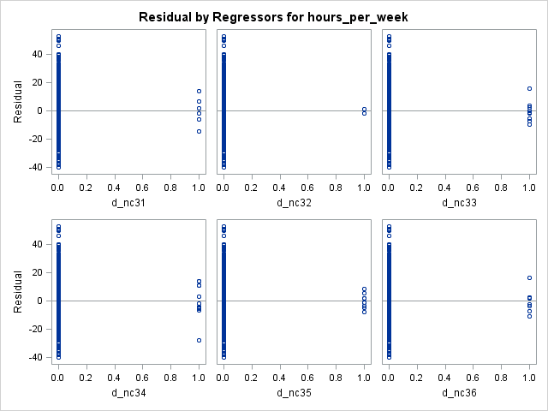

*Figure 24. Figure 25.*

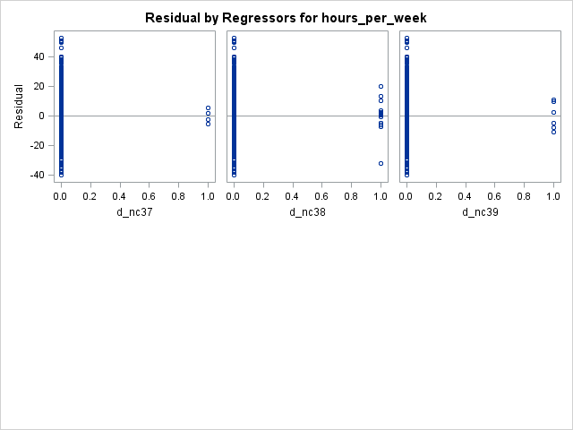

*Figure 26.*

|  |  |  |  |
| --- | --- | --- | --- |
| *Table 1. Dummy Variables* | | | |
| Original Variable | Dummy Variable | Original Variable | Dummy Variable |
| Workclass | | Relationship | |
| Private | 0 (base) | Other-relative | 0 (base) |
| Local-gov, Federal-gov, State-gov | d_workclassGov | Wife | d_rlnshipWife |
| Self-emp-inc, Self-emp-not-inc | d_workclassSelf | Own-child | d_rlnshpChild |
| Without-pay | d_workclassNoPay | Husband | d_rlnshpHubs |
| Never-worked | d_workclassNeverWork | Not-in-family | d_rlnshpNIF |
| Race | | Unmarried | d_rlnshpSngl |
| White | d_raceWht | Education | |
| Asian-Pac-Islander | d_raceAPI | Preschool | d_edu1 |
| Amer-Indian-Eskimo | d_raceAIE | 1st-4th | 0 (base) |
| Black | d_raceBlk | 5th-6th | d_edu3 |
| Other | 0 (base) | 7th-8th | d_edu4 |
| Sex | | 9th | d_edu5 |
| Male | 0 (base) | 10th | d_edu6 |
| Female | d_sex | 11th | d_edu7 |
| Occupation | | 12th | d_edu8 |
| Adm-clerical | d_occup1 | HS-grad | d_edu9 |
| Armed-Forces | d_occup2 | Some-college | d_edu10 |
| Craft-repair | d_occup3 | Assoc-acdm | d_edu11 |
| Exec-managerial | d_occup4 | Assoc-voc | d_edu12 |
| Farming-fishing | d_occup5 | Prof-school | d_edu13 |
| Handlers-cleaners | d_occup6 | Bachelors | d_edu14 |
| Machine-op-inspect | d_occup7 | Masters | d_edu15 |
| Other-service | 0 (base) | Doctorate | d_edu16 |
| Priv-house-serv | d_occup9 |  |  |
| Prof-specialty | d_occup10 |  |  |
| Protective-serv | d_occup11 |  |  |
| Sales | d_occup12 |  |  |
| Tech-support | d_occup13 |  |  |
| Transport-Moving | d_occup14 |  |  |

*Table 2: Dummy variables for native-country by increasing GDP*

|  |  |  |
| --- | --- | --- |
| *country* | *gdp* | *dummy variable* |
| *Laos* | *1,543,606,400* | *d_nc1* |
| *Haiti* | *2,378,749,950* | *d_nc2* |
| *Cambodia* | *2,791,000,000* | *d_nc3* |
| *Nicaragua* | *2,977,433,090* | *d_nc4* |
| *Honduras* | *3,432,356,610* | *d_nc5* |
| *Jamaica* | *4,938,132,500* | *d_nc6* |
| *Trinadad&Tobago* | *4,947,206,100* | *d_nc7* |
| *Outlying-US(Guam-USVI-etc)* | *6,193,000,400* | *d_nc8* |
| *El-Salvador* | *8,085,554,200* | *d_nc9* |
| *Dominican-Republic* | *10,927,265,800* | *d_nc10* |
| *Guatemala* | *12,983,235,600* | *d_nc11* |
| *Vietnam* | *16,286,434,300* | *d_nc12* |
| *Ecuador* | *18,581,907,500* | *d_nc13* |
| *Cuba* | *28,450,000,000* | *d_nc14* |
| *Puerto-Rico* | *39,690,600,000* | *d_nc15* |
| *Hungary* | *41,521,517,000* | *d_nc16* |
| *Peru* | *44,909,998,000* | *d_nc17* |
| *Ireland* | *55,417,197,000* | *d_nc18* |
| *Philippines* | *64,084,541,000* | *d_nc19* |
| *Iran* | *67,128,218,000* | *d_nc20* |
| *Columbia* | *81,709,449,000* | *d_nc21* |
| *Portugal* | *95,332,368,000* | *d_nc22* |
| *Poland* | *98,515,952,000* | *d_nc23* |
| *Yugoslavia* | *120,100,000,000* | *d_nc24* |
| *Greece* | *128,788,201,000* | *d_nc25* |
| *Hong* | *135,542,440,000* | *d_nc26* |
| *Thailand* | *144,526,557,000* | *d_nc27* |
| *Taiwan* | *256,438,000,000* | *d_nc28* |
| *India* | *323,506,143,000* | *d_nc29* |
| *Holand-Netherlands* | *351,190,221,000* | *d_nc30* |
| *Mexico* | *421,725,045,000* | *d_nc31* |
| *South Korea* | *423,434,453,000* | *d_nc32* |
| *China* | *559,225,900,000* | *d_nc33* |
| *Canada* | *564,494,010,000* | *d_nc34* |
| *United Kingdom(Eng + Scot)* | *1,042,206,950,000* | *d_nc35* |
| *Italy* | *1,053,924,260,000* | *d_nc36* |
| *France* | *1,364,286,370,000* | *d_nc37* |
| *Germany* | *2,146,293,780,000* | *d_nc38* |
| *Japan* | *4,760,416,600,000* | *d_nc39* |
| *United-States* | *7,017,500,000,000* | *0 (base)* |

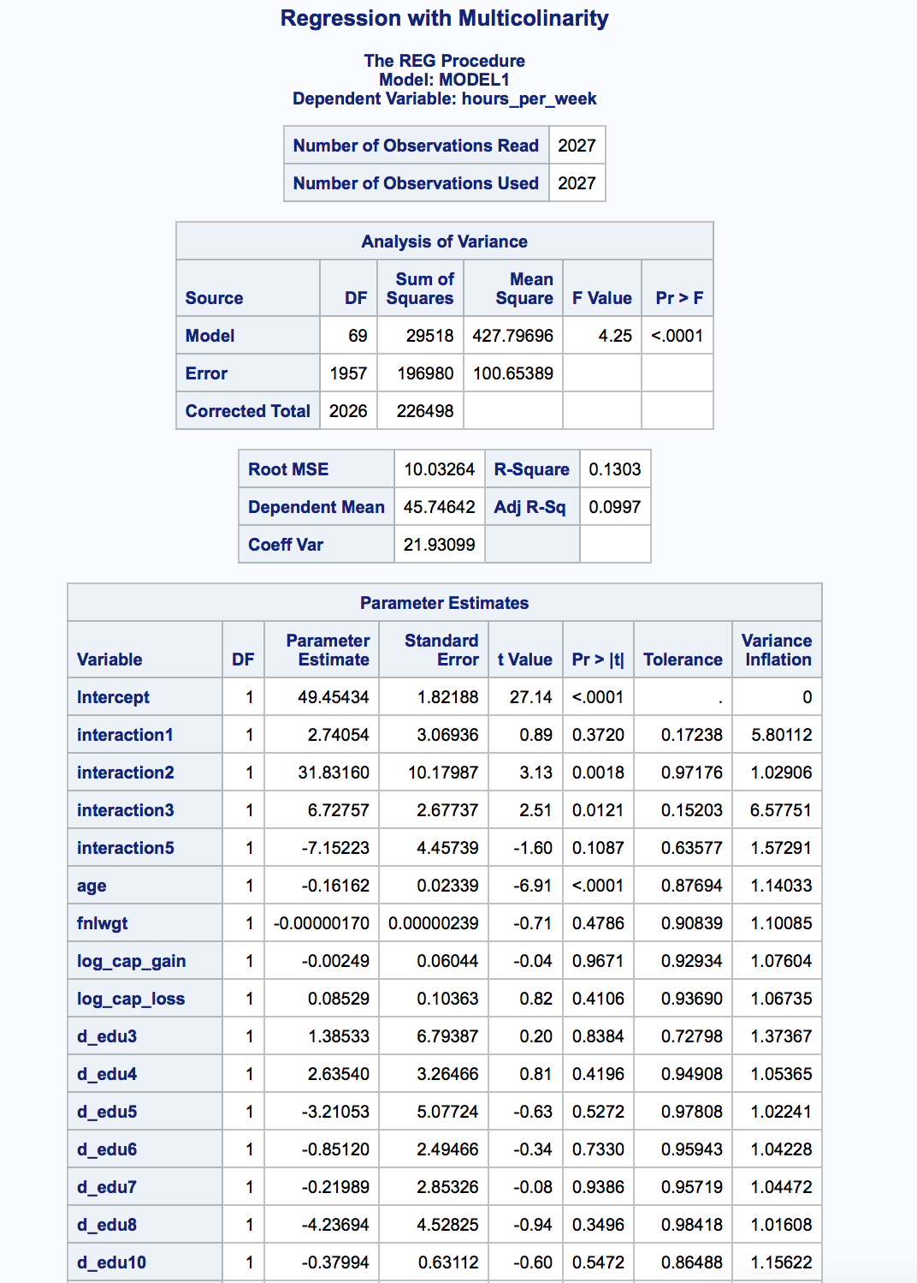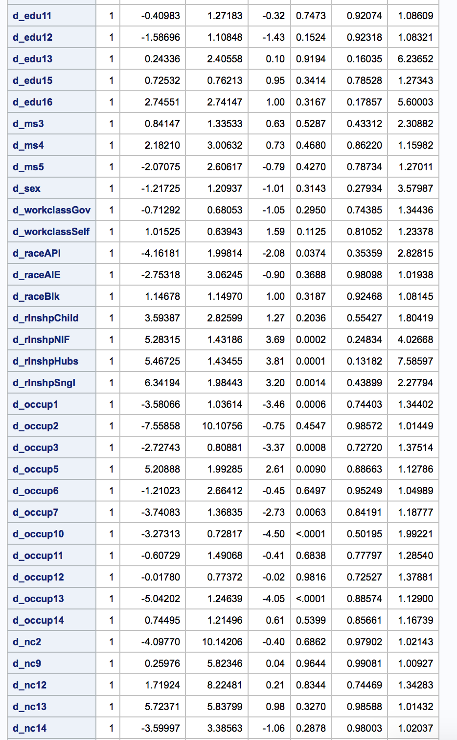

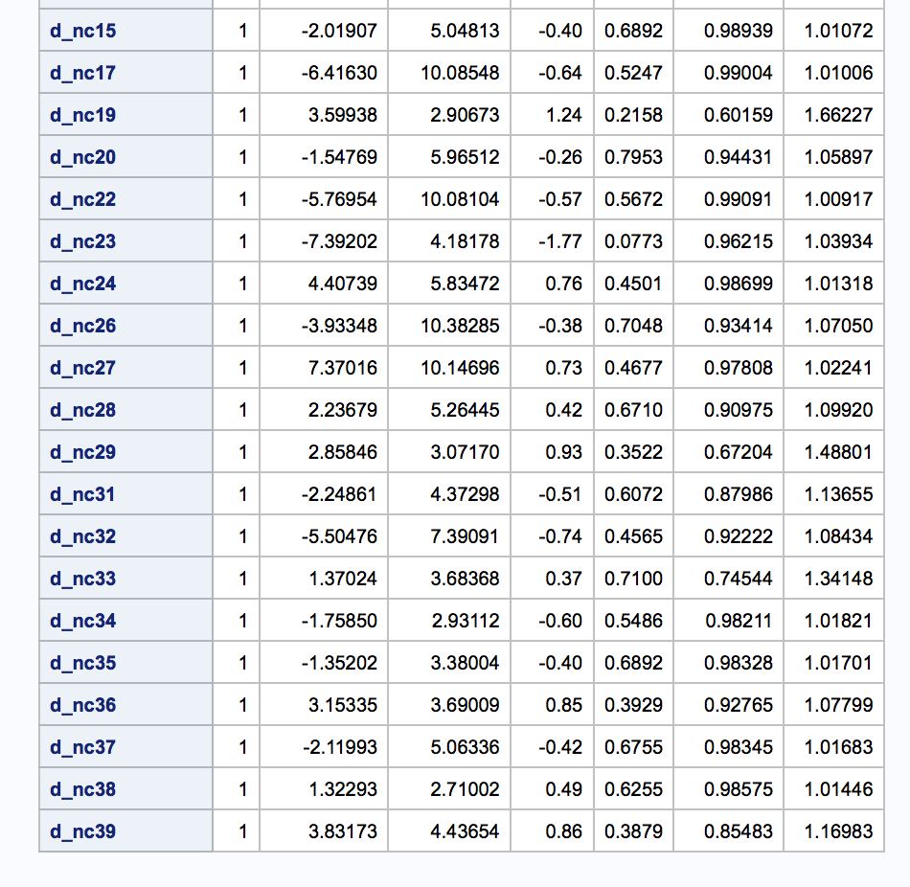

*Figure 27. Regression analysis after analyzing for multicollinearity was finished*

|  |  |  |  |
| --- | --- | --- | --- |
| *Table 3. Model comparison* | | | |
|  | Training | | |
|  | Model 1 | Model 2 | Model 3 |
| RMSE | 9.95023 | 9.98377 | 9.9856 |
| R2 | 0.1253 | 0.1194 | 0.1191 |
| adjR2 | 0.1171 | 0.1131 | 0.1109 |
| GOF | ok | ok | ok |
| residuals | ok | ok | ok |

|  |  |  |  |
| --- | --- | --- | --- |
| *Table 4. Model comparison* | | | |
|  | Testing | | |
|  | Model 1 | Model 2 | Model 3 |
| RMSE | 10.1650 | 10.1934 | 10.2748 |
| MAE | 7.47623 | 7.54007 | 7.62972 |
| R2 | 0.0733 | 0.0682 | 0.0581 |
| adjR2 | 0.0647 | 0.0595 | 0.0493 |
| CV | 0.052 | 0.0512 | 0.061 |
| N | 1521 | 1521 | 1521 |
| K | 14 | 14 | 14 |

# 

*Figure 28. Final Linear Regression Model Output.*

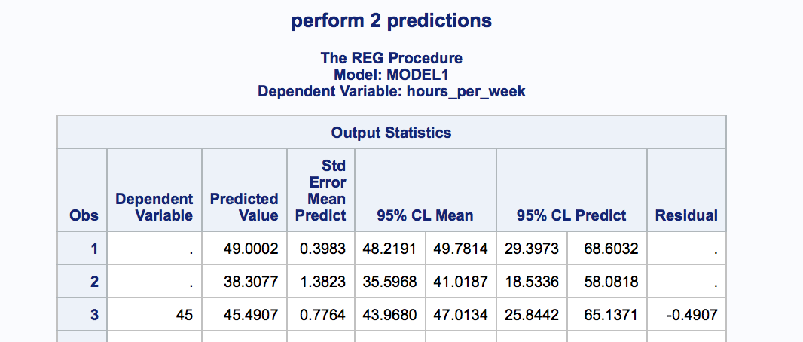

*Figure 29. Prediction output*

# Appendix B - Jenny

Figures

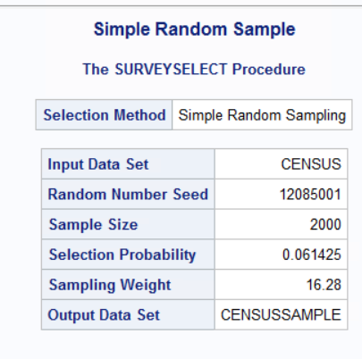

*Figure 1*. Random sample of 2000 observations with a seed of 12085001.

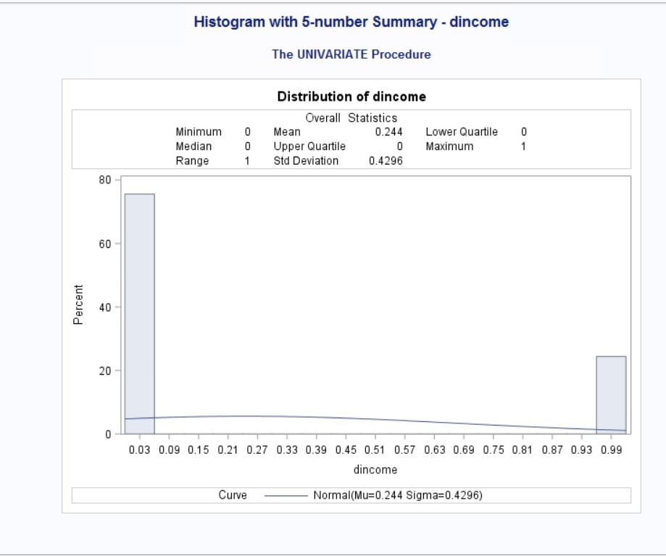

*Figure 2*. Histogram with 5-number summary

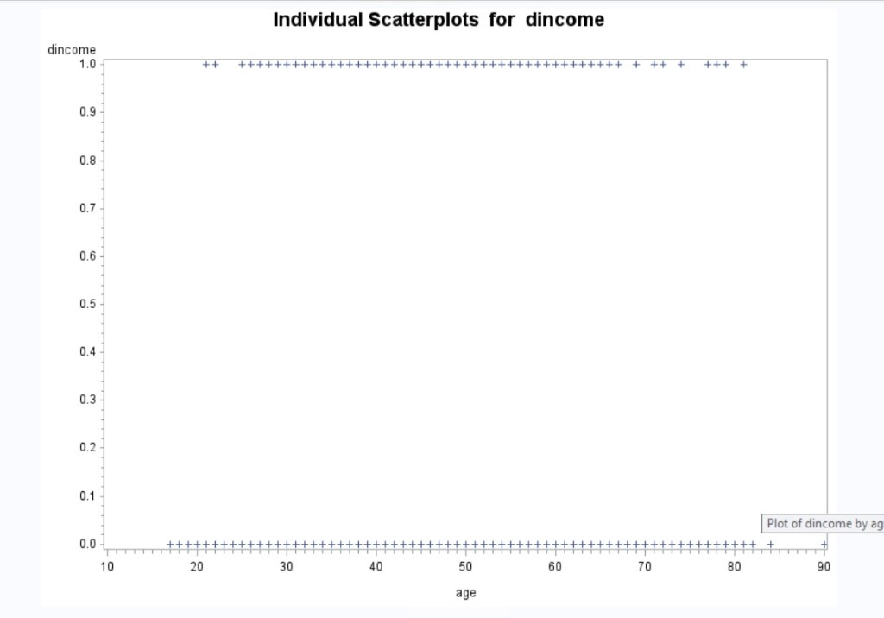

*Figure 3*. Scatterplot of dincome by age

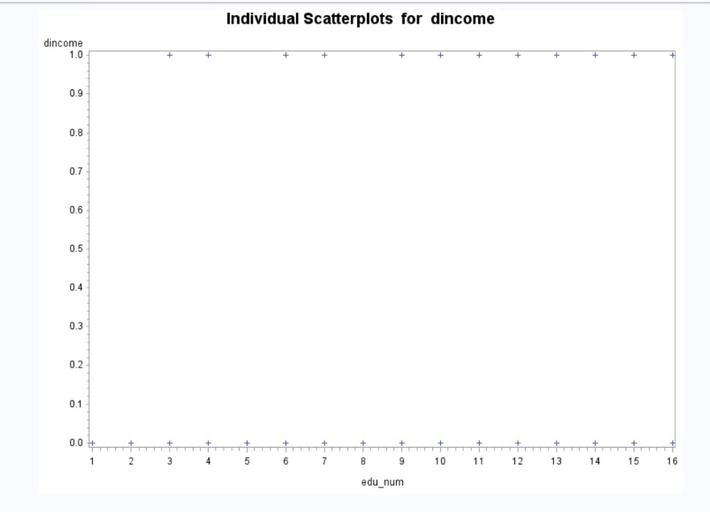

*Figure 4.* Scatterplot of dincome by edu_num

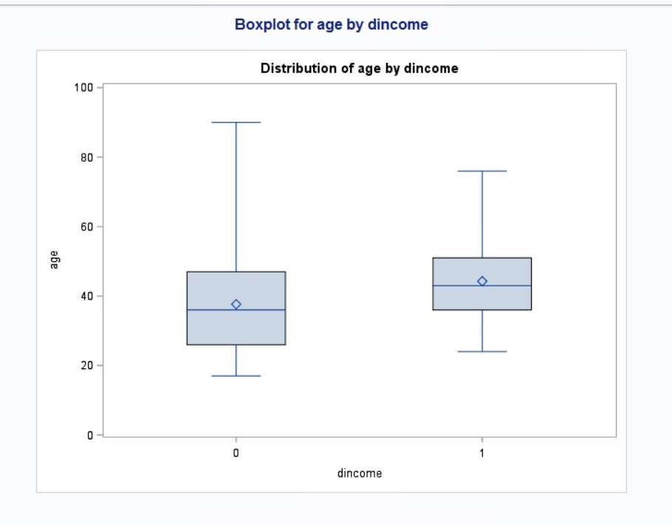

*Figure 5.* Boxplot of age by dincome

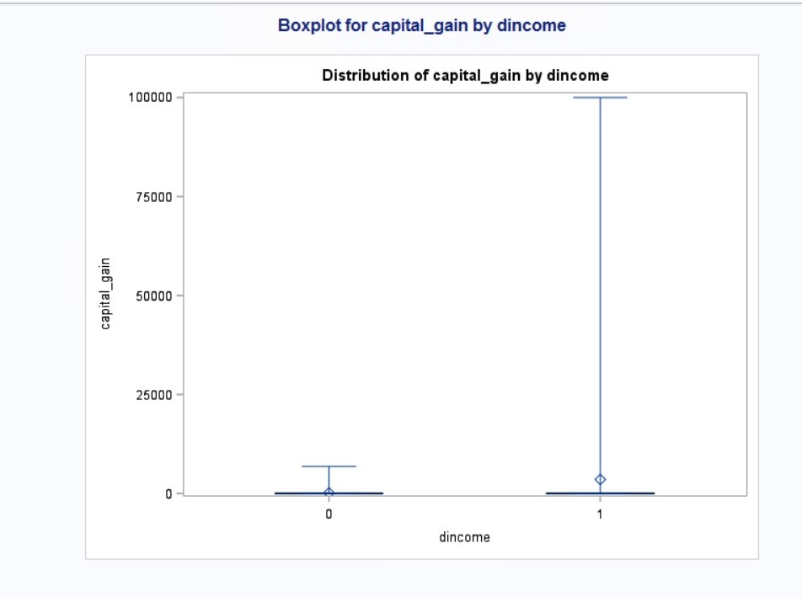

*Figure 6*. Boxplot of capital_gain by dincome

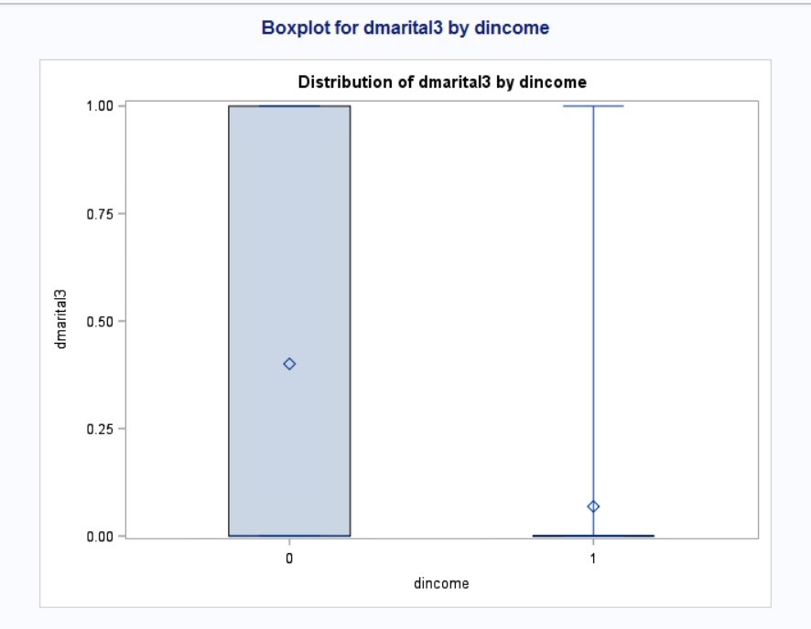

*Figure 7*. Boxplot of dmartial3 by dincome

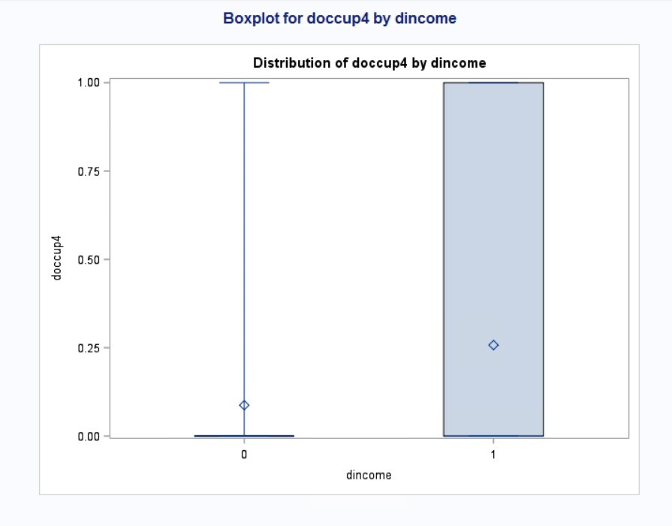

*Figure 8*. Boxplot of doccup4 by income

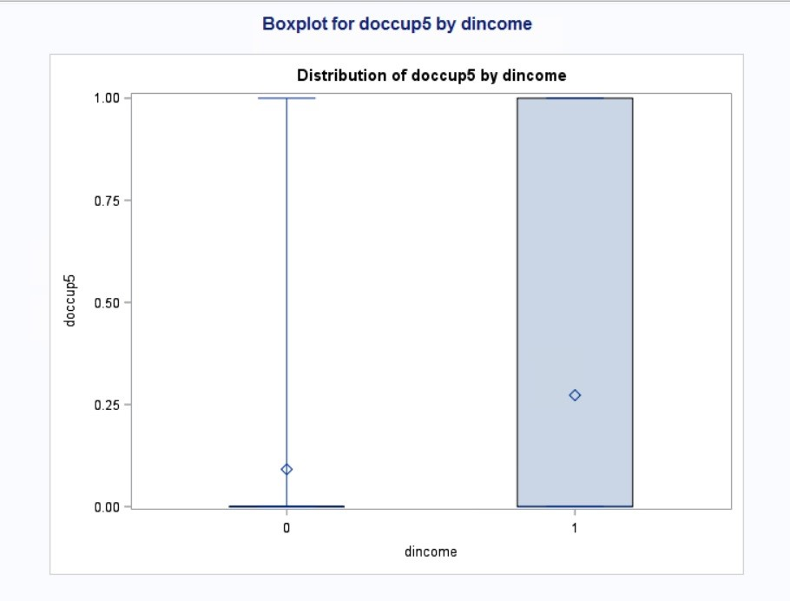

*Figure 9*. Boxplot of doccup5 by income.

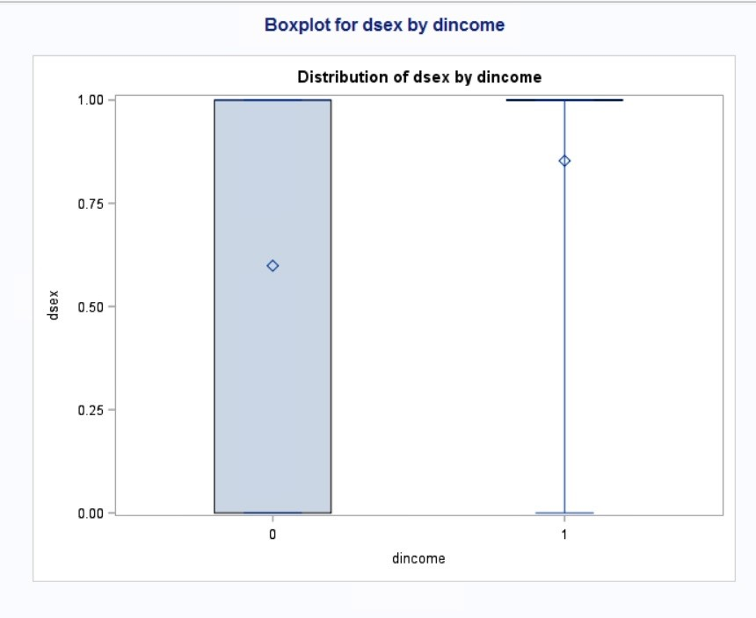

*Figure 10*. Boxplot of dsex by dincome

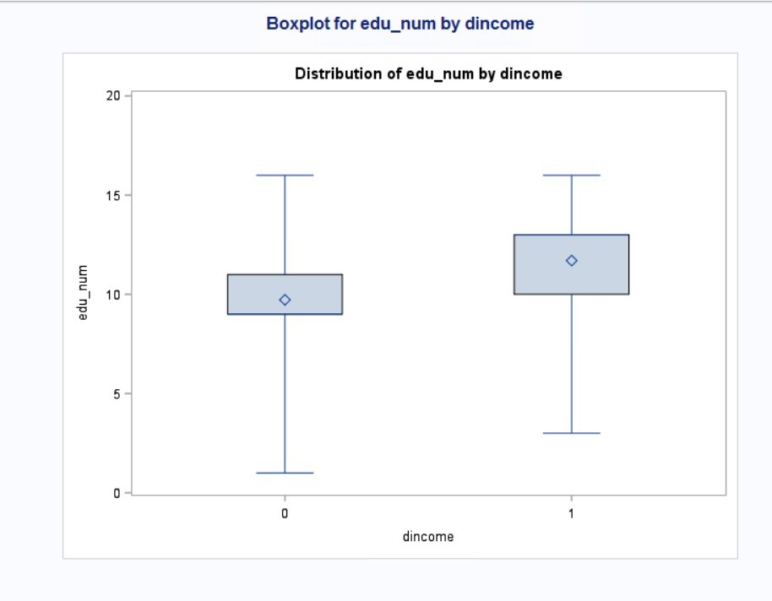

*Figure 11*. Boxplot of edu_num by dincome

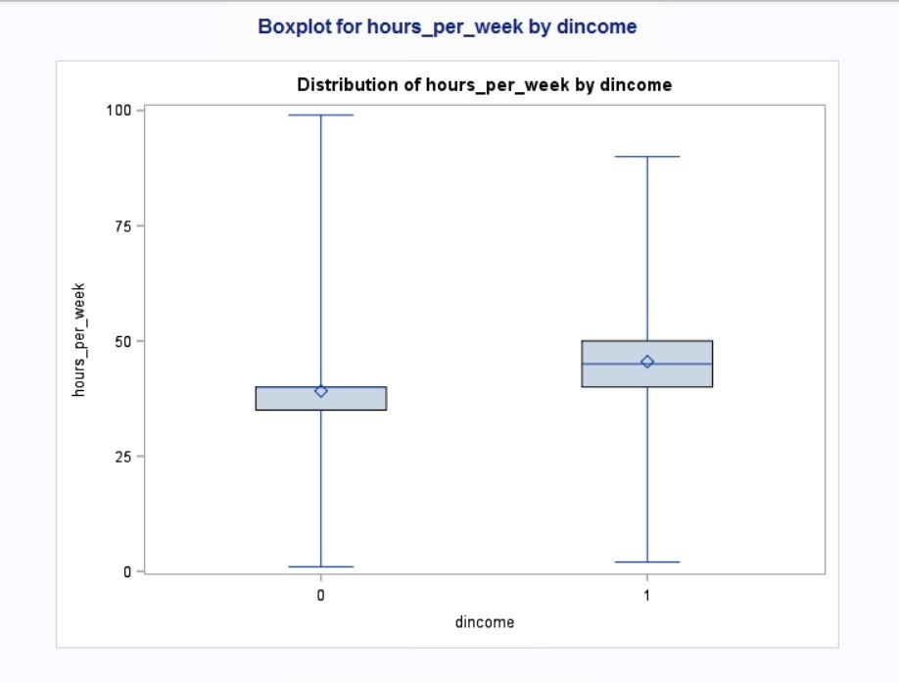

*Figure 12*. Boxplot of hours_per_week by dincome

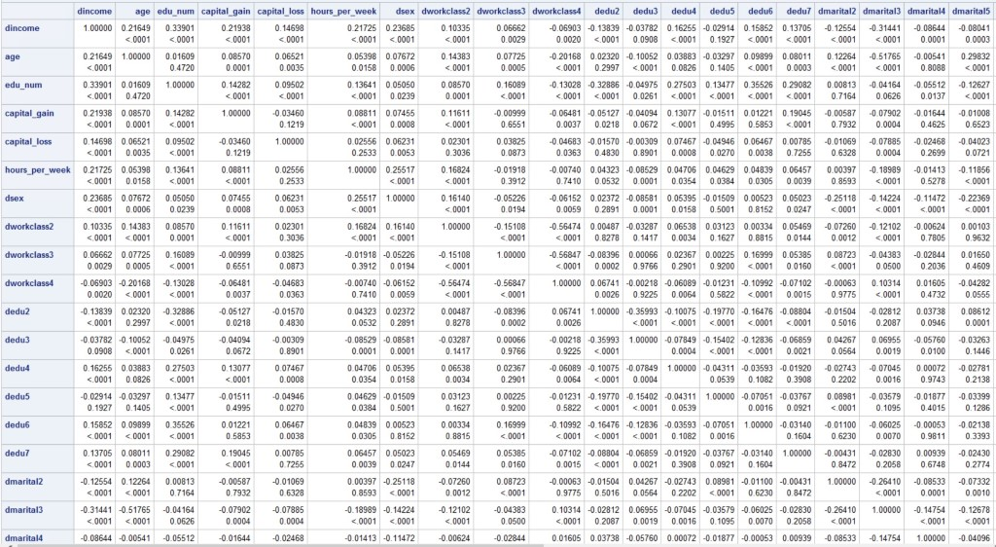

*Figure 13*. Pearson correlation matrix

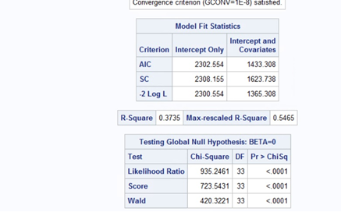

*Figure 14*. Full model results

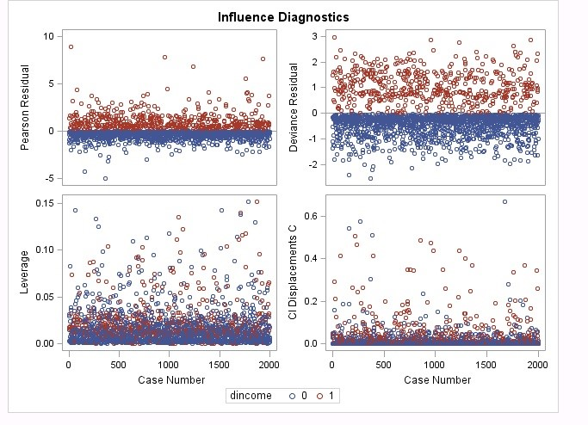

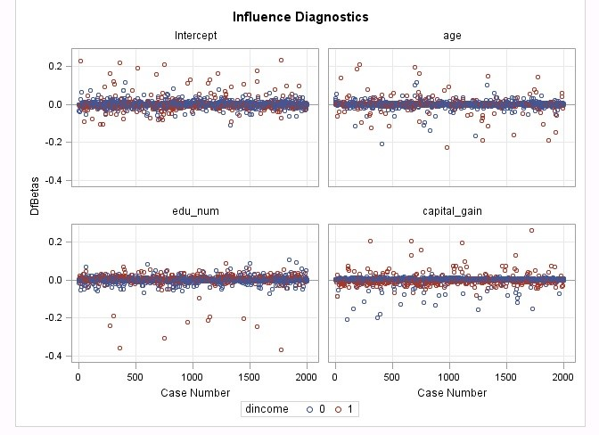

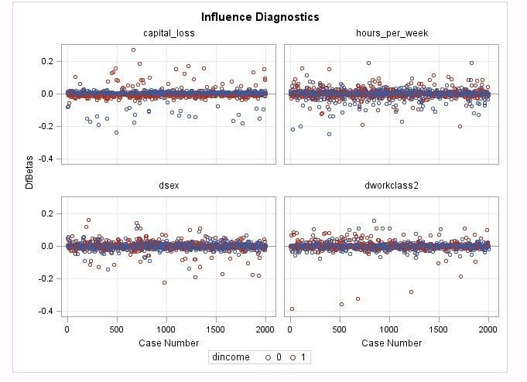

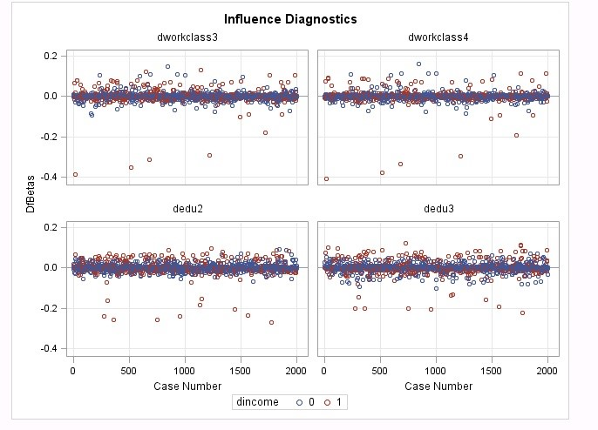

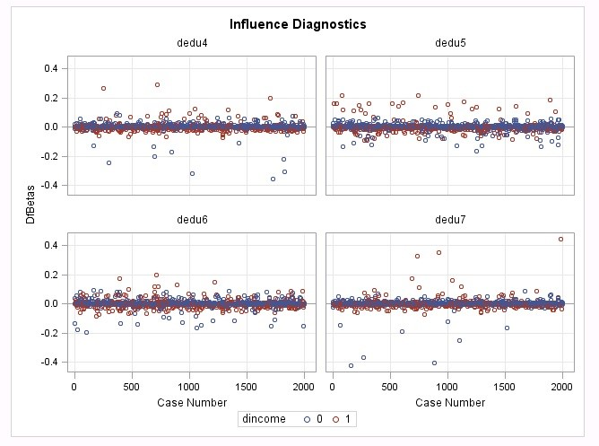

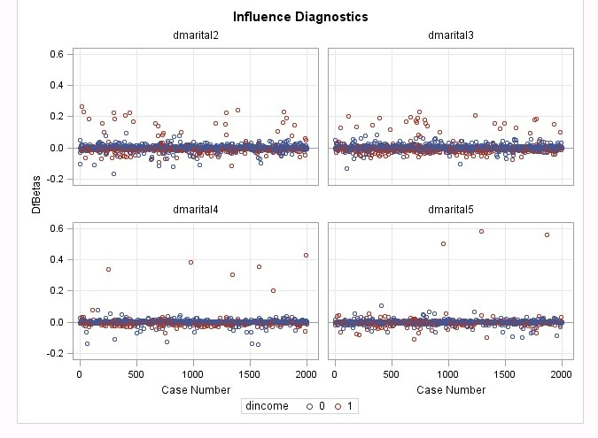

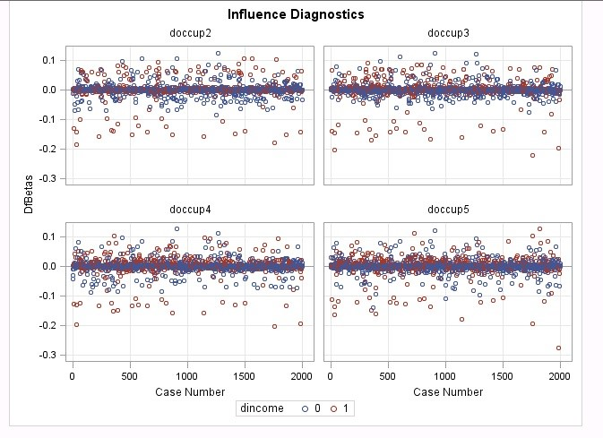

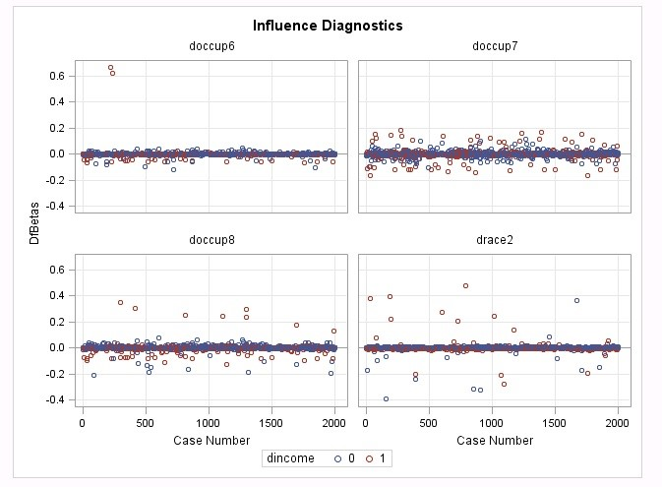

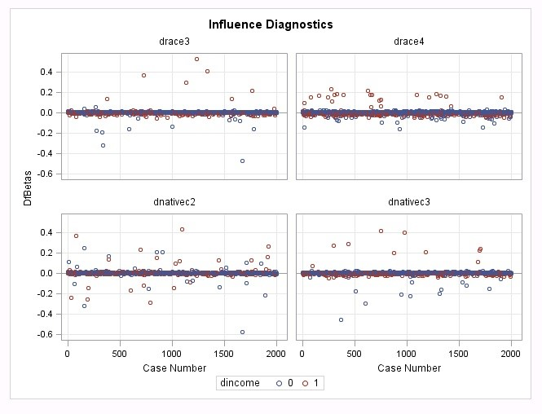

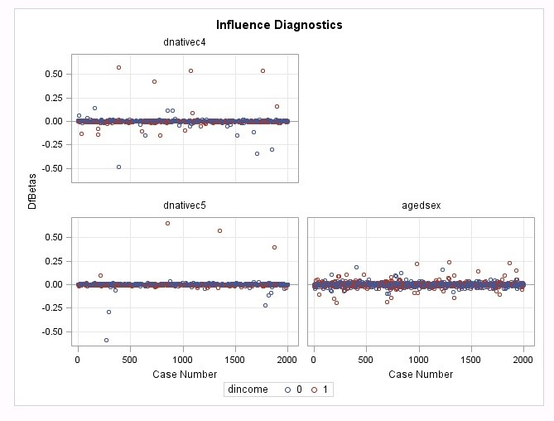

*Figure 15.* Full model Pearson residuals and dfbetas

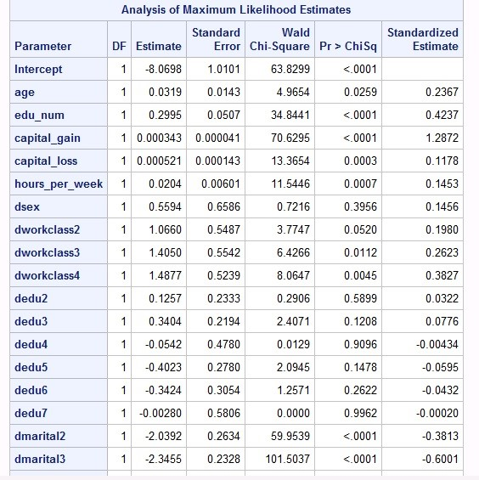

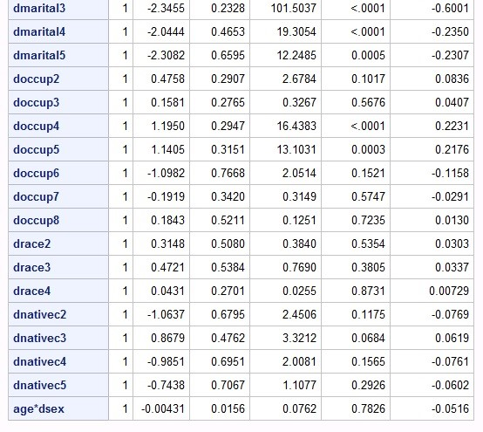

*Figure 16.* Full model variables

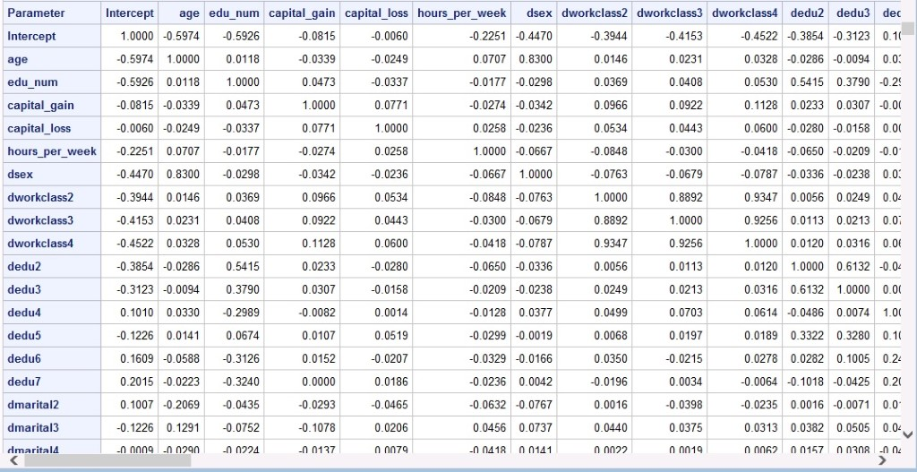

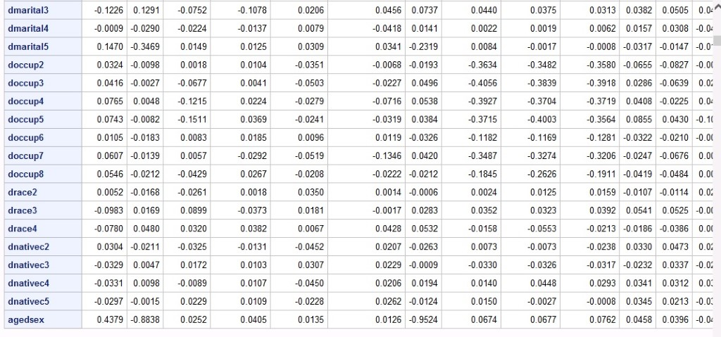

*Figure 17*. Full model correlation of coefficients matrix



*Observation 15*



*Observation 277*



*Observation 389*



*Observation 623*



*Observation 955*



*Observation 1233*



*Observation 1281*



*Observation 1491*



*Observation 1758*



*Observation 1795*



*Observation 1820*



*Observation 1928*

*Figure 18*. Observations that are influential points and outliers, in order: 15, 277, 389, 623, 955, 1233, 1281, 1491, 1758, 1795, 1820, 1928

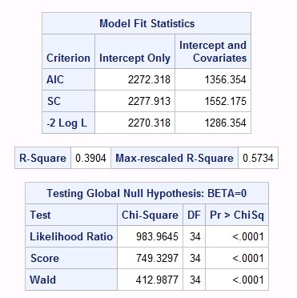

*Figure 19.* Full model after removing observations that are influential points and outliers



*Observation 33*



*Observation 77*



*Observation 120*



*Observation 157*



*Observation 222*



*Observation 294*



*Observation 366*



*Observation 434*



*Observation 726*



*Observation 742*



*Observation 774*



*Observation 786*



*Observation 977*



*Observation 1196*



*Observation 1394*



*Observation 1403*



*Observation 1772*



*Observation 1774*



*Observation 1786*



*Observation 1992*

*Figure 20:* Outliers, in order: 33, 77, 120, 157, 222, 294, 366, 434, 726, 742, 774, 786, 977, 1196, 1394, 1403, 1772, 1774, 1786, 1992

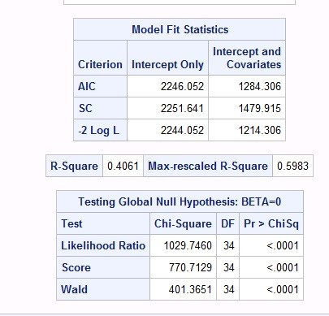

*Figure 21:* Full model after removing more outliers in addition to previously removed observations

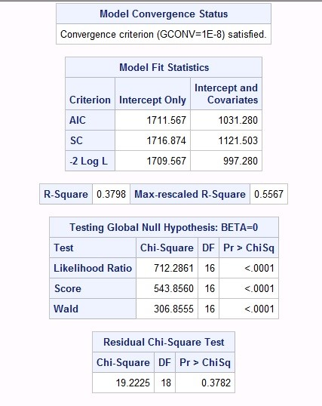

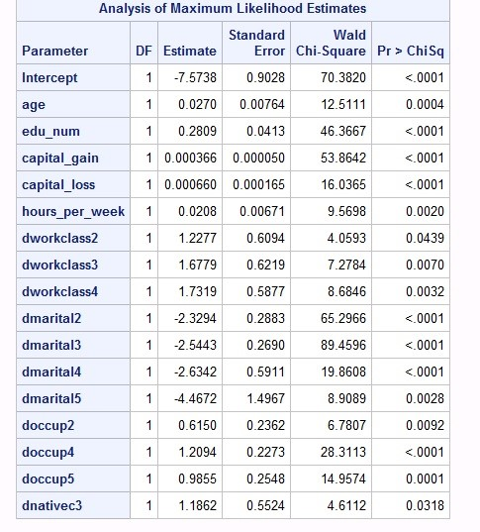

*Figure 22:* Stepwise selection model result

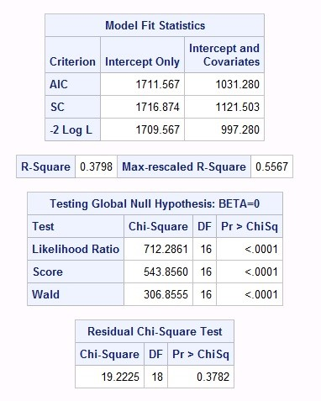

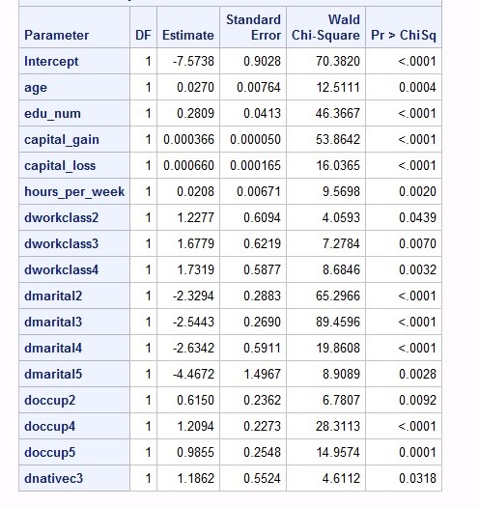

*Figure 23:* Backward selection model result

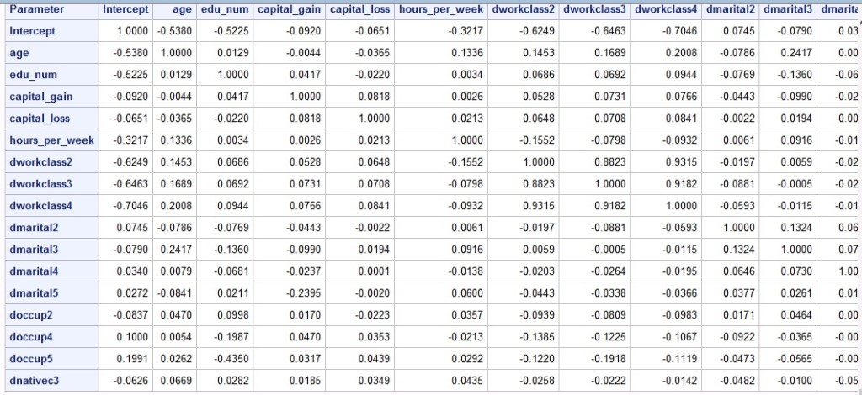

*Figure 24:* Fitted model correlation of coefficients matrix

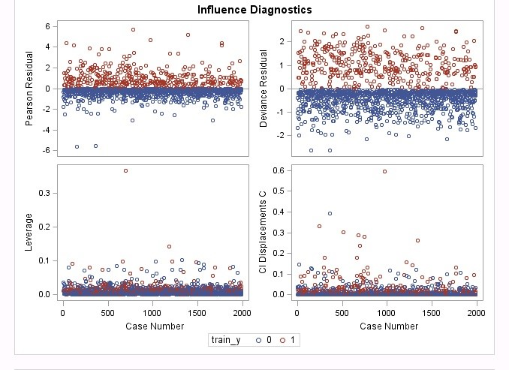

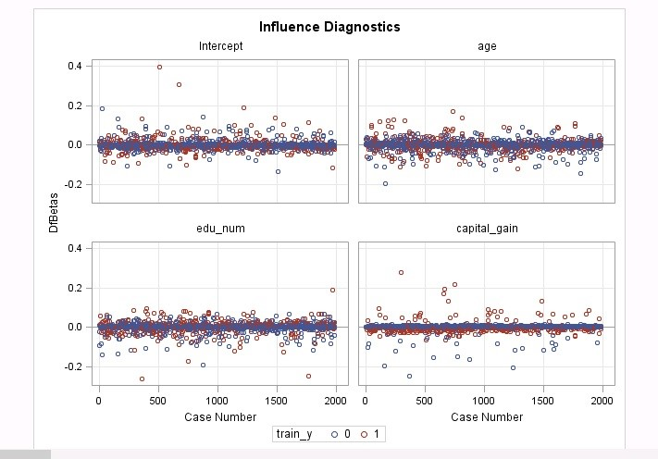



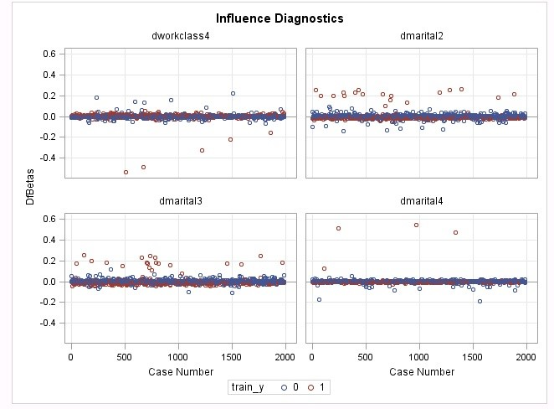

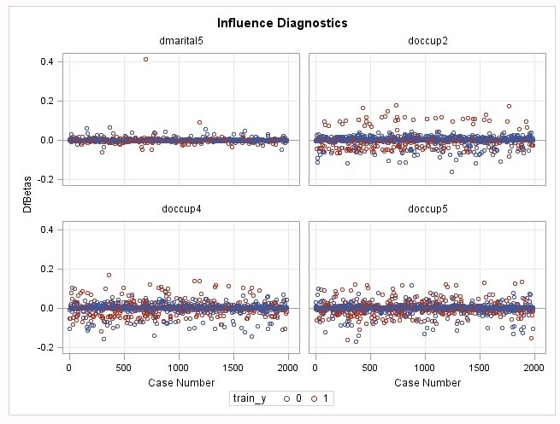

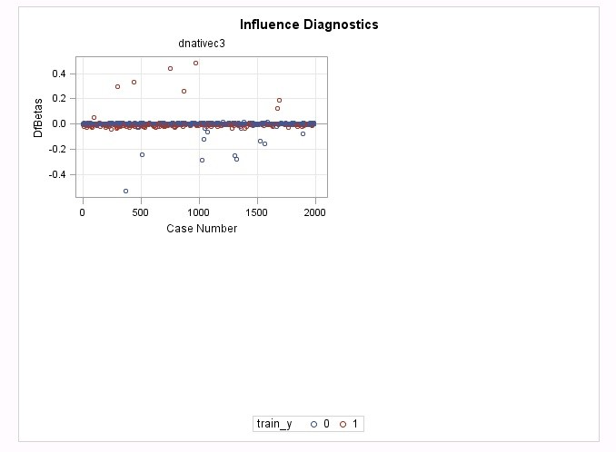

*Figure 25:* Fitted model Pearson residuals and dfbetas



*Observation 292*



*Observation 364*



*Observation 396*



*Observation 509*



*Observation 675*



*Observation 782*



*Observation 972*



*Observation 1191*



*Observation 1281*



*Observation 1664*



*Observation 1763*

*Figure 26:* Fitted Model outliers and influential points, in order: 292, 364, 396, 509, 675, 782, 972, 1191, 1281, 1664, 1763



*Observation 32*



*Observation 119*



*Observation 156*



*Observation 431*



*Observation 738*



*Observation 770*



*Observation 790*



*Observation 1387*



*Observation 1765*

*Figure 27*: Fitted model outliers, in order: 32, 119, 156, 431, 738, 770, 790, 1387, 1765

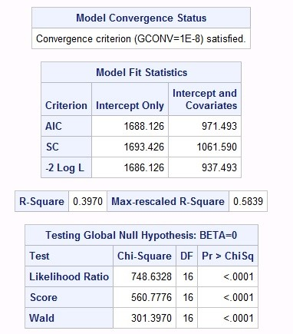

*Figure 28*: Fitted model with outliers and influential points removed

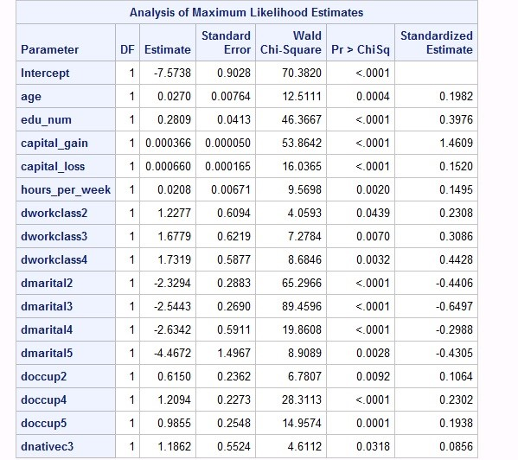

*Figure 29.* Final model with standardized estimates

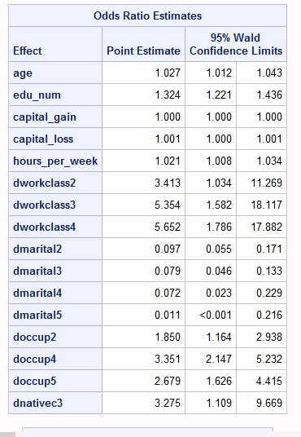

*Figure 30.* Final model odds ratios

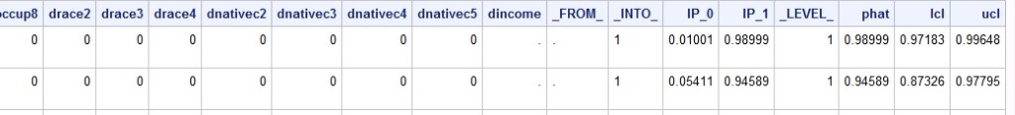

*Figure 31.* Final model predictions

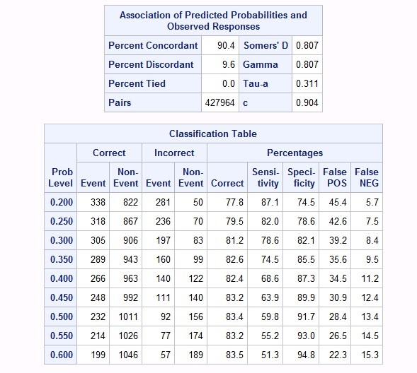

*Figure 32*. Final model classification table

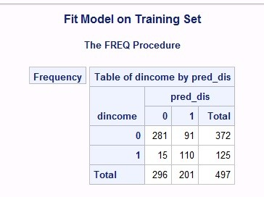

*Figure 33.* Final model test classification matrix

|  |  |  |  |
| --- | --- | --- | --- |
|  | | | |
|  |  | | |
|  |  |  |  |
|  |  |  |  |
|  |  |  |  |
|  |  |  |  |
|  |  |  |  |
|  |  |  |  |

|  |  |  |  |
| --- | --- | --- | --- |
|  | | | |
|  |  | | |
|  |  |  |  |
|  |  |  |  |
|  |  |  |  |
|  |  |  |  |
|  |  |  |  |
|  |  |  |  |
|  |  |  |  |
|  |  |  |  |

# 

# 

# Appendix C - Danyang

Original Income_Train (not fitted and the ratio of train and test is 75：25)

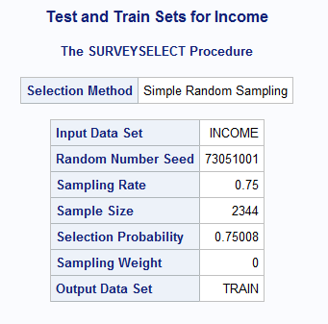

Linearity

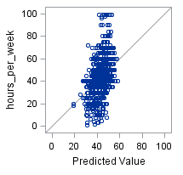

Q-Q plot

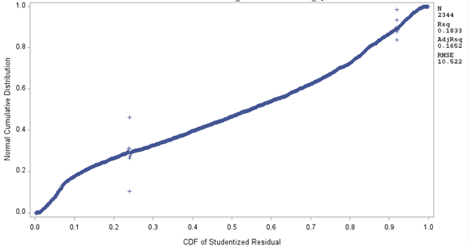

Residuals

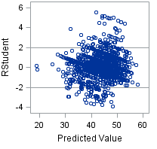

Before dropping insignificant variables  
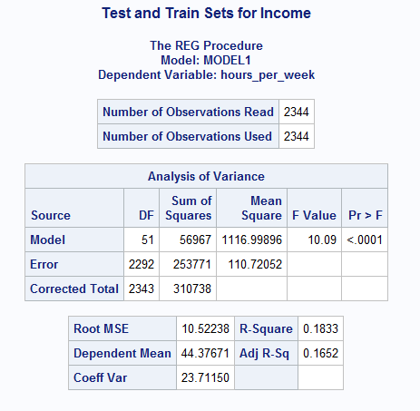

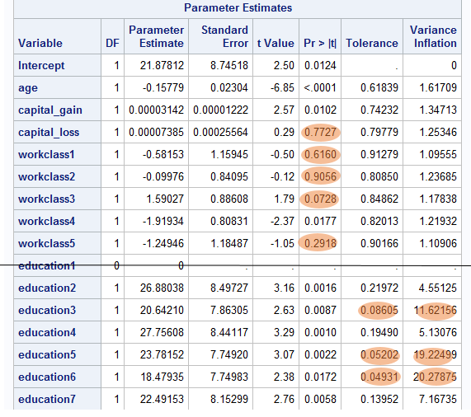

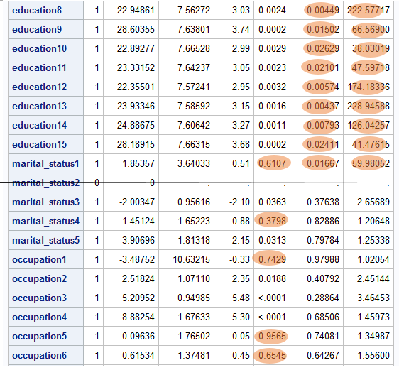

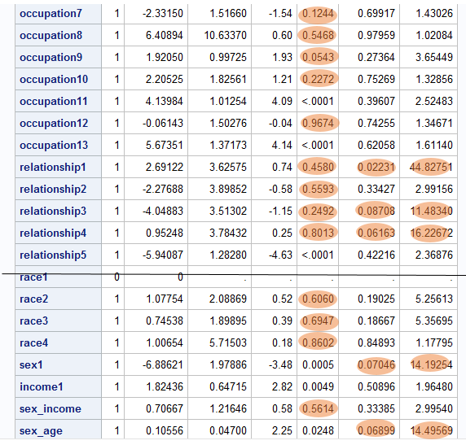

Income_Train_new  
   
 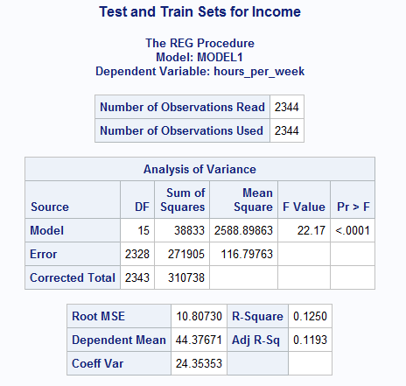  
  
  
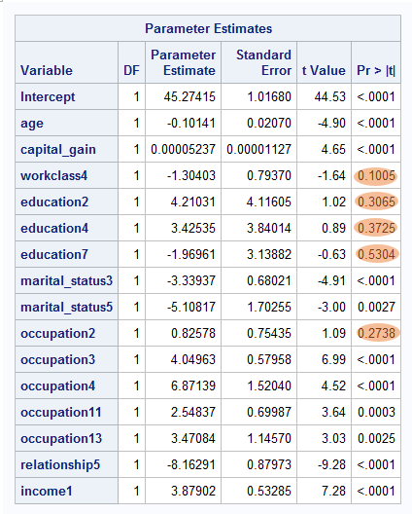

Income_Train_New (after dropping insignificant variables)  
   
 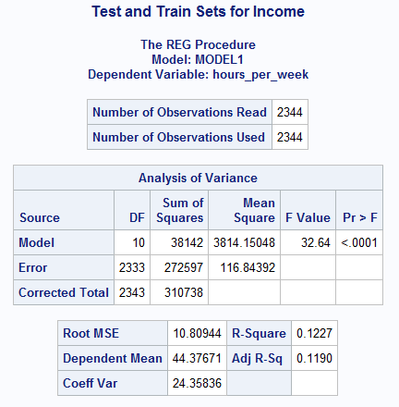

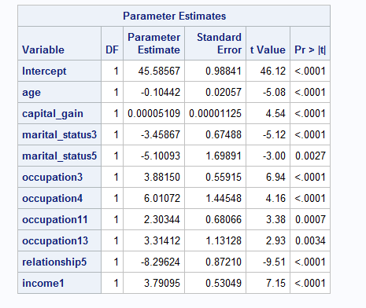

The final model(Dropping 238 outliers and influential points):  
   
 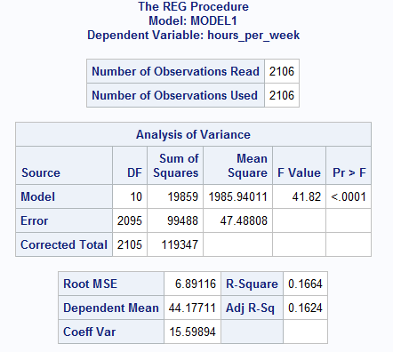

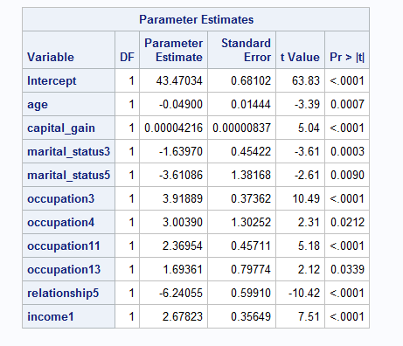

Test performance of test set  
 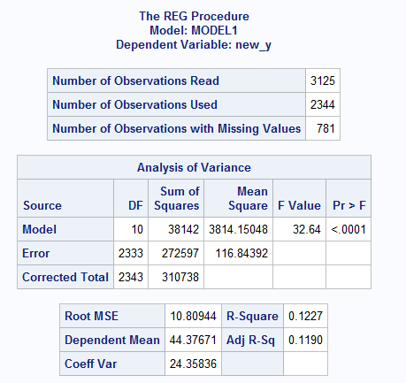

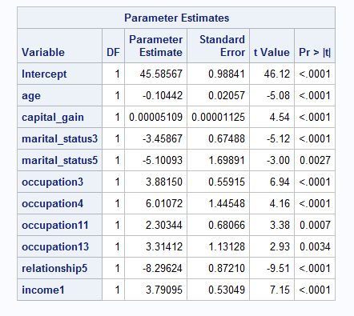

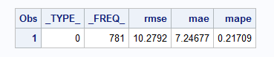

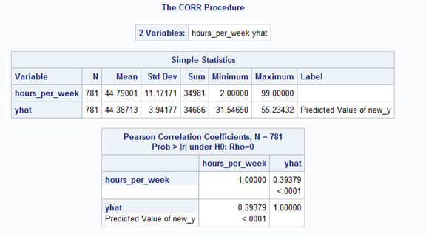

5-folder Cross validation: stepwise and backward

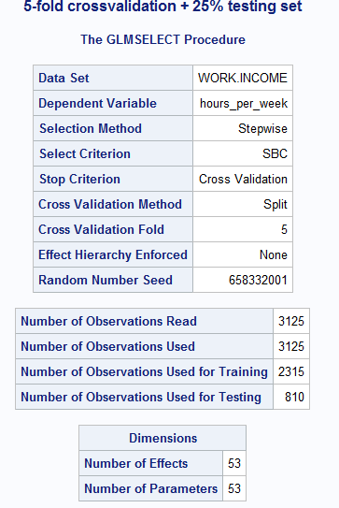

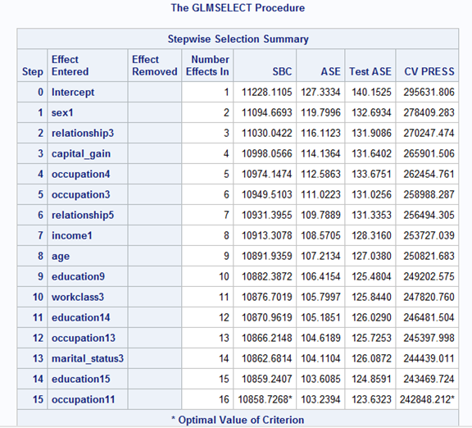

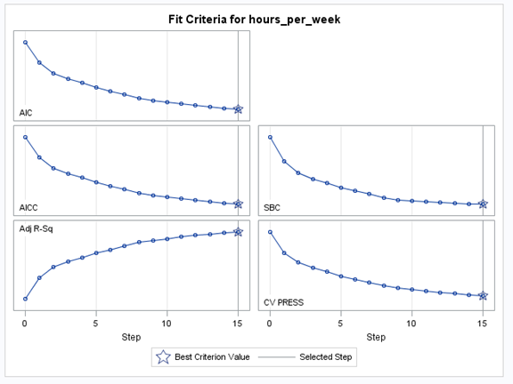

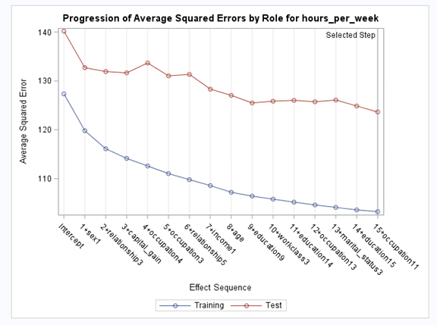

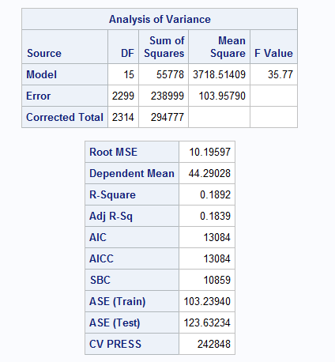

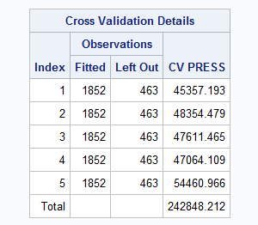

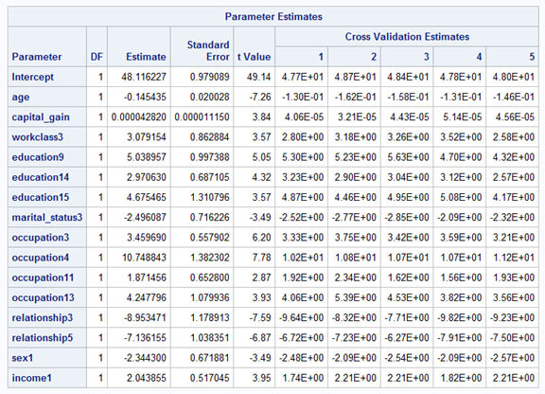

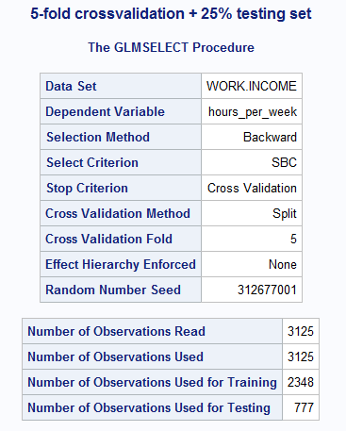

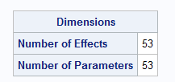

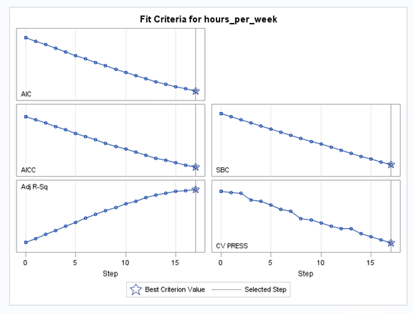

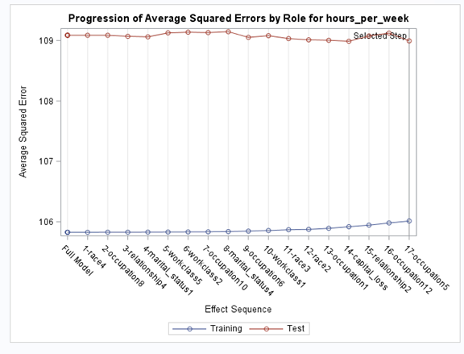

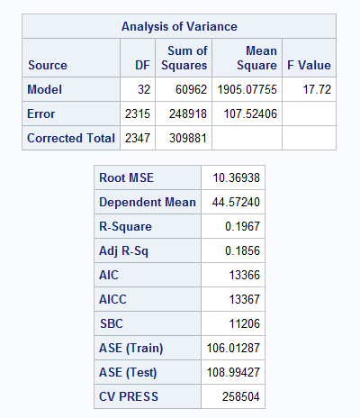

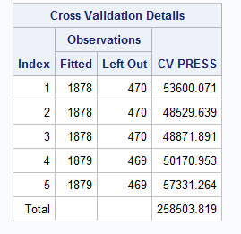

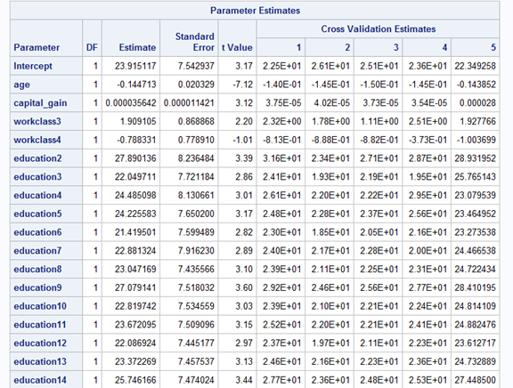

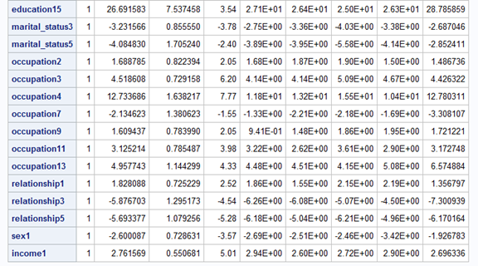

# 2 predictions

# 

# 

# 

# 

# 

# Models from reference:

# Forward

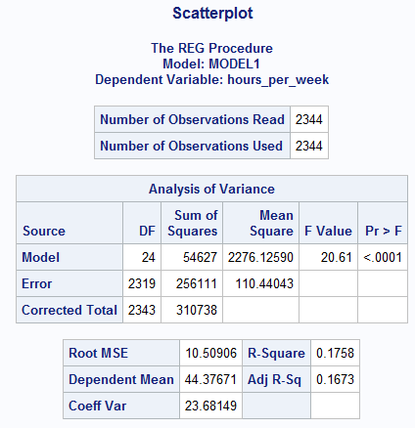

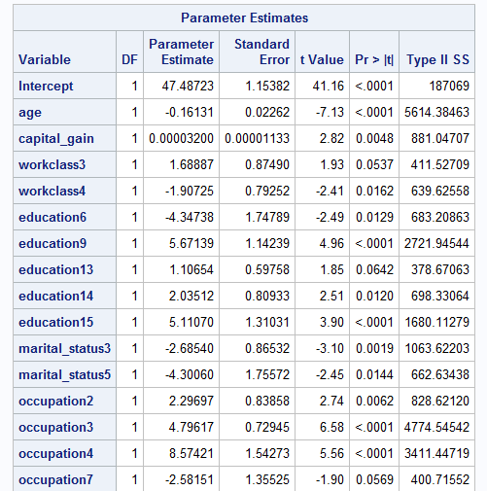

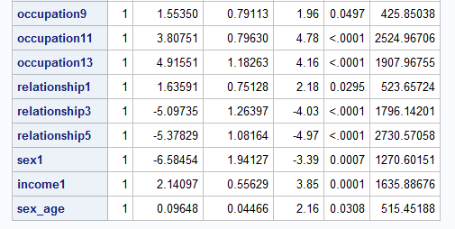

# Backward:

# 

# 

# 

# 

# 

# 

# 

# Stepwise:

# 

# 

# 

# 

# 

# 

# 

# Adjrsq:

# 

# 

# 

# 

# 

# 

# 

# Appendix D - Persid

Data obtained was cleaned from the rows with missing values and imported in SAS as .csv file (data1.csv). A sample of 2000 data points were selected by simple random sampling technique. The data created was then exported in a second .csv file (Random Sample.cvs) and was used for the regression analysis.

proc import datafile="S:\Final_Project\data1.csv" out=censusIncome replace;

delimiter=',';

getnames=yes;

Run;

*Randomly Selected Sample;

proc surveyselect data=censusIncome

method=srs n=2000 out=censusSample;

run;

PROC PRINT data=censusSample;

RUN;

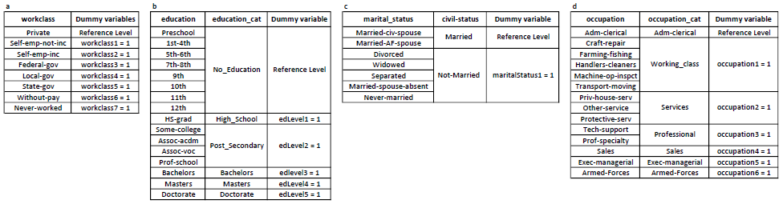  
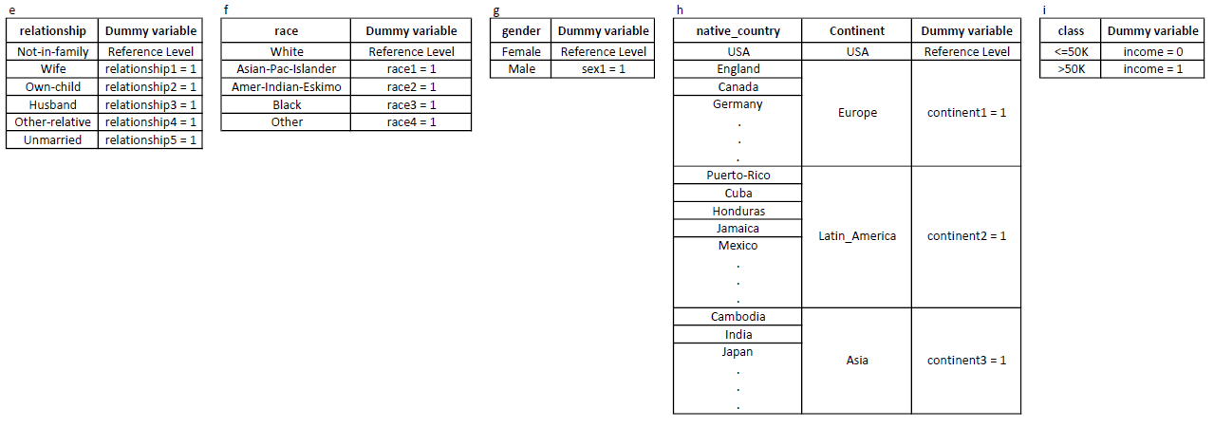 Table 1. Grouping and Coding of the Qualitative Variables

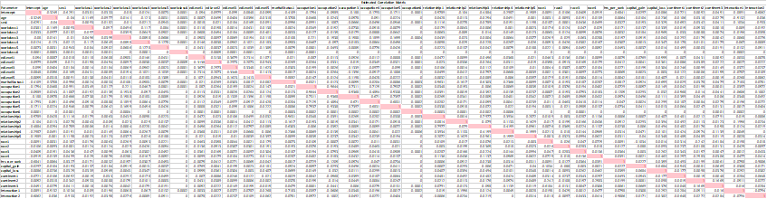  
 Table 2. Estimated Correlation Matrix.

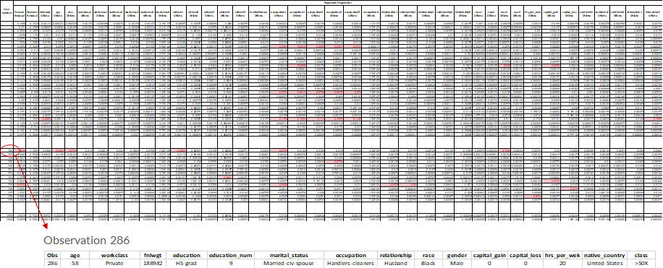

Table 3. Influential Points and Outliers.

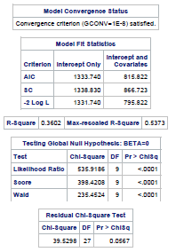

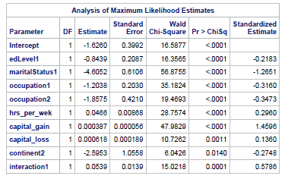

Table 4. Stepwise Selection Procedure Summary

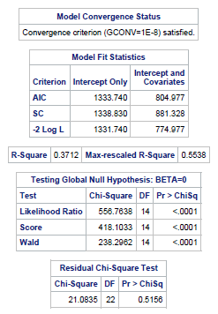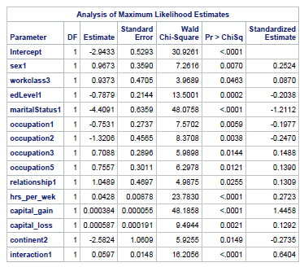

Table 5. Backward Selection Procedure Summary

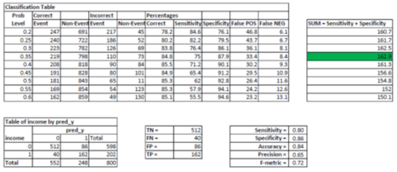

Table 6. Classification Table

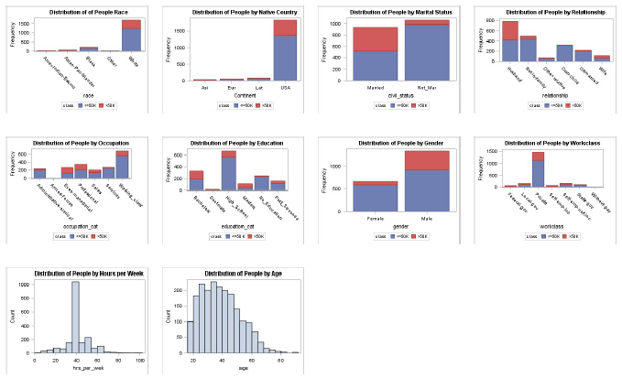

Figure 1. Distribution of Variables

# Appendix E - Alice

Data Exploration

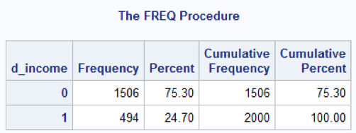

Figure 1

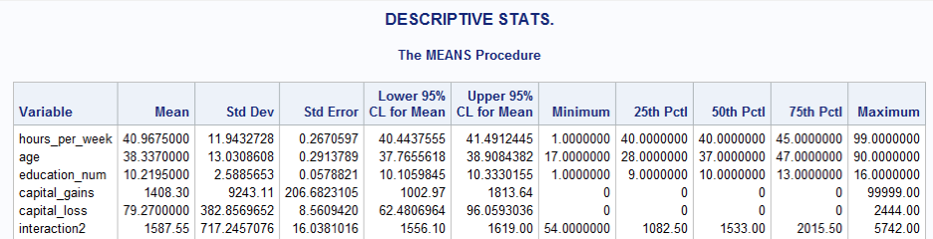

Figure 2

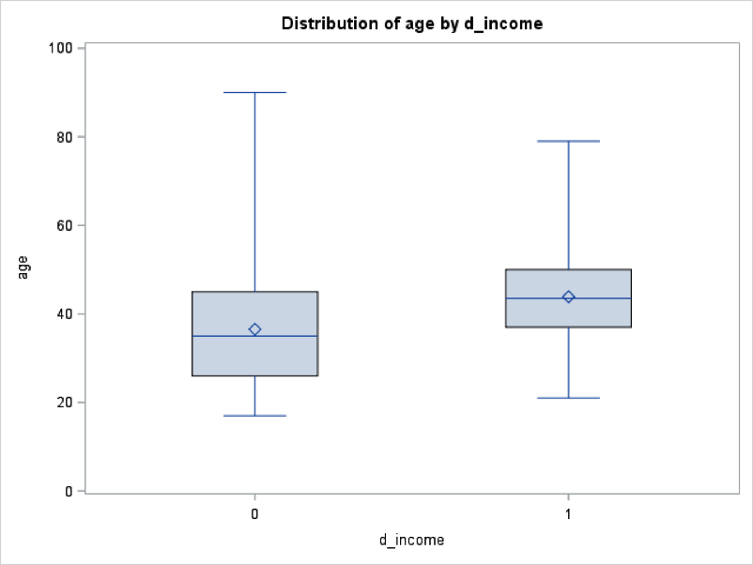

Figure 3

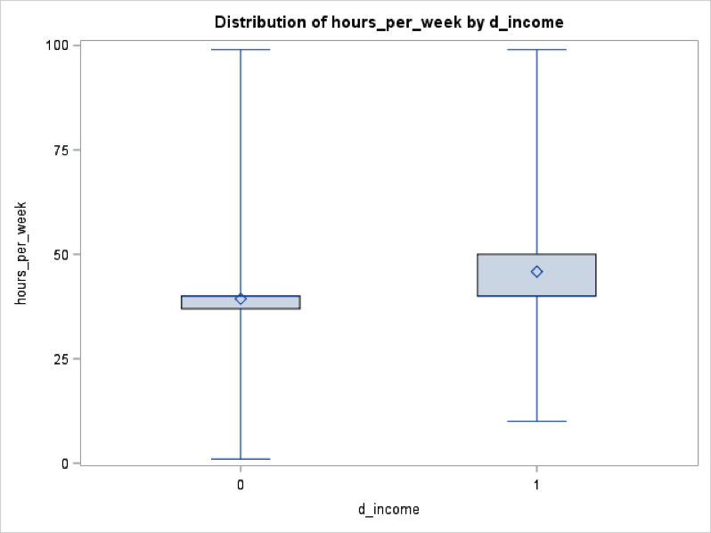

Figure 4

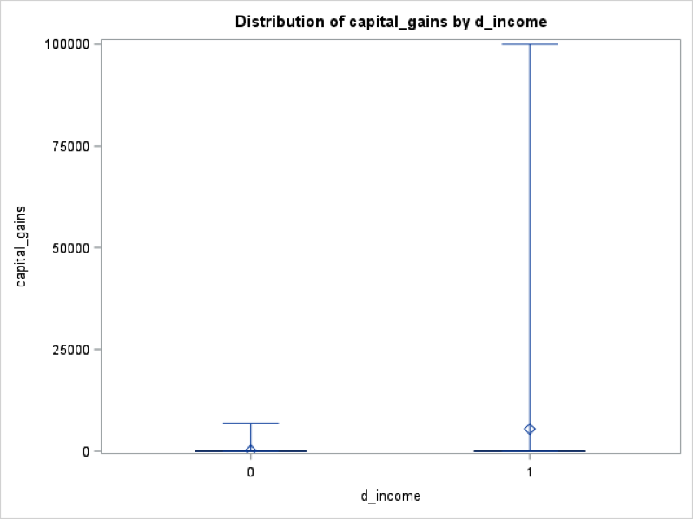

Figure 5

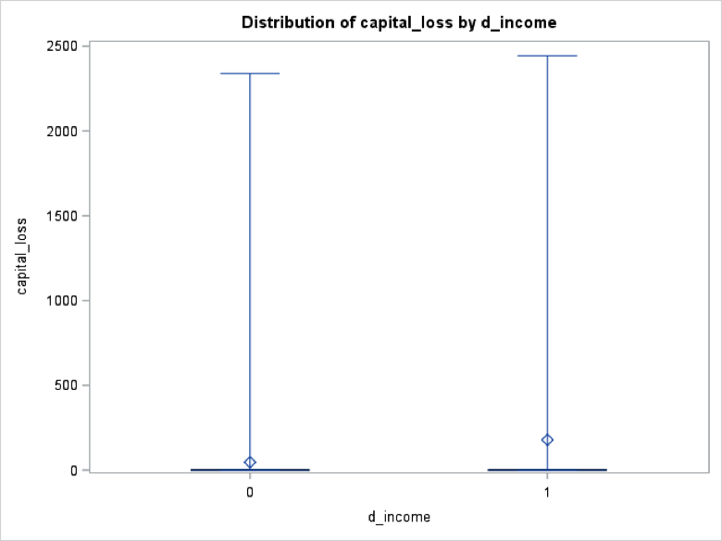

Figure 6

Counts

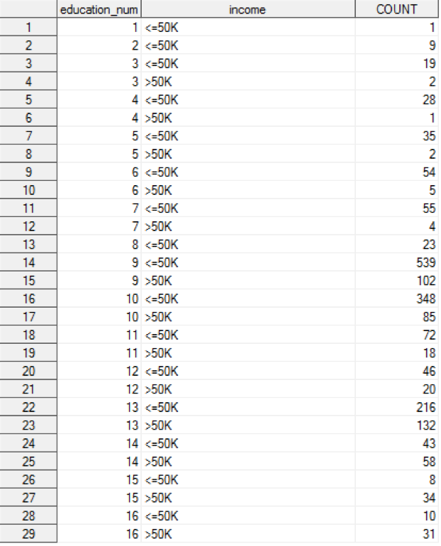

Figure 7

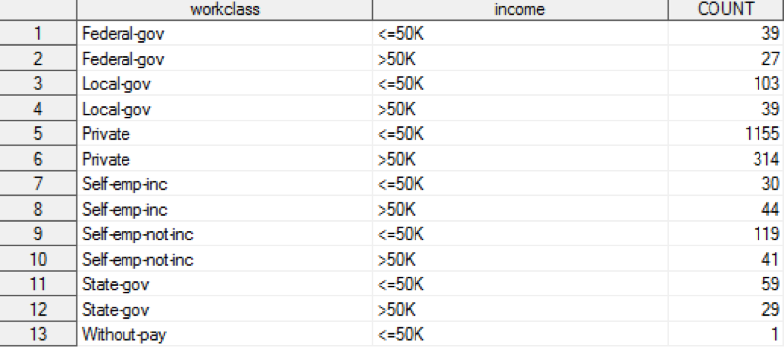

Figure 8

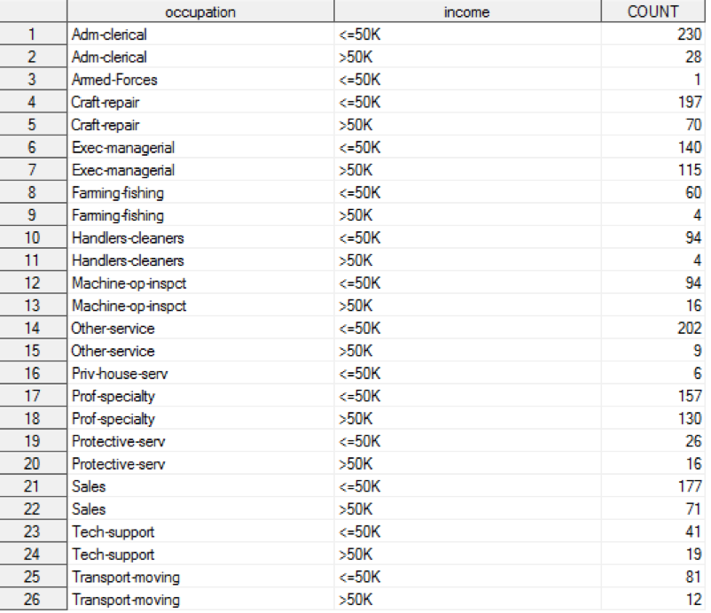

Figure 9

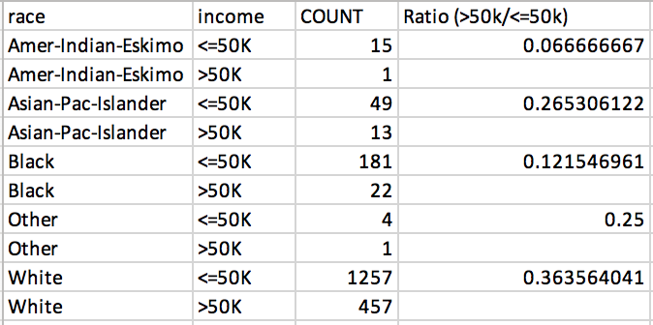

Figure 10

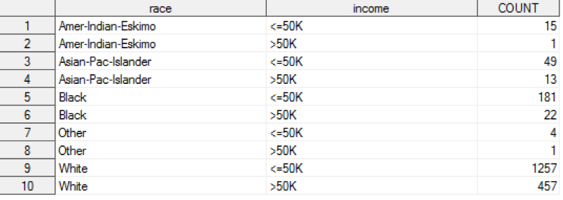

Figure 11

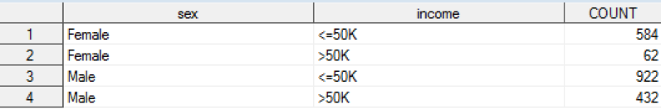

Figure 12

Full Model

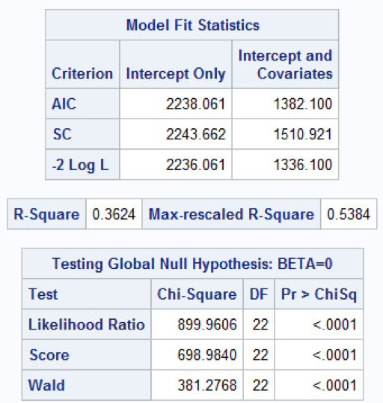

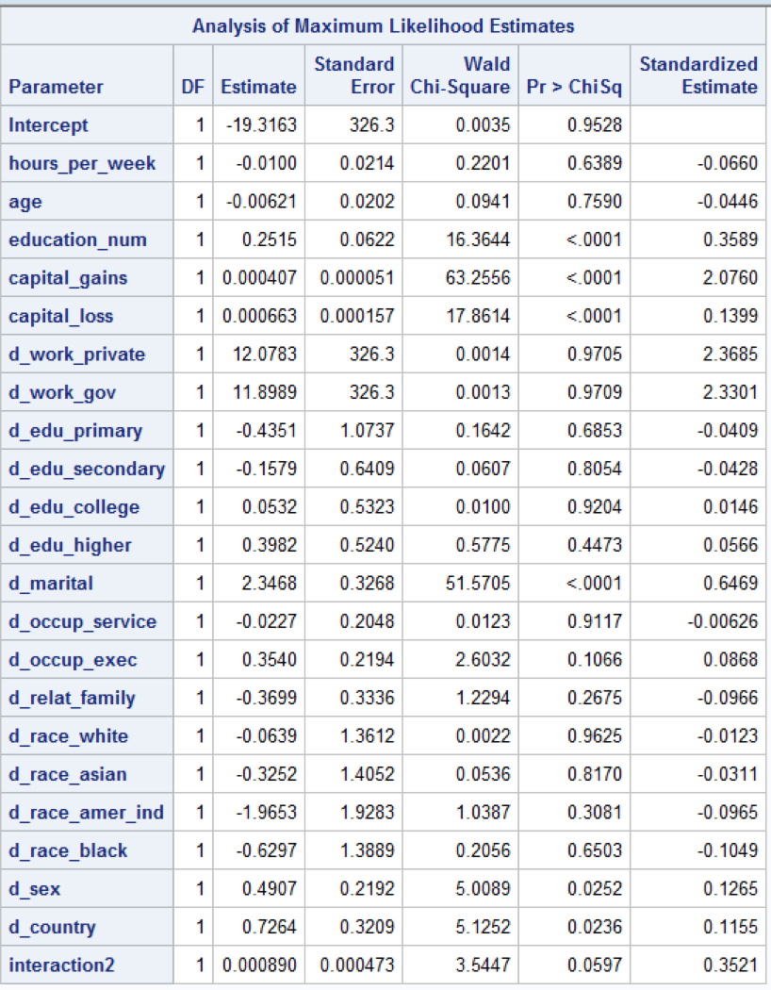

Figure 13

Correlation Matrix

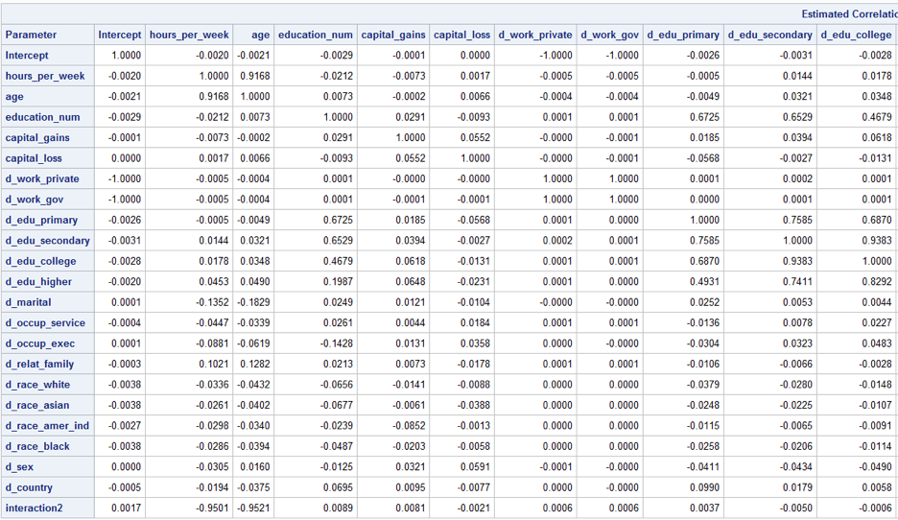

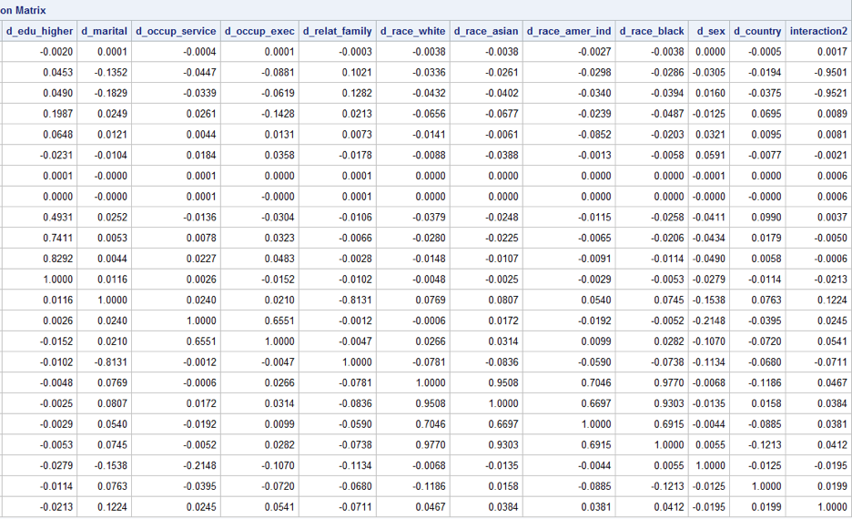

Figure 14

Outliers/Influential points: First time

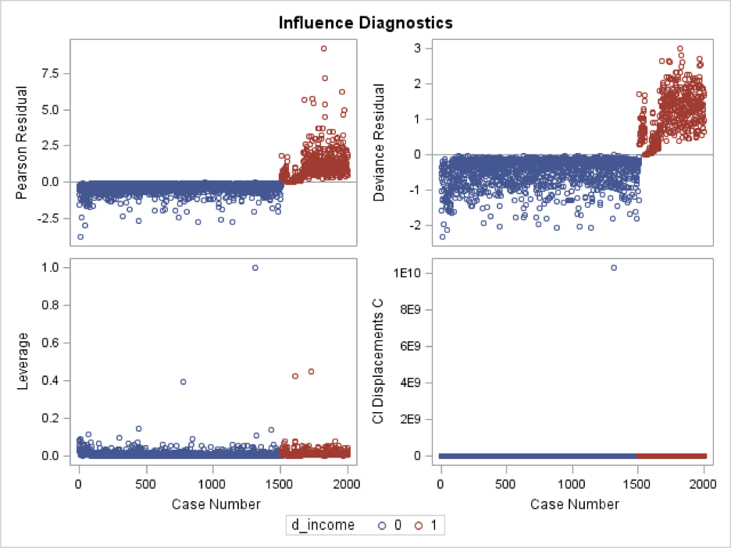

Figure 15

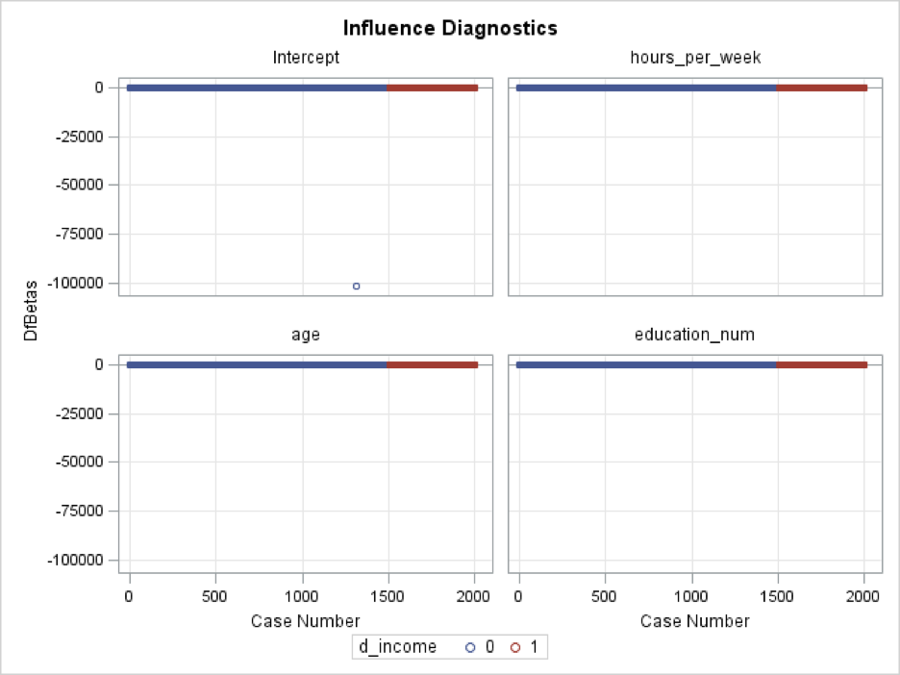

Figure 16

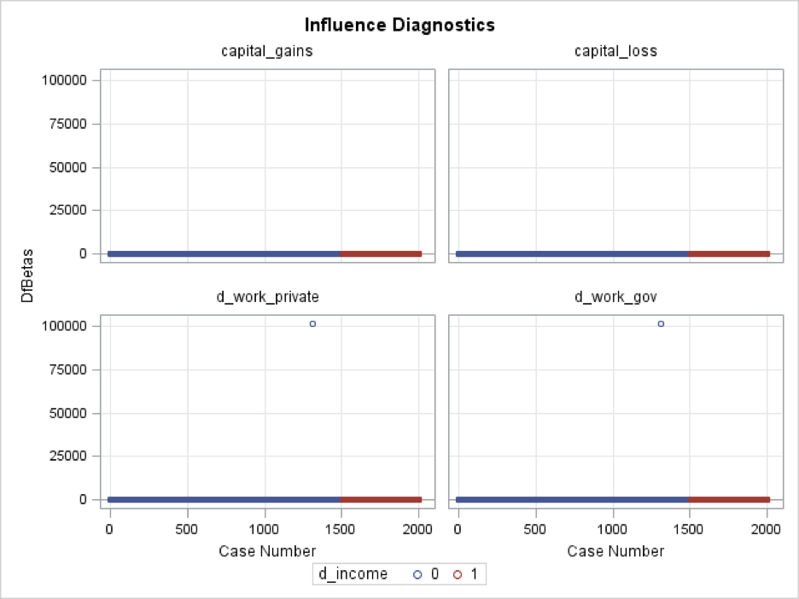

Figure 17

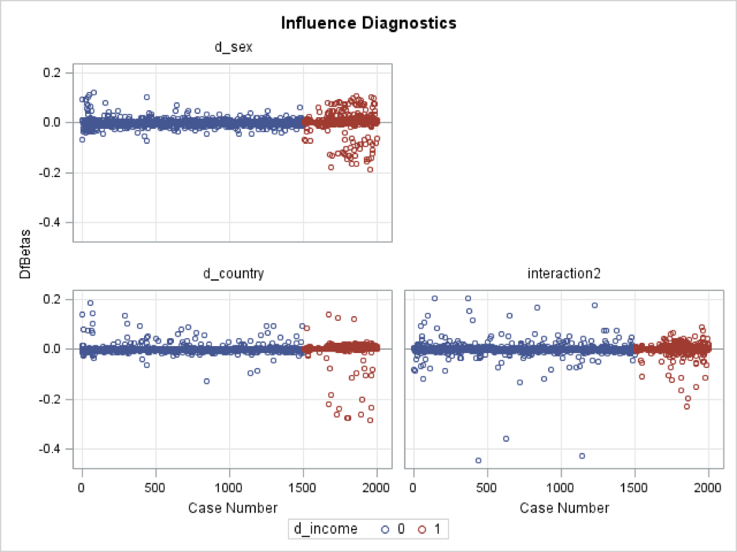

Figure 18

Model Fit after Outliers are handled

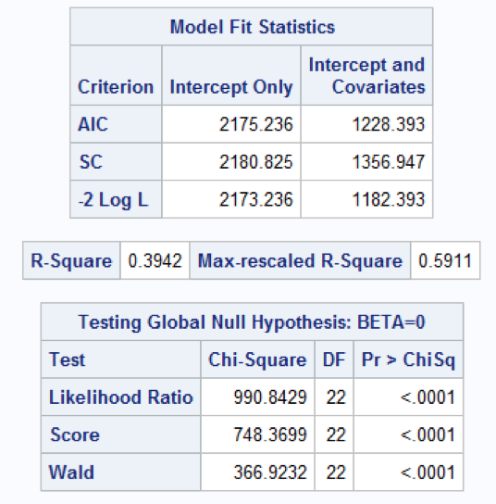

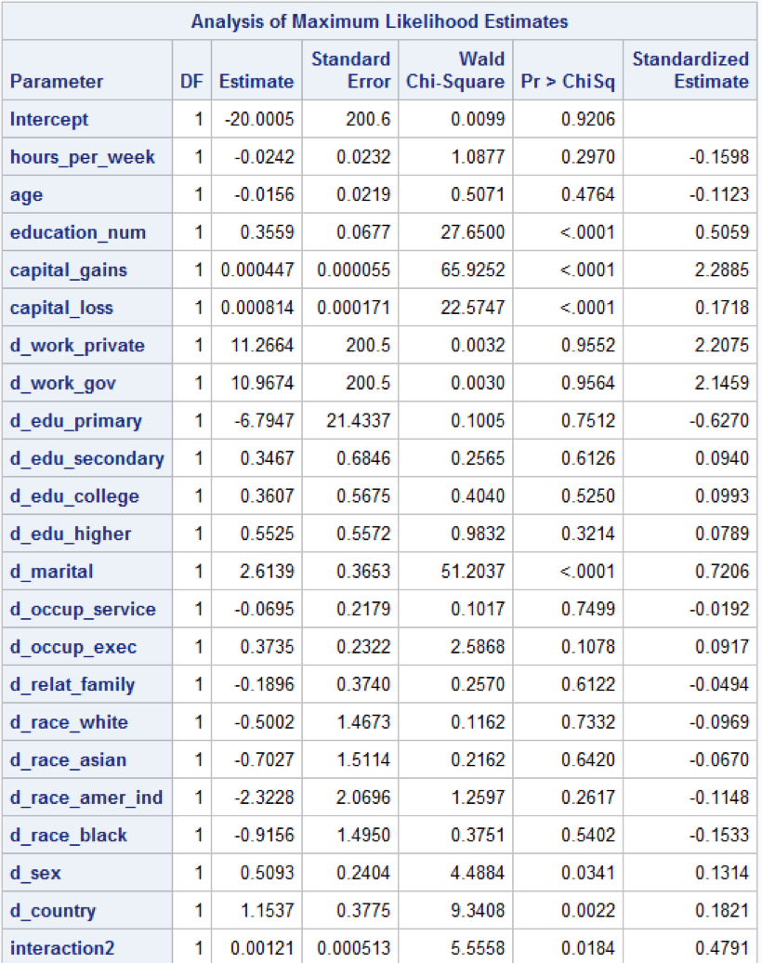

Figure 19

Stepwise

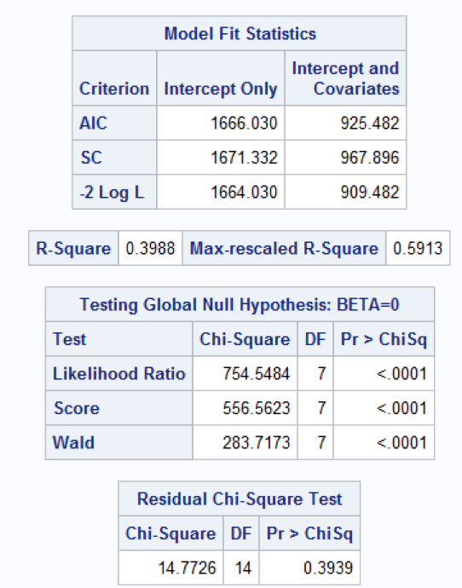

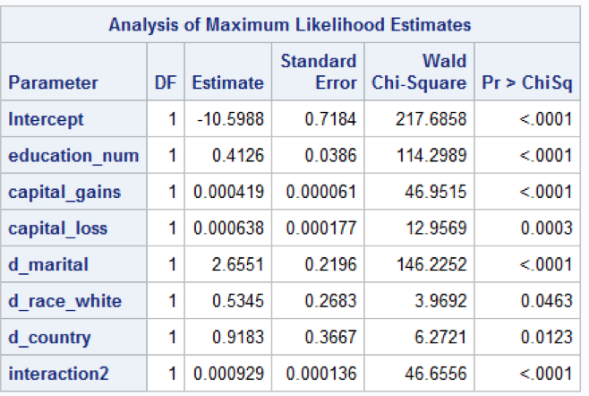

Figure 20

Backward

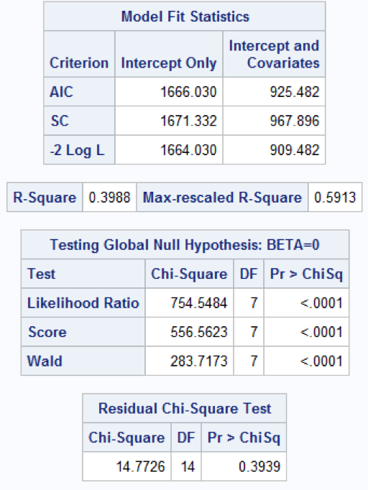

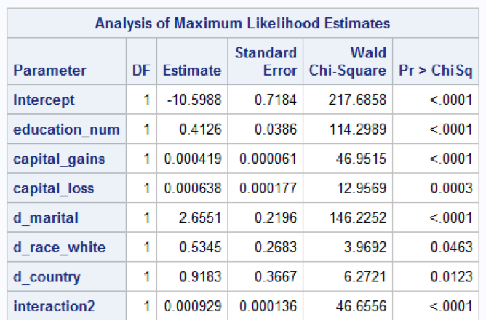

Figure 21

Forward

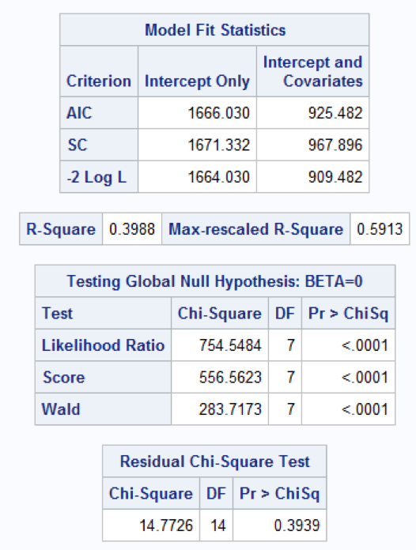

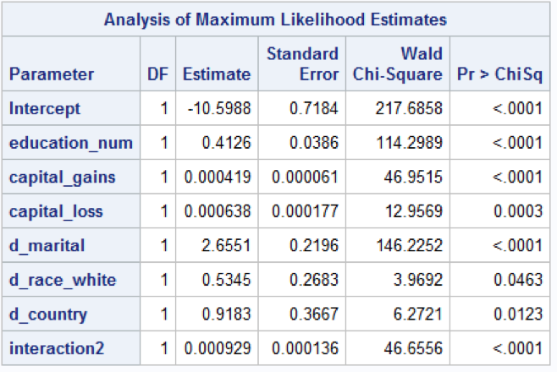

Figure 22

Outliers/Influential points: 2nd time

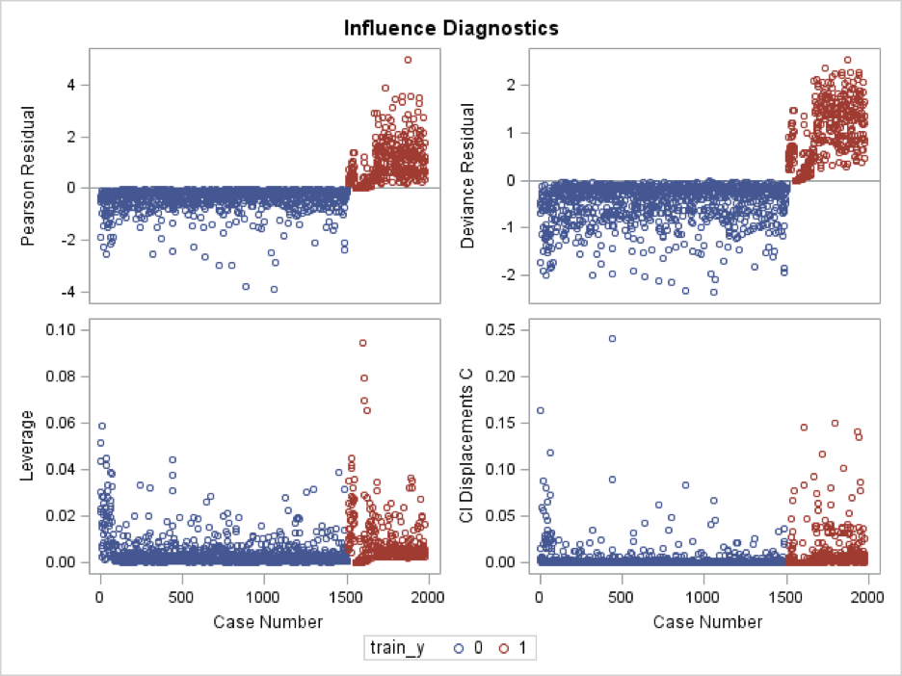

Figure 23

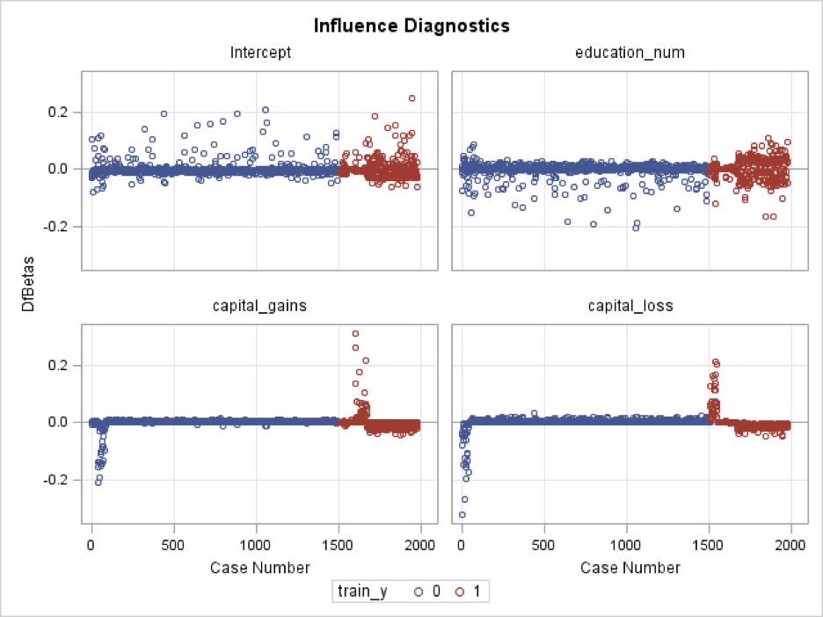

Figure 24

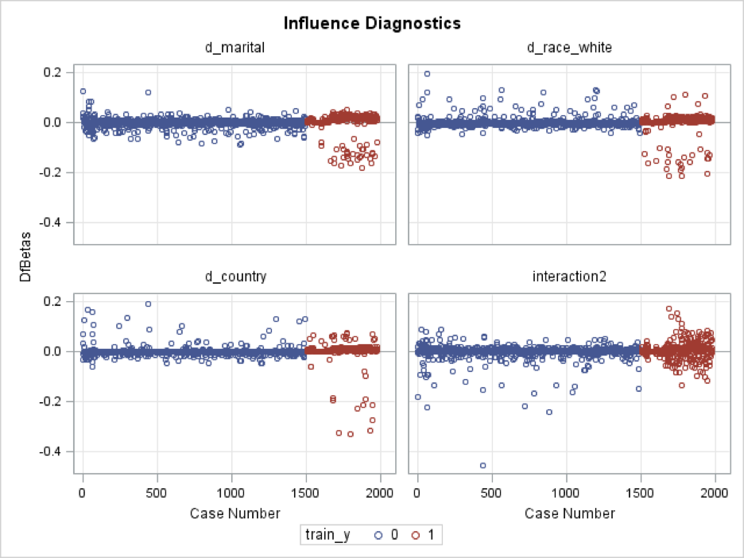

Figure 25

Final Model

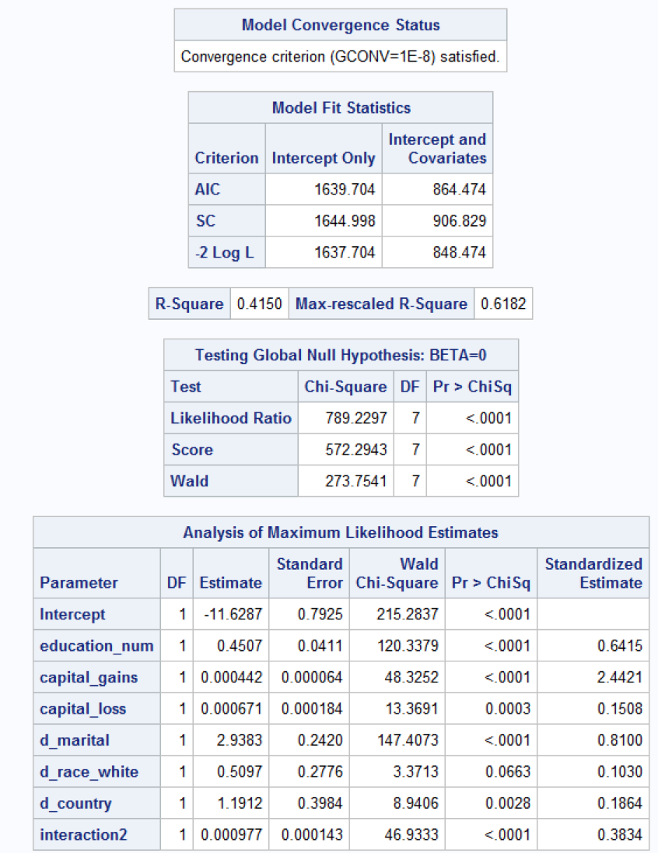

Figure 26

1st Prediction



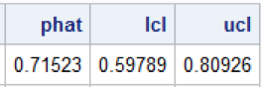

Figure 27

2nd Prediction



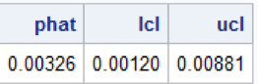

Figure 28

Classification Table

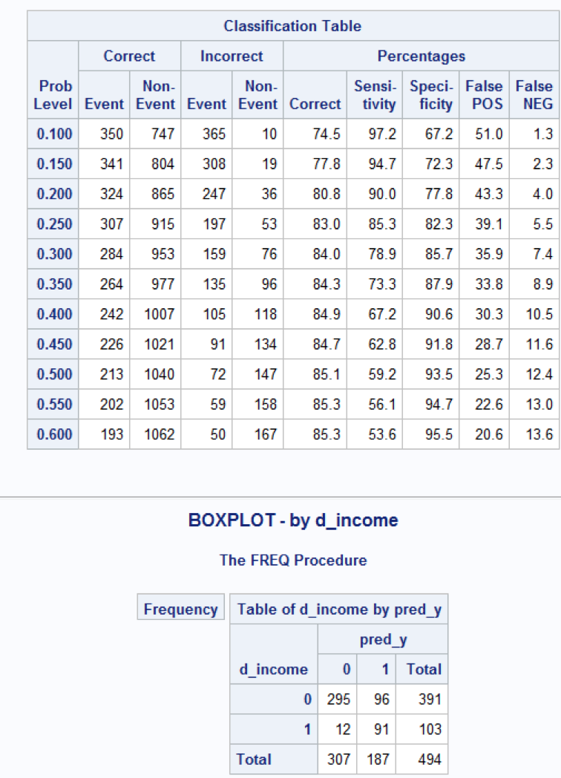

Figure 29

Model 2 Classification Matrix

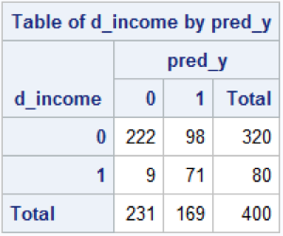

Figure 30

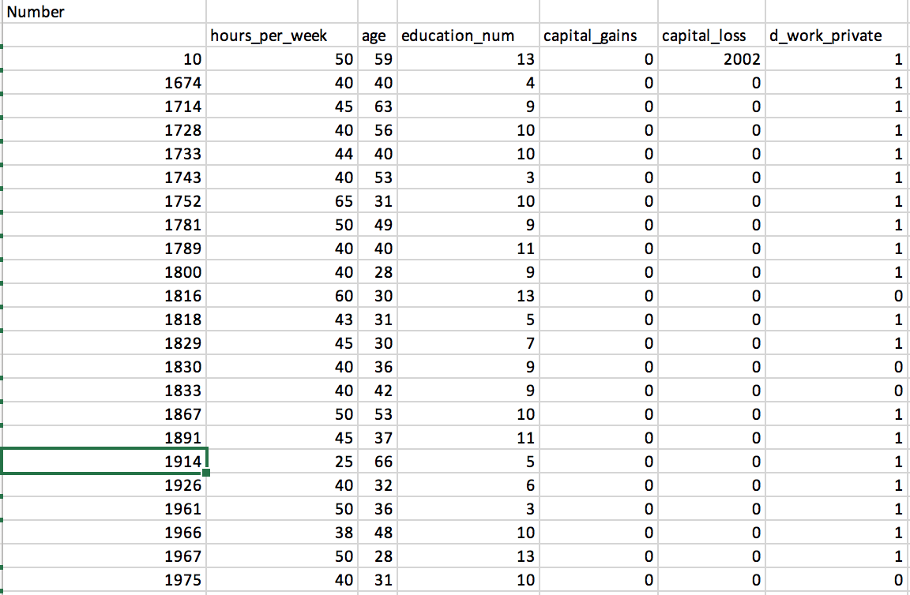

Figure 31

# 

# Appendix F - Carl

Figure 1

# 

Figure 2

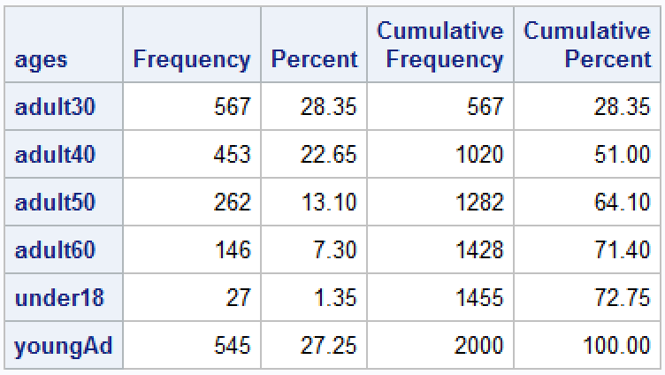

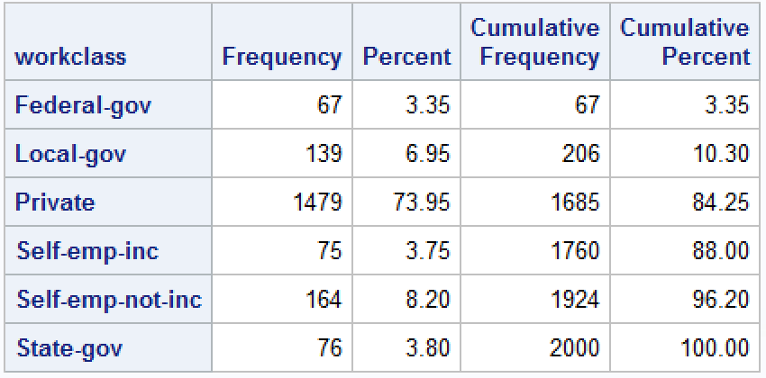

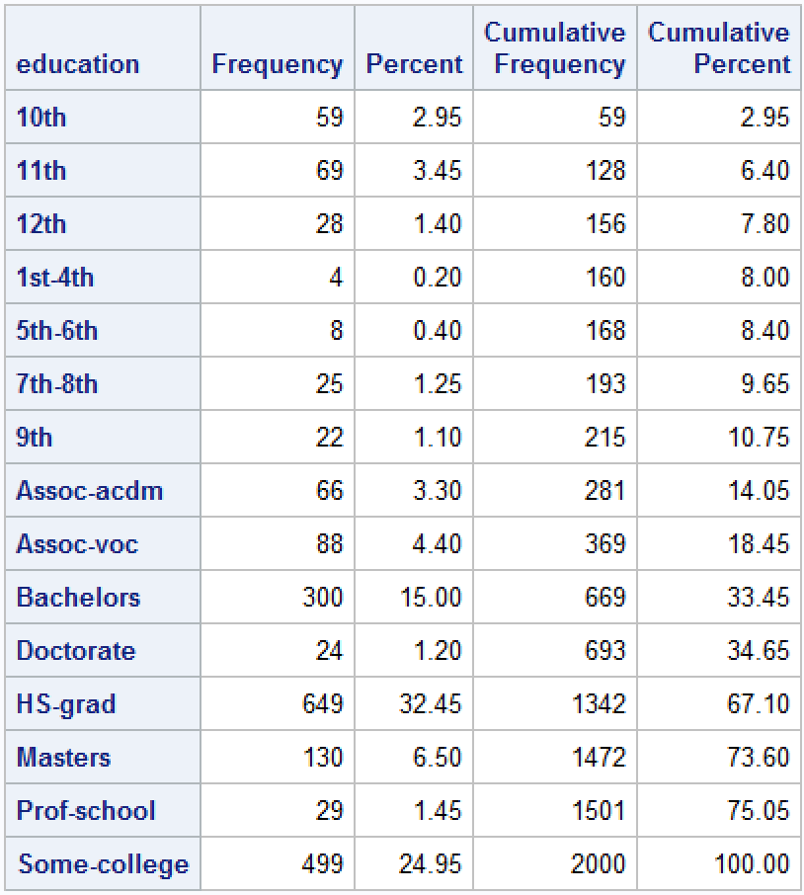

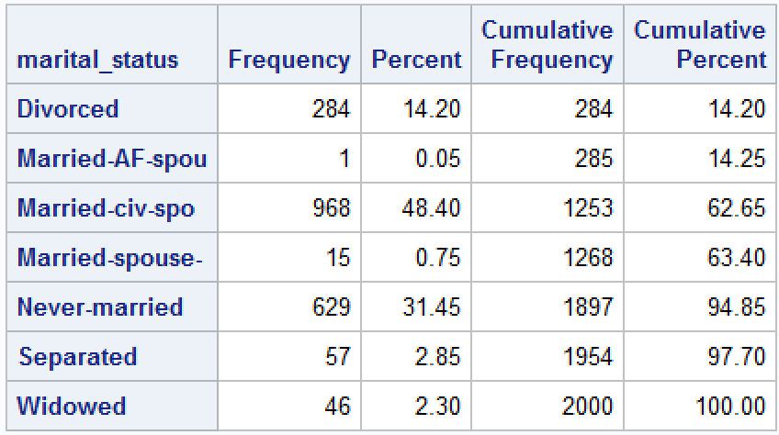

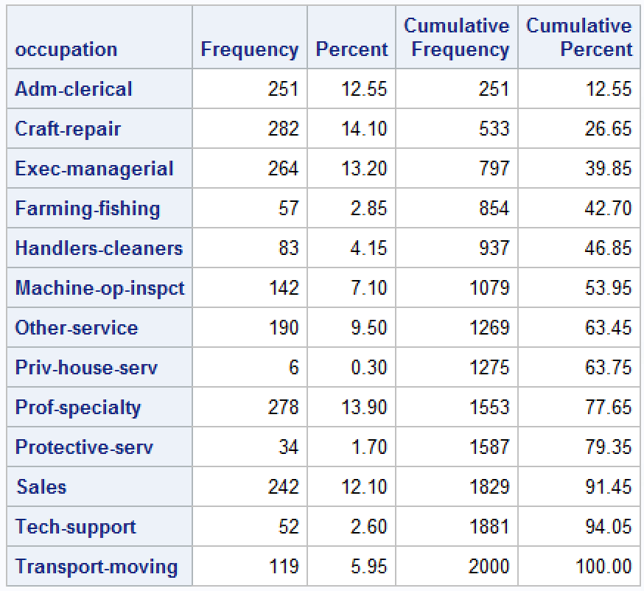

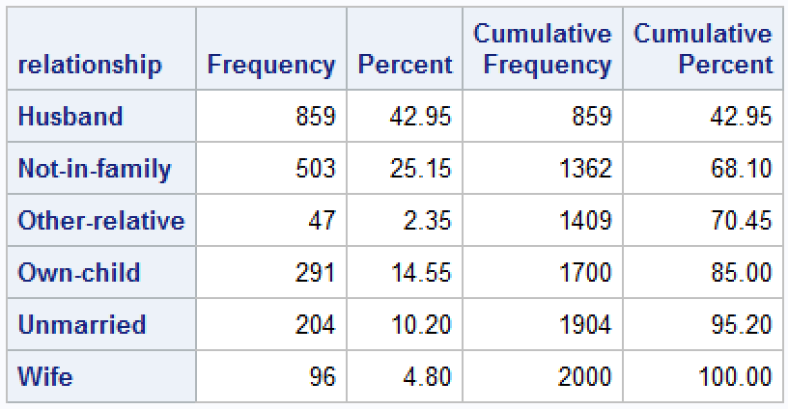

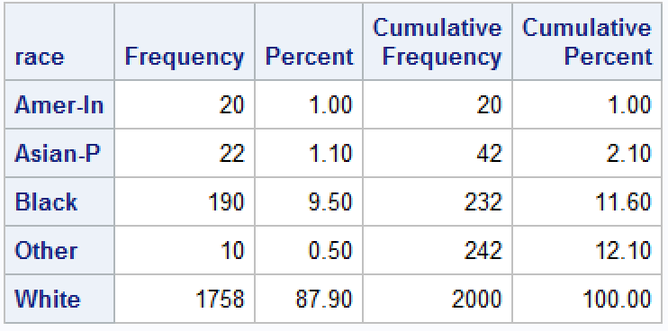

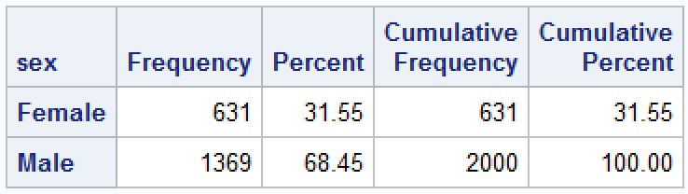

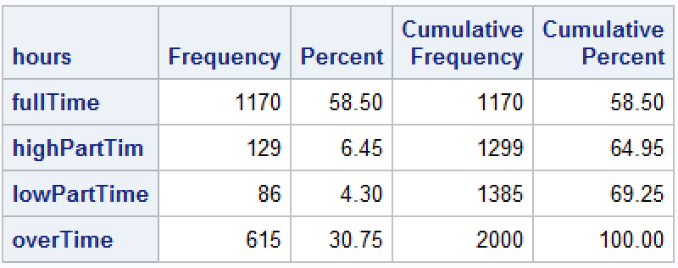

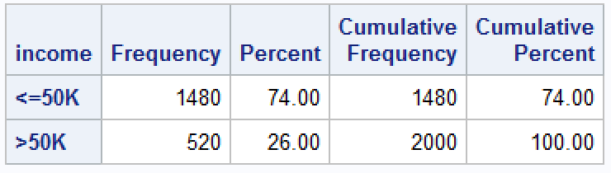

Figure 3

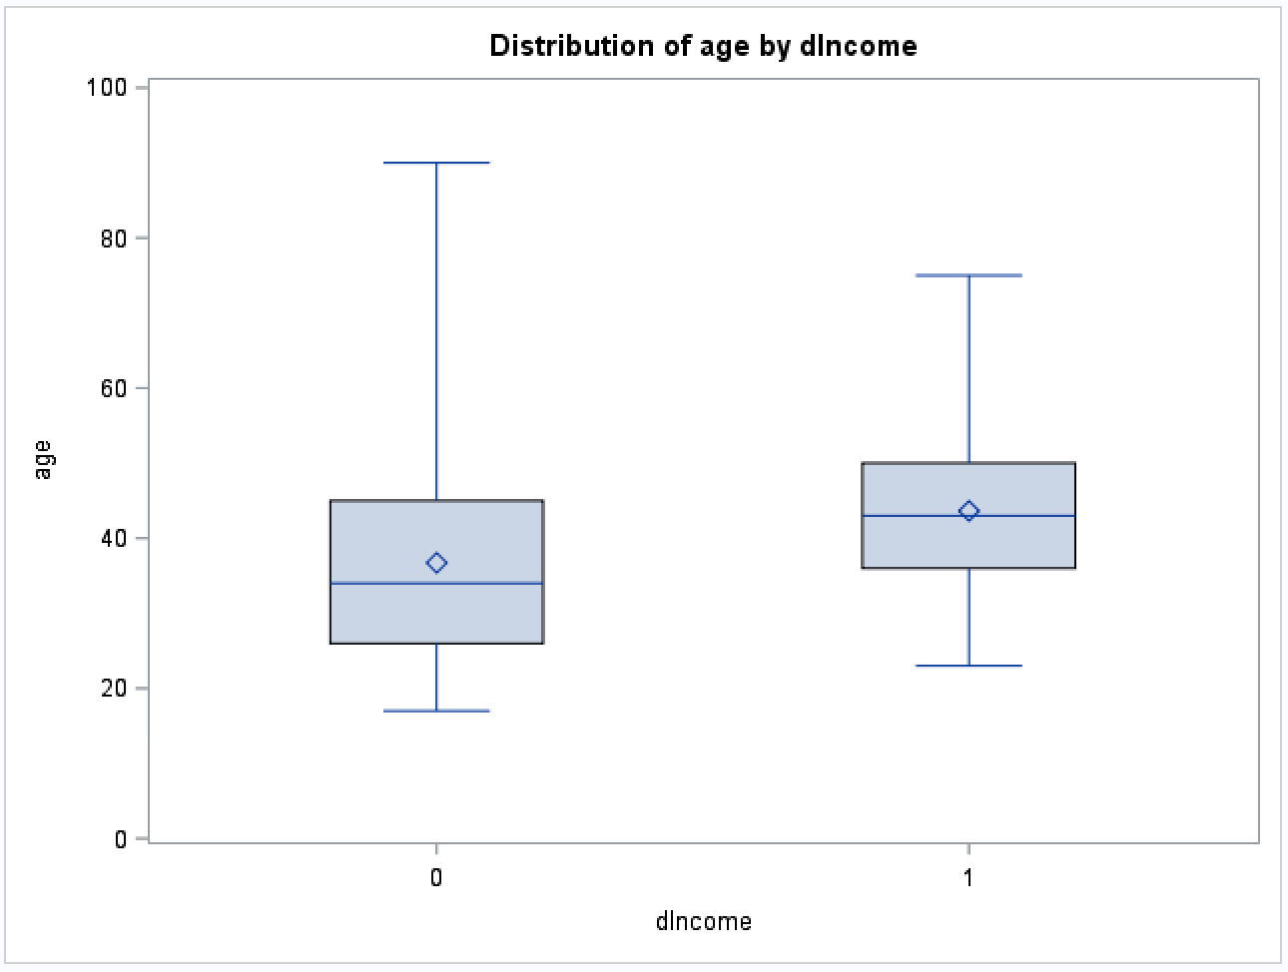

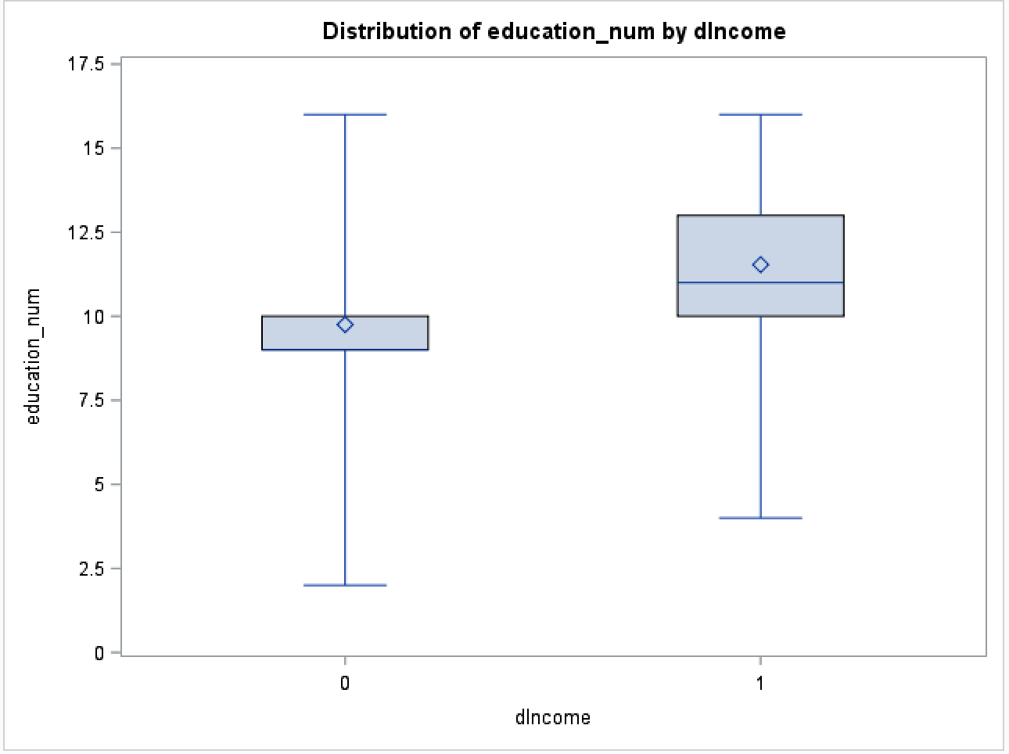

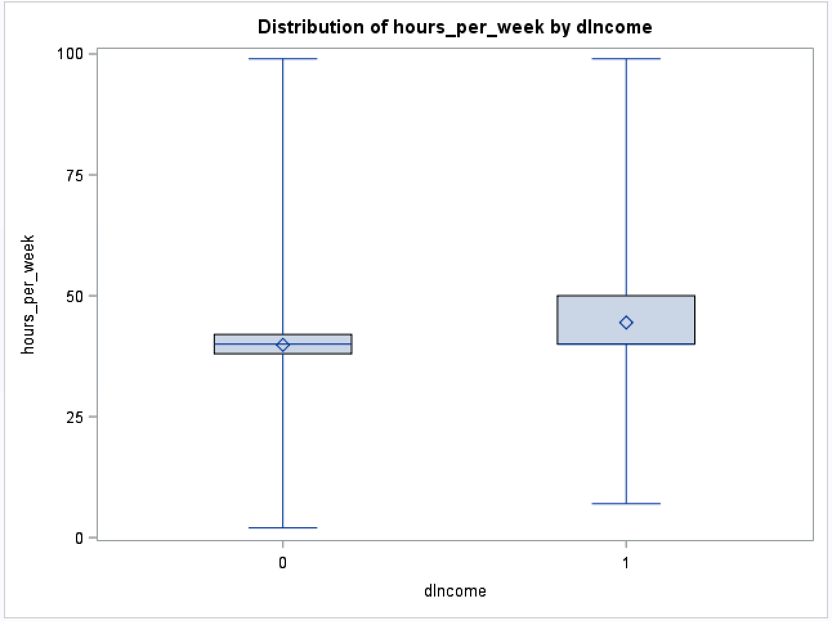

Figure 4

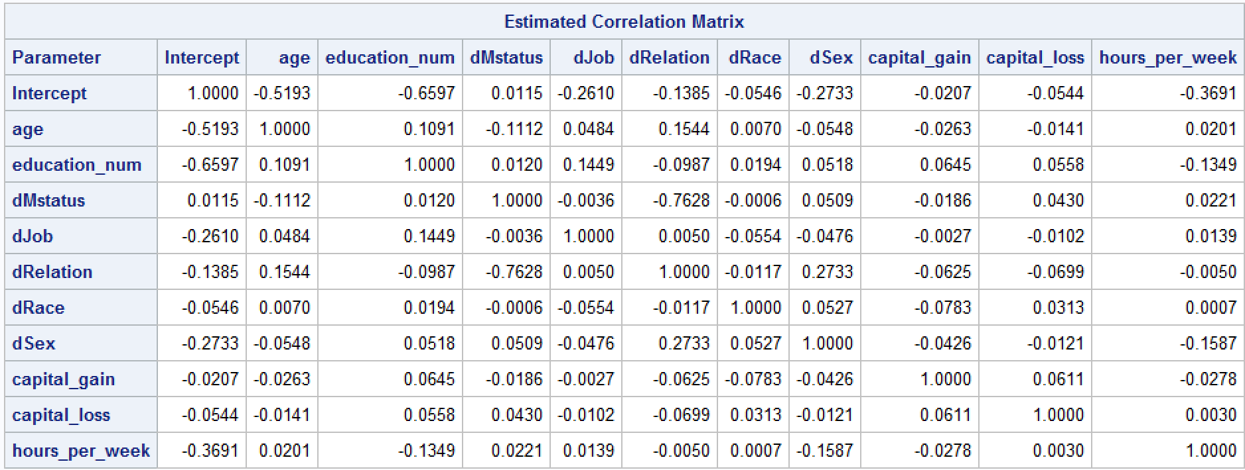

Figure 5

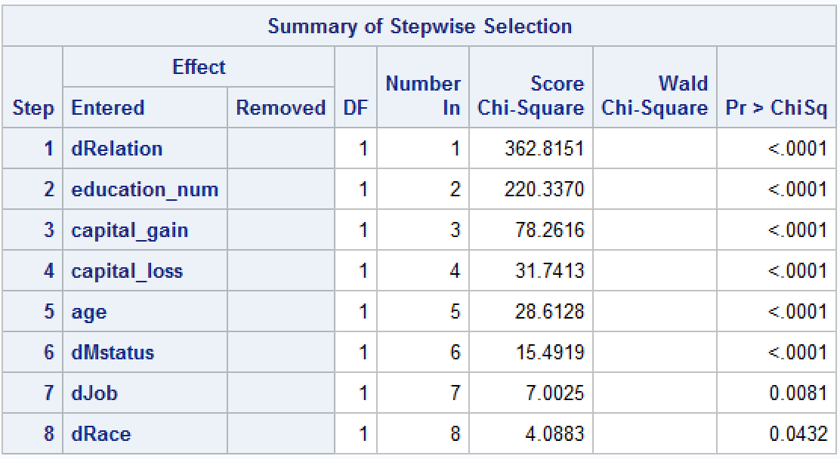

Figure 6

